[cid:009601d11877$0e0e7654$_CDOSYS2.0](http://www.worldviz.com/)



PPT Studio 2013

Welcome to the documentation for the Precision Position Tracker, brought to you by WorldViz. We would like to thank you for purchasing a PPT system, and WorldViz looks forward to supporting you in using PPT for all of your tracking needs.

This documentation should contain everything you need to know about setting up and operating your PPT system. However, if you have any problems using your system, feel free to contact our support team at [support@worldviz.com](mailto:support@worldviz.com) and we will be more than happy to help you. It is also a good idea to check that your support contract with us is up to date. Customers with support contracts receive free updates to the PPT software, priority support, and are covered if the hardware should fail due to normal use. Please email us if you would like more information about support contracts.

When using this documentation, you can use the following quick links to get started, or you can use the table of contents to explore all the information that is available for your reference.

### [Quick installation guide](file:///C:/Users/Daniel/AppData/Local/Temp/CHM%20Editor/ppt_42314.4058039352/PPT_Quick_Instructions.htm)

### [Pre-Tracking Checklist](file:///C:/Users/Daniel/AppData/Local/Temp/CHM%20Editor/ppt_42314.4058039352/Purpose.htm)

### [Troubleshooting](file:///C:/Users/Daniel/AppData/Local/Temp/CHM%20Editor/ppt_42314.4058039352/Troubleshooting_&_Support.htm)

Technical Specifications [PPT-E](file:///C:/Users/Daniel/AppData/Local/Temp/CHM%20Editor/ppt_42314.4058039352/Technical_specification_(PPT-E).htm)  
Technical Specifications [PPT-X](file:///C:/Users/Daniel/AppData/Local/Temp/CHM%20Editor/ppt_42314.4058039352/Technical_specifications_(PPT-X).htm)

Technical Specifications [PPT-H](file:///C:/Users/Daniel/AppData/Local/Temp/CHM%20Editor/ppt_42314.4058039352/Technical_specification_(PPT-H).htm)

PPT Studio 2013 Documentation - Version 3.40 - Copyright © 2002-2013 WorldViz. All Rights Reserved.

[cid:009601d11877$0e0e7654$_CDOSYS2.0](http://www.worldviz.com/)

## Pre-Tracking Checklist

Follow the steps below if:

* The lighting conditions in the room have changed
* A camera has moved
* You want to ensure high quality tracking

1. **Check the cameras**   
   Place the calibration rig in the center of your tracked space. Verify that all cameras see each of the four lights, one at a time. Verify that no camera identifies other light sources (the cross hair in each camera should never flicker to any other spot). Infra-red light contamination can cause poor tracking, and will prevent calibration. To solve this issue, either block the contaminating light or crop out portions of the camera view. See [Preparing your tracking workspace](file:///C:/Users/Daniel/AppData/Local/Temp/CHM%20Editor/ppt_42314.4058039352/Preparing_your_capture_environment.htm).
2. **Calibrate**   
   The slightest movement of any of the cameras is enough to introduce severe tracking distortion. If cameras have been touched or tracking is abnormal, calibrate. To ensure accuracy for important data collection, [Calibrate](file:///C:/Users/Daniel/AppData/Local/Temp/CHM%20Editor/ppt_42314.4058039352/Calibrating.htm).
3. **Tune**   
   Before using PPT for a project, always press the Tune button and follow the instructions. [Tuning](file:///C:/Users/Daniel/AppData/Local/Temp/CHM%20Editor/ppt_42314.4058039352/Tuning.htm) tells PPT where the important tracking area is and whether you are tracking fast or slow motion. If you change a 2D or 3D plugin, you should Tune PPT again.
4. **Verify 3D data**   
   Move a marker through the tracked space and watch a trace of the motion in your [3D view](file:///C:/Users/Daniel/AppData/Local/Temp/CHM%20Editor/ppt_42314.4058039352/Using_your_3D_view.htm). If traces are not turned on, right-click in the 3D View and enable Markers / History. The dot lines should not have any large gaps and will appear a steady, jitter free line. [Troubleshoot](file:///C:/Users/Daniel/AppData/Local/Temp/CHM%20Editor/ppt_42314.4058039352/Troubleshooting_&_Support.htm) if the traces are unusual.
5. **Adjust number of markers**   
   Verify that PPT is looking for the [number of markers](Using_your_3D_view.htm#Number_markers) you intend to track.
6. **Send data**   
   Press the "Talk" button to start sending data. Confirm that your plugins are configured to send data over the appropriate channel for your setup.(The "Talk" mode is automatically turned on when PPT Studio is in 3D view and it can also be turn off under 2D view tab)

**NOTE: Reload factory settings**

If you're having difficulty finding user interface functions as discussed in this documentation, you should select "Load factory settings" under the File menu. This will restore your PPT's graphical user interface back to the default factory settings which correspond the pictures used throughout the documentation.

PPT Studio 2013 Documentation - Version 3.40 - Copyright © 2002-2013 WorldViz. All Rights Reserved.

[cid:009601d11877$0e0e7654$_CDOSYS2.0](http://www.worldviz.com/)

## Quick Installation Guide

Step 1

See [Locate system components](file:///C:/Users/Daniel/AppData/Local/Temp/CHM%20Editor/ppt_42314.4058039352/Locate_System_Components.htm) for a full parts list of what is included with a PPT system.

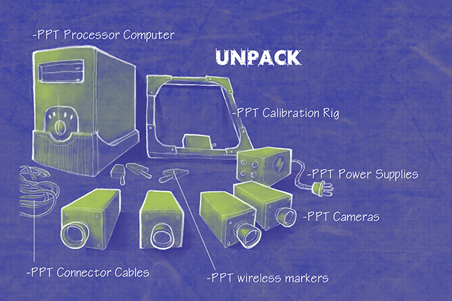

Step 2

See [Camera positioning](file:///C:/Users/Daniel/AppData/Local/Temp/CHM%20Editor/ppt_42314.4058039352/Choosing_your_layout.htm) for suggestions on how the place the cameras in your tracking space.

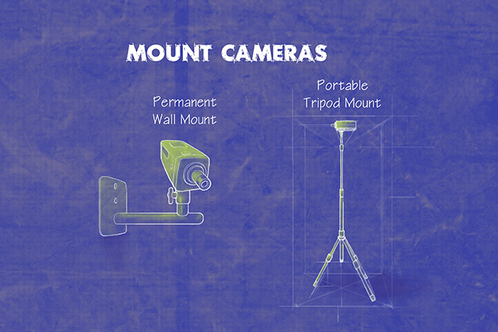

Step 3

WorldViz currently sells 3 kinds of PPT systems. See the page that is appropriate for your configuration:

* PPT-E Systems (International, all voltages) - [Connecting PPT-E camera cables](file:///C:/Users/Daniel/AppData/Local/Temp/CHM%20Editor/ppt_42314.4058039352/ppt-e_configuration.htm)
* PPT-H Systems (International, all voltages) - [Connecting PPT-H camera cables](file:///C:/Users/Daniel/AppData/Local/Temp/CHM%20Editor/ppt_42314.4058039352/PPT-H_configuration.htm)
* PPT-X Systems (United States, 110V only) - [Connecting PPT-X camera cables](file:///C:/Users/Daniel/AppData/Local/Temp/CHM%20Editor/ppt_42314.4058039352/PPT-X_configuration.htm)
* PPT-X Systems (International, all voltages) - [Connecting PPT-X camera cables (International](file:///C:/Users/Daniel/AppData/Local/Temp/CHM%20Editor/ppt_42314.4058039352/PPT-X_configuration_(International).htm))

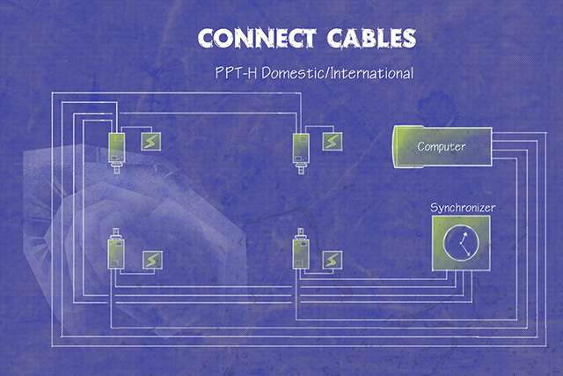

Step 4

See [Adjusting camera settings](file:///C:/Users/Daniel/AppData/Local/Temp/CHM%20Editor/ppt_42314.4058039352/Adjusting_camera_settings.htm), [Calibrating](file:///C:/Users/Daniel/AppData/Local/Temp/CHM%20Editor/ppt_42314.4058039352/Calibrating.htm), and [Using the 3D view](file:///C:/Users/Daniel/AppData/Local/Temp/CHM%20Editor/ppt_42314.4058039352/Using_your_3D_view.htm).

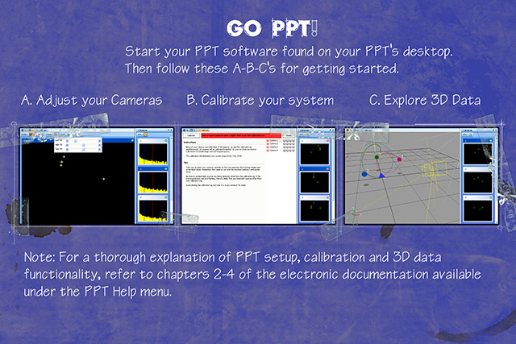

PPT Studio 2013 Documentation - Version 3.40 - Copyright © 2002-2013 WorldViz. All Rights Reserved.

[cid:009601d11877$0e0e7654$_CDOSYS2.0](http://www.worldviz.com/)

## Locate system components

Please identify each of these components before proceeding.

PPT-E

* PPT computer (with power cable, keyboard and mouse)
* PPT-E cameras (4 or more depending on purchased configuration)
* PPT calibration rig
* PPT wireless markers
* Camera mounts (one for each PPT camera)
* Optional RS-232 serial data cable (9 pin)
* CAT5e ethernet cable for PPT computer
* CAT5e ethernet cables (one for each camera)
* Power-over-ethernet gigabit network switch

PPT-H

* PPT computer (with power cable, keyboard and mouse)
* PPT-H cameras (4 or more depending on purchased configuration)
* Combination power-video cables (one for each PPT camera)
* One low voltage DC power supply for each camera
* Power strip
* PPT calibration rig
* PPT wireless markers
* Camera mounts (one for each PPT camera)
* Optional RS-232 serial data cable (9 pin)
* CAT5e ethernet cable for PPT computer
* CAT5e ethernet cables (one for each camera)
* Power/video-based sync cables (one for each camera)
* Sync Y-split adaptors with 12-pin round connector (one for each camera)
* Power adaptors with 10-pin round connector (one for each camera)
* One PPT-H Sync Box
* One 12V DC power supply for PPT-H Sync Box

PPT-X - United States version, 110-120 volts AC power

* PPT computer (with power cable, keyboard and mouse)
* PPT-X cameras (2, 4, or 8 depending on purchased configuration)
* Combination power-video cables (one for each PPT camera)
* One 24V AC camera power supply with 4 or 8 leads
* Power strip
* PPT calibration rig
* PPT wireless markers
* Camera mounts (one for each PPT camera)
* Ethernet cable for PPT computer (recommended connection method)
* RS-232 serial data cable / 9 pin (optional connection method)

PPT-X - International, 110-240 volts AC power

* PPT computer (with power cable, keyboard and mouse)
* PPT-X cameras (2, 4, or 8 depending on purchased configuration)
* Combination power-video cables (one for each PPT camera)
* One 12V DC camera power supply with one lead
* Power splitter cables to power each camera
* Power strip
* PPT calibration rig
* PPT wireless markers
* Camera mounts (one for each PPT camera)
* Gen-lock cables (one less than number of PPT cameras)
* BNC T-connectors (one less than number of PPT cameras)
* Ethernet cable for PPT computer (recommended connection method)
* RS-232 serial data cable / 9 pin (optional connection method)

NOTE: WorldViz does not supply a computer monitor with PPT purchases. Customers must purchase separately a SVGA compatible or better monitor for use with the PPT system.

PPT Studio 2013 Documentation - Version 3.40 - Copyright © 2002-2013 WorldViz. All Rights Reserved.

[cid:009601d11877$0e0e7654$_CDOSYS2.0](http://www.worldviz.com/)

## Camera positioning guidelines

Position and orient the PPT cameras in any configuration that fits your workspace. The optimal height of the cameras depends on your application. For typical upper body tracking, the cameras should be mounted as high as possible to reduce the likelihood of blocking a marker placed on the head.

While limited fluorescent lighting will not affect the PPT cameras, any visible sunlight and some heat sources will interfere with tracking. Light sources in the room must be kept out of the direct field-of-view of the cameras. Read more about this in [Preparing your tracking workspace](file:///C:/Users/Daniel/AppData/Local/Temp/CHM%20Editor/ppt_42314.4058039352/Preparing_your_capture_environment.htm).

#### Optimize the tracked volume

For effective PPT tracking, a marker must be visible to at least 2 cameras. Try to arrange your cameras to maximize the overlap of their field-of-views.

#### Optimize tracking accuracy

The ideal angle between your cameras is 90 degrees (perpendicular). Two adjacent cameras directed at angles that are at similar angles (near parallel) will result in poor triangulation accuracy. However, sometimes 90 degree angles between cameras can reduce the tracked volume and you should adopt a compromise.

#### Example: Square workspace

Two camera arrangements are shown below. Orange indicates tracking by 2 cameras, yellow indicates 3 cameras, and green indicates 4 cameras. In the left image, the cameras are adjusted to maximize the trackable footprint (camera views are flush against opposite walls). In the right image, the cameras are adjusted to maximize the high-quality tracking region (yellow and green) at the cost of a few holes in the tracking coverage. You will need to analyze your requirements to work out which solution is the best for you.

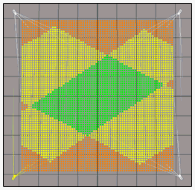  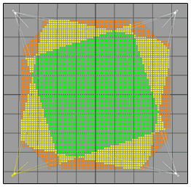

#### Example: Rectangular workspace

Two camera arrangements are shown below. Orange indicates tracking by 2 cameras, yellow indicates 3 cameras, and green indicates 4 cameras. In the left image, full coverage tracking is optimized by adjusting the camera views flush against the long (left/right) walls. In the right image, coverage is sub-optimal due to adjusting the camera views flush against the short (top/bottom) walls. For rectangular workspaces, these diagrams show how critical your camera arrangement is for determining your tracking performance.

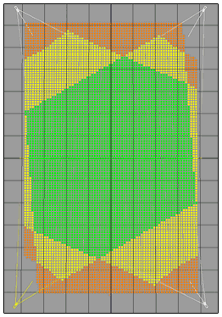  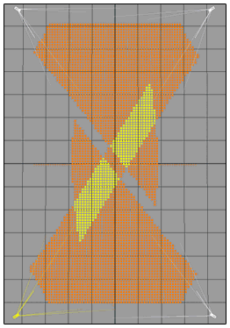

PPT Studio 2013 Documentation - Version 3.40 - Copyright © 2002-2013 WorldViz. All Rights Reserved.

[cid:009601d11877$0e0e7654$_CDOSYS2.0](http://www.worldviz.com/)

# Connecting PPT-E camera cables

|  |  |
| --- | --- |
| **Step 1:**  The cameras used in PPT-E are smart cameras operating at high resolution and fast frame rates. The cameras are able to automatically identify themselves to the PPT software, reducing configuration time. | cid:00a001d11877$0e0e7654$_CDOSYS2.0 |
| **Step 2:**  Connect an Ethernet cable to the back of the camera and run the cable to the main PPT ethernet switch. The cable must be capable of operating with gigabit Ethernet, and so should be rated to at least CAT5e standard. | cid:00a101d11877$0e0e7654$_CDOSYS2.0 |
| **Step 3:**  All of the camera Ethernet cables must be connected to the PoE (Power over Ethernet) gigabit network switch that is supplied to you. It does not matter what port each camera is plugged into. Note that you must use the supplied switch, since it provides power using PoE to all of the cameras.    Next, you must run a separate Ethernet cable from this switch to the back of the PPT computer. Make sure you plug this Ethernet cable into the port marked “Camera Network”. | cid:00a201d11877$0e0e7654$_CDOSYS2.0 |

**Start tracking:**

Once all the wiring is complete, you will need to power up the cameras. If you have already powered up the cameras this is not a problem - simply turn the power off and then on again to reboot them. The cameras must be turned on after all the cables are connected and the host PPT computer is running. If not then they may not be visible to the network and you will need to reboot them once all the connections are completed correctly.

NOTE:

1. PPT-E cameras expect a DHCP server to be available, so this must be supplied either via a network router, or by DHCP server software running on the host machine. Typically, on a WorldViz configured PPT-E system, a DHCP server is added and is configured to generate IP addresses from 192.168.99.100-192.168.99.199. If do not get the computer system directly from us, please make sure your network adapter connected to PPT-E cameras has an IP of 192.168.99.1 for DHCP server to work properly.

2. If the system is not going to be used for a long period of time, it is suggested to unplug the power of the POE switch allowing the cameras to be powered off. This helps to increase the lifespan of a camera.

PPT Studio 2013 Documentation - Version 3.40 - Copyright © 2002-2013 WorldViz. All Rights Reserved.

[cid:009601d11877$0e0e7654$_CDOSYS2.0](http://www.worldviz.com/)

## Connecting PPT-X camera cables 12V (International)

|  |  |
| --- | --- |
| **STEP 1:**  Notice that each camera has a number on the top.  The cameras will be numbered accordingly from 1 to 4.  If you have more than 4 cameras, each camera will have its respective number located on the top. | cid:00a301d11877$0e0e7654$_CDOSYS2.0 |
| **STEP 2:**  You have received several power/video cables (one for each camera) with your PPT system. These cables have BNC plugs and power plugs on both ends. Locate these cables    Note: One side of the power/video cable has a male termination, and the other side has a female termination. Be sure to run your power/video cables so that the power termination matches the power connector on the camera.    Identify the power connector at the back of the camera and connect it with the power plug of the power/video cable.    **NOTE: DO NOT PLUG THE POWER SUPPLY INTO THE POWER OUTLET OR TURN IT ON UNTIL STEP 7** | cid:00a401d11877$0e0e7654$_CDOSYS2.0 |
| **STEP 3:**  After connecting the power connector, plug the BNC end of the power/video cable to the video out BNC connector of the camera. | cid:00a501d11877$0e0e7654$_CDOSYS2.0 |
| **STEP 4:**  Repeat steps 2 through 3 for each of your cameras. |  |
| **STEP 5:**  Locate the power supply (12V). | **NOTE: THE POWER ADAPTER SHOULD NOT BE PLUGGED INTO THE POWER OUTLET UNTIL YOU HAVE COMPLETED STEP 6.** |
| **STEP 6:**  Now connect the BNC plugs at the other ends of the power/video cables into the back of your computer. Next, connect the 12V power supply plugs to the computer end of the power/video cables.  You can use the Y-splitters to power 2 cameras with one 12V power supply.    The ports on the back of the PPT PC are marked with numbers. Match the number on each camera to the number on each port, i.e. Camera ‘1’ connects to port ‘1’. | cid:00a601d11877$0e0e7654$_CDOSYS2.0 |
| **STEP 7:**  The PPT system works best if the 12V power supply and the PPT computer are plugged into the same power source. So, connect the power box to a power strip with an available outlet for the PPT computer. Once you have completed all the above steps, you may turn on the power supply and test the cameras. |  |

NOTE: If the system is not going to be used for a long period of time, it is suggested to unplug the power of the cameras. This helps to increase the lifespan of a camera.

PPT Studio 2013 Documentation - Version 3.40 - Copyright © 2002-2013 WorldViz. All Rights Reserved.

[cid:009601d11877$0e0e7654$_CDOSYS2.0](http://www.worldviz.com/)

## Connecting PPT-X camera cables 24V

|  |  |
| --- | --- |
| **STEP 1:**  Notice that each camera has a number on the top.  The cameras will be numbered accordingly from 1 to 4.  If you have more than 4 cameras, each camera will have its respective number located on the top. | cid:00a701d11877$0e0e7654$_CDOSYS2.0 |
| **STEP 2:**    You have received four or eight power/video cables (one for each camera) with your PPT. These cables have BNC plugs and power plugs on both ends. Locate these cables.    Note: One side of the power/video cable has a male termination, and the other side has a female termination. Be sure to run your power/video cables so that the power termination matches the power connector on the camera. | cid:00a801d11877$0e0e7654$_CDOSYS2.0 |
| **STEP 3:**  Identify the power connector at the back of the camera, and connect it with the power plug of the power/video cable.  After connecting the power connector, plug the BNC end of the power/video cable to the video out BNC connector if the camera.    **NOTE: DO NOT PLUG THE POWER SUPPLY INTO THE POWER OUTLET OR TURN IT ON UNTIL YOU HAVE COMPLETED STEP 7.** | cid:00a901d11877$0e0e7654$_CDOSYS2.0 |
| **STEP 4:**  Repeat steps 2 through 3 for each of your cameras. |  |
| **STEP 5:**  Now locate the Matrox card on the back of your PPT computer. Also look for the 24 volt power supply.    **NOTE: DO NOT CONNECT THE POWER CONNECTOR ON THE CABLE'S COMPUTER END TO THE POWER SUPPLY BOX UNTIL STEP 7** | **cid:00aa01d11877$0e0e7654$_CDOSYS2.0**    **cid:00ab01d11877$0e0e7654$_CDOSYS2.0** |
| **STEP 6:**  Connect the BNC plugs at the other ends of the power/video cables into the back of your computer. **Do not connect the power plugs yet.**    The ports are marked between 1-4. Match the number on each camera to the number on each port ie. Camera ‘1’ goes to into port ‘1’. | **cid:00ac01d11877$0e0e7654$_CDOSYS2.0** |
| **STEP 7:**  Connect the powers supply plugs to the computer end of the power/video cables. |  |
| **STEP 8:**  The PPT system works best if the power box and the PPT computer are plugged into the same power source. So, connect the power box to a power strip with an available outlet for the PPT computer. Once you have completed all the above steps, you may turn on the power supply and test the cameras. |  |

NOTE: If the system is not going to be used for a long period of time, it is suggested to unplug the power of the cameras. This helps to increase the lifespan of a camera.

PPT Studio 2013 Documentation - Version 3.40 - Copyright © 2002-2013 WorldViz. All Rights Reserved.

[cid:009601d11877$0e0e7654$_CDOSYS2.0](http://www.worldviz.com/)

# Connecting PPT-H camera cables

|  |  |
| --- | --- |
| **Step 1:**  The cameras used in PPT-H are smart cameras operating at high resolution and fast frame rates. The cameras are able to automatically identify themselves to the PPT software, reducing configuration time. | cid:00ad01d11877$0e0e7654$_CDOSYS2.0 |
| **Step 2:**  Examine one of your cameras and note that 4 of the 5 available ports will be used in setup. | cid:00ae01d11877$0e0e7654$_CDOSYS2.0 |
| **Step 3:**  Insert the USB connector for the attached fan into the back of the camera.    Connect an Ethernet cable to the back of the camera and run the cable to the main PPT processing computer. The cable must be capable of operating with gigabit Ethernet, and so should be rated to at least CAT5e standard. | cid:00af01d11877$0e0e7654$_CDOSYS2.0 |
| **Step 4:**  Plug one of the provided 12 volt DC power supply into one of the supplied 10-pin round adapters. Plug the 10-pin round connector into the left plug on the back of the cameras.    Once you have connected each camera's power supply, you will need to supply it with AC power. Typically, you will plug the power supply into a nearby power socket. If more length is required, you can use any AC extension lead or you can order DC extension cables from WorldViz. | cid:00b001d11877$0e0e7654$_CDOSYS2.0 |
| **Step 5:**  Each camera has a sync cable adaptor with two inputs and a 12-pin round connector. These adaptors connect the camera to the long black power/video sync cables. The end of the power/video sync cables are labeled "CAMERA" and "SYNC BOX". Plug the "CAMERA" end of the power/video sync cable into the sync adapter, and then the sync adaptor into the camera.    The sync cable adaptors will all have the same colors except for one. The differently colored adaptor is known as the master adaptor. Any camera may be configured as the sync master, but you can only have one master within a group of cameras. If you do not have a master then the cameras will not be able to operate in synchronized mode. | cid:00b001d11877$0e0e7654$_CDOSYS2.0 |
| **Step 6:**  All of the camera Ethernet cables must be connected to the gigabit network switch that is supplied to you. It does not matter what port each camera is plugged into.    Next, you must run a separate Ethernet cable from this switch to the back of the PPT computer. Make sure you plug this Ethernet cable into the port marked “Camera Network”. | cid:00b101d11877$0e0e7654$_CDOSYS2.0 |
| **Step 7:**  The sync power/video cables have two connectors, and these must be connected to a port on the black synchronization box that is supplied with your PPT-H system. After all the cables are connected to the sync box, plug the remaining 12 volt DC power supply into the synchronization box. | cid:00b201d11877$0e0e9d5d$_CDOSYS2.0 |

**Start tracking:**

Once all the wiring is complete, you will need to power up the cameras. If you have already powered up the cameras this is not a problem - simply turn the power off and then on again to reboot them. The cameras must be turned on after all the cables are connected and the host PPT computer is running. If not then they may not be visible to the network and you will need to reboot them once all the connections are completed correctly.

NOTE:

1. PPT-H cameras expect a DHCP server to be available, so this must be supplied either via a network router, or by DHCP server software running on the host machine. Typically, on a WorldViz configured PPT-H system, a DHCP server is added and is configured to generate IP addresses from 192.168.99.100-192.168.99.199

2. If the system is not going to be used for a long period of time, it is suggested to unplug the power of the cameras. This helps to increase the lifespan of a camera.

PPT Studio 2013 Documentation - Version 3.40 - Copyright © 2002-2013 WorldViz. All Rights Reserved.

[cid:009601d11877$0e0e7654$_CDOSYS2.0](http://www.worldviz.com/)

## Connecting PPT-X camera cables

|  |  |
| --- | --- |
| **STEP 1:**  Notice that each camera has a colored sticker on top. Camera '1' has a red sticker, camera '2' has a blue sticker, camera '3' has a yellow sticker and camera '4' has a green sticker.    If you have more than 4 cameras, the color pattern repeats but with a black mark. | cid:00b301d11877$0e0e9d5d$_CDOSYS2.0 |
| **STEP 2:**  You have received four or eight power/video cables (one for each camera) with your PPT. These cables have BNC plugs and power plugs on both ends. Locate these cables.    Note: One side of the power/video cable has a male termination, the other side has a female termination. Be sure to run your power/video cable so that the power termination matches the power connector on the camera. | cid:00b401d11877$0e0e9d5d$_CDOSYS2.0 |
| **STEP 3:**  Identify the power connector at the back of the camera, and connect it with the power plug of the power/video cable.    NOTE: DO NOT PLUG THE POWER SUPPLY INTO THE POWER OUTLET OR TURN IT ON UNTIL YOU HAVE COMPLETED STEP 8. | cid:00b501d11877$0e0e9d5d$_CDOSYS2.0 |
| **STEP 4:**  After connecting the power connector, plug the BNC part of the power/video cable to the video out BNC connector on the camera. | cid:00b601d11877$0e0e9d5d$_CDOSYS2.0 |
| **STEP 5:**  Repeat steps 3 through 4 for each of your cameras. |  |
| **STEP 6:**  Now connect the BNC plugs at the other ends of the power/video cables into the back of your computer. Do not connect the power plugs yet.    The ports are marked '0' (red), '1' (blue), '2' (yellow), '3' (green). The cable from camera '1' (red) should be plugged into port '0' (red), the cable from camera '2' (blue) should be plugged into port '1' (blue), the cable from camera '3' (yellow) should be plugged into port '2' (yellow), and the cable from camera '4' (green) should be plugged into port '3' (green). | cid:00b701d11877$0e0e9d5d$_CDOSYS2.0 |
| **STEP 7:**  Locate the power supply box.    NOTE: DO NOT PLUG THE POWER BOX INTO THE POWER OUTLET UNTIL YOU HAVE COMPLETED STEP 8. | cid:00b801d11877$0e0e9d5d$_CDOSYS2.0 |
| **STEP 8:**  Connect the power supply plugs to the computer end of the power/video cables. | cid:00b601d11877$0e0e9d5d$_CDOSYS2.0 |
| **STEP 9:**  The PPT system works best if the power box and the PPT computer are plugged into the same power source. So, connect the power box to a power strip with an available outlet for the PPT computer. Once you have completed all the above steps, you may turn on the power supply and test the cameras. |  |

NOTE: If the system is not going to be used for a long period of time, it is suggested to unplug the power of the cameras. This helps to increase the lifespan of a camera.

PPT Studio 2013 Documentation - Version 3.40 - Copyright © 2002-2013 WorldViz. All Rights Reserved.

[cid:009601d11877$0e0e7654$_CDOSYS2.0](http://www.worldviz.com/)

## Connecting PPT-X camera cables (International)

|  |  |
| --- | --- |
| **STEP 1:**  Notice that each camera has a colored sticker on top. Camera '1' has a red sticker, camera '2' has a blue sticker, camera '3' has a yellow sticker and camera '4' has a green sticker.    If you have more than 4 cameras, the color pattern repeats but with a black mark. | cid:00b301d11877$0e0e9d5d$_CDOSYS2.0 |
| **STEP 2:**  You have received four or eight power/video cables with your PPT. These cables have BNC plugs and power plugs on both ends. Find these cables.    Note: One side of the power/video cable has a male termination, the other side has a female termination. Be sure to run your power/video cable so that the power termination matches the power connector on the camera.    Identify the power connector at the back of the camera, and connect it with the power plug of the power/video cable.    NOTE: DO NOT PLUG THE POWER SUPPLY INTO THE POWER OUTLET OR TURN IT ON UNTIL YOU HAVE COMPLETED STEP 12. | cid:00b401d11877$0e0e9d5d$_CDOSYS2.0 |
| **STEP 3:**  Find the three T-connectors that came with your system. | cid:00b901d11877$0e0e9d5d$_CDOSYS2.0 |
| **STEP 4:**  There are two terminals on the bottom half of the cameras, the one on the left is marked "gen-lock" and the one on the right is marked "video out". Locate these terminals. Plug one of your T-connectors into the "video out" of camera '1' (the camera with the red sticker).    Do not connect the other two T-connectors yet. | cid:00ba01d11877$0e0e9d5d$_CDOSYS2.0 |
| **STEP 5: (CAMERA 1 ONLY)**  Take one of these cables and join the BNC connector with the T-connector that is attached to the "Video Out" of camera '1' (red).    NOTE: The other end of the T-connector will be used below to split off the video signal and use it to drive the synchronization across all cameras. | cid:00ba01d11877$0e0e9d5d$_CDOSYS2.0 |
| **STEP 6: (CAMERAS 2, 3, 4 ONLY)**  Take the BNC plug on the end of each power/video cable and plug it into the "Video Out" terminal of each camera, Cameras '2' (blue), '3' (yellow), and '4' (green). The camera should look like the image on the right. | cid:00bb01d11877$0e0e9d5d$_CDOSYS2.0 |
| **STEP 7:**  Now plug the BNC cables into the video capture card on the back of your computer.    The ports are marked '0' (red), '1' (blue), '2' (yellow), '3' (green). The cable from camera '1' (red) should be plugged into port '0' (red), the cable from camera '2' (blue) should be plugged into port '1' (blue), the cable from camera '3' (yellow) should be plugged into port '2' (yellow), and the cable from camera '4' (green) should be plugged into port '3' (green). | cid:00b701d11877$0e0e9d5d$_CDOSYS2.0 |
| **STEP 8:**  Now find the three gen-lock cables that came with your system. | cid:00bc01d11877$0e0e9d5d$_CDOSYS2.0 |
| **STEP 9: (CAMERA 1 ONLY)**  Use the three gen-lock cables to connect the cameras in your system into a chain. First, plug one end of one of these cords into the T-connector of camera '1' (red).    NOTE: The gen-lock terminal on camera '1' remains empty. | cid:00bd01d11877$0e0e9d5d$_CDOSYS2.0 |
| **STEP 10: (CAMERAS 2 & 3 ONLY)**  Connect the remaining two T-connectors to the gen-lock jacks on cameras 2 and 3.    Next, connect the loose cable from camera one (split from the video-out) into the T-connector of camera 2 (blue).    Then, use the second cable to connect the T-connector of camera '2' (blue) to the T-connector of camera '3' (yellow) | cid:00be01d11877$0e0e9d5d$_CDOSYS2.0 |
| **STEP 11: (CAMERA 4 ONLY)**  Finally, use the third cable to connect the T-connector of camera '3' (yellow) directly into the "gen-lock" jack of camera '4' (green). | cid:00bf01d11877$0e0e9d5d$_CDOSYS2.0 |
| **STEP 12:**  Look at the switches on the upper right hand side of each camera. Your system will arrive with theses switches in the appropriate settings so DO NOT change them. If these settings ever get changed, make sure that cameras '1' (red), '2' (blue), and '3' (yellow) are set so that all switches are to the left (see left hand side of the image), and make sure that camera '4' (green) is set so that only the bottom switch is set to the right (see right hand side of image). This switch affects the termination of the gen-lock signal. | cid:00c001d11877$0e0e9d5d$_CDOSYS2.0 |
| **STEP 13:**  Make sure the power supply is turned off before starting this step.    Get the camera power supply and connect the camera power supply to the power plugs on the computer end of the power/video cables.    You may now turn on the power supply and test the cameras within the PPT application. | cid:00c101d11877$0e0e9d5d$_CDOSYS2.0 |

NOTE: If the system is not going to be used for a long period of time, it is suggested to unplug the power of the cameras. This helps to increase the lifespan of a camera.

PPT Studio 2013 Documentation - Version 3.40 - Copyright © 2002-2013 WorldViz. All Rights Reserved.

[cid:009601d11877$0e0e7654$_CDOSYS2.0](http://www.worldviz.com/)

## Powering and restarting PPT

PPT systems are designed to be used as a generic tracking device, and require no intervention by the user once it is up and running. PPT is able to be run continuously 24/7 if this is desired, there is no need to exit from the PPT Studio software, or to shut down the computer. If you desire tracking that is available whenever it is needed by other systems, it is recommended that you leave the system running continuously to minimize startup delay.

#### PPT-X Startup and Reset

The PPT-X system requires no special startup sequence. Simply turn on the power supply for the cameras and start up the PPT machine. You may then start the PPT Studio software, and the cameras will immediately begin working. PPT-X cameras are passive devices, and should require no intervention by the user, so they can be powered on or off at any time. You may reboot the system at any time.

#### PPT-E Startup and Reset

The PPT-E system requires special attention to ensure that the overall system will operate correctly. The cameras use Ethernet for communications, and require a DHCP server to be available when they start up to assign an IP address. It is important that a DHCP server be running before the cameras are started. With a WorldViz configured PPT system, the DHCP software runs on the PPT host machine, and so this must be running before the cameras. WorldViz typically configures the DHCP server to generate IP addresses 192.168.99.100-192.168.99.199 on a secondary network card.

To start up a PPT-E system, perform the following steps:

1. Connect all PPT-E cameras to the PoE ethernet switch

2. Power up the PPT host computer

3. Wait until the host computer has completely started, and the DHCP server software is running

4. Wait at least 1 minute for the PPT-E cameras to start, acquire network addresses, and prepare for capturing

5. If there are any problems, power cycle the PoE ethernet switch, which will reboot the cameras

6. Start up the PPT Studio software, and tracking should begin

If there are problems with the cameras, simply power cycle the PoE ethernet switch, which will reboot all the cameras. The system should be ready 1 minute later and ready to use.

#### PPT-H Startup

The PPT-H system requires special attention to ensure that the overall system will operate correctly. The cameras use Ethernet for communications, and require a DHCP server to be available when they start up to assign an IP address. It is important that a DHCP server be running before the cameras are started. With a WorldViz configured PPT system, the DHCP software runs on the PPT host machine, and so this must be running before the cameras. WorldViz typically configures the DHCP server to generate IP addresses 192.168.99.100-192.168.99.199 on a secondary network card.

To start up a PPT-H system, perform the following steps:

1. Power up all Ethernet switches and accessories

2. Power up the PPT host computer

3. Wait until the host computer has completely started, and the DHCP server software is running

4. Power up the PPT-H cameras

5. Wait at least ***5 minutes*** for the PPT-H cameras to start, acquire network addresses, and prepare for capturing

6. Start up the PPT Studio software, and tracking should begin

If you have problems during the startup sequence, you can look at the DHCP server software to verify that all cameras are connected to the network.

#### PPT-H Restart

If you are experiencing problems or would like to restart your PPT-H system, you must ensure that everything starts in the correct order as discussed previously.

To reboot a PPT-H host computer, perform the following steps:

1. Reboot the PPT host computer

2. Wait until the host computer has completely restarted, and the DHCP server software is running

3. Power cycle the PPT-H cameras

4. Wait at least ***5 minutes*** for the PPT-H cameras to start, acquire network addresses, and prepare for capturing

5. Start up the PPT Studio software, and tracking should begin

If you fix up a network problem or other issue with a PPT-H camera, you will need to restart it:

1. Exit the PPT Studio software

2. Power cycle the desired PPT-H camera

3. Wait at least ***5 minutes*** for the PPT-H camera to start, acquire a network address, and prepare for capturing

4. Start up the PPT Studio software, and tracking should begin with the rebooted camera, plus the others

PPT Studio 2013 Documentation - Version 3.40 - Copyright © 2002-2013 WorldViz. All Rights Reserved.

[cid:009601d11877$0e0e7654$_CDOSYS2.0](http://www.worldviz.com/)

## Activating and de-activating cameras

#### cid:00c201d11877$0e0e9d5d$_CDOSYS2.0Turning off a camera

Sometimes a situation arises in which you need to suppress one of your PPT system cameras. A typical reason for suppressing a camera is a hardware fault or poor calibration and you choose to continue to capture motion using the remaining cameras before servicing the device.

To suppress a camera, go to the Cameras panel and right click the camera in question. In the pop-up menu, click the Active label to de-select the camera as shown in the figure below. The camera will appear as a white square once it has been disabled.

#### Activating a camera

If a new camera is added to an existing PPT system, the camera will show up as a white square with no image in it. In order to use this camera, it must be activated. Following the same procedure as before, right click on the camera, and select Active. This will activate the camera, and it will show images and can be used for tracking once it has been calibrated.

#### Camera errors

If PPT detects that a camera is not returning images or tracking information, it will show a red error indicator. This means that the camera is currently not working, and tracking will not operate when all cameras are not working. In order to perform tracking with the remaining cameras, the failed camera must be disabled using the above mentioned procedure.

PPT Studio 2013 Documentation - Version 3.40 - Copyright © 2002-2013 WorldViz. All Rights Reserved.

[cid:009601d11877$0e0e7654$_CDOSYS2.0](http://www.worldviz.com/)

## Preparing your tracking workspace

PPT cameras track infrared (IR) light emitted from PPT markers. Infrared light from non-marker sources renders tracking unreliable or impossible. Thus, the tracked workspace should be lit by "cool" light sources (such as fluorescent or xenon lights) that do not generate IR light.

#### Common infrared contamination sources

* **Windows:** Completely block outdoor light from the room's windows. Standard curtains and venetian blinds are usually not sufficient as they let through too much IR light. Use a high-quality block-out plastic or felt drape to achieve full light blockage.
* **Incandescent (tungsten) light bulbs:** Turn off all warm light sources and only use fluorescent light to illuminate your workspace during tracking.
* **Some computer monitors and status lights:** Some computer monitors and status lights on electronic devices emit IR.  Use the large camera view when troubleshooting for interfering light sources.
* **Reflective surfaces:** Sometimes a surface reflects a warm light source that would otherwise not be in the field of view of the PPT cameras (e.g., a ceiling light reflecting off a chrome chair). Even the glass surface of a widescreen TV or the enamel surface of a white-board can be reflective enough to interfere.

#### Light leaking into your workspace?

If tracking is poor or calibration fails, check for light contamination:

1. Turn off all of your PPT markers.
2. Look at each camera's 2D view. If any show a cross-hair, then there is stray light.
3. Often it is a good idea to raise a camera's sensitivity to better detect stray light of this sort (lowering sensitivity after the problem light has been resolved). The [Adjusting camera settings](file:///C:/Users/Daniel/AppData/Local/Temp/CHM%20Editor/ppt_42314.4058039352/Adjusting_camera_settings.htm) topic has more information on these settings.

#### Always control ambient lighting?

Yes, every time you use your PPT system you will need to eliminate infrared light contamination. This includes during calibration and normal tracking.

PPT Studio 2013 Documentation - Version 3.40 - Copyright © 2002-2013 WorldViz. All Rights Reserved.

[cid:009601d11877$0e0e7654$_CDOSYS2.0](http://www.worldviz.com/)

## Adjusting Camera Settings

In this section you will learn how to adjust your PPT cameras so that they readily detect your wireless PPT markers and avoid being distracted by interfering light sources in your workspace.

There are three camera settings which need to be adjusted whenever your tracking environment changes: Low Threshold, High Threshold, and Gain. These settings are used by the [2D Plugin](file:///C:/Users/Daniel/AppData/Local/Temp/CHM%20Editor/ppt_42314.4058039352/2D_Plugin.htm) to determine valid lights within each camera image.

#### Low Threshold

The low threshold is *sensor black*. Pixels with intensities below this threshold are not taken into consideration when determining the image location of an LED marker seen by a camera.

Generally this threshold should always be set above the background noise level. This threshold is represented by the blue line in the histogram.

#### High Threshold

The high threshold is *sensor white*. When beginning a search for a light, the PPT will ignore all pixels below this threshold. Only pixels with intensities equal to or greater than this threshold will trigger light detection.

This threshold is represented by the red line in the histogram.

#### Gain

The gain setting is a *multiplier* to the camera signal. The typical setting for gain with PPT-X is 50, and for PPT-E and PPT-H is 0. This is ideal for a 3m x 3m workspace with very little ambient lighting.

#### Viewing the Camera Settings

1. Enable the histogram by clicking on the button in the camera panel. You should see a histogram overlaid on top of all the active camera thumbnails in the camera panel. The blue line represents the low threshold and the red line represents the high threshold.  
     
   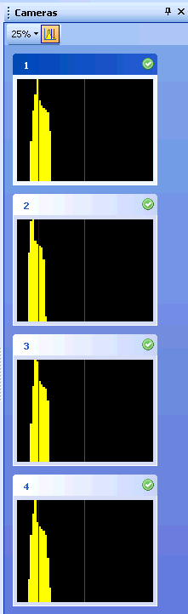
2. Select a camera by double-clicking on the camera's thumbnail in the camera panel. The selected camera's image is now shown in the large center view.
3. Turn on the threshold visibility by clicking on the button cid:00c401d11877$0e0e9d5d$_CDOSYS2.0.  Dark green visualizes the area above the low threshold and light green the area above the high threshold.  
     
   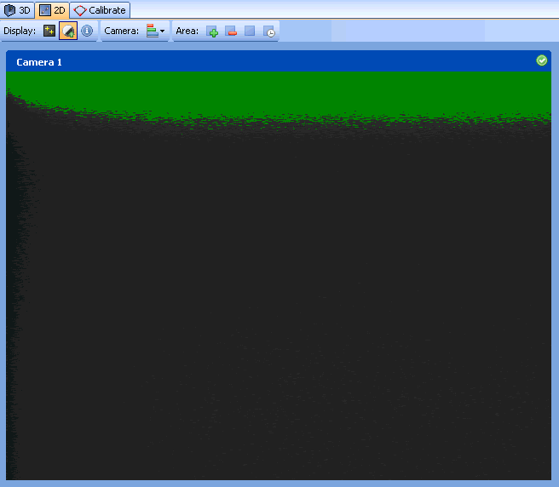

#### Changing Settings

To change the settings:

1. Turn off all PPT wireless markers. Physically block out any outside light and prepare your workspace for the controlled conditions ([see previous section](file:///C:/Users/Daniel/AppData/Local/Temp/CHM%20Editor/ppt_42314.4058039352/Preparing_your_capture_environment.htm)) that you intend to use during your actual motion tracking situations.
2. From the Cameras panel, turn on the histogram overlay. cid:00c601d11877$0e0e9d5d$_CDOSYS2.0
3. Double-click on the camera you would like to adjust. This forces the 2D view to appear in the middle showing an enlargement of this camera's view.
4. Turn on the threshold visibility. cid:00c401d11877$0e0e9d5d$_CDOSYS2.0Dark green visualizes the area above the low threshold and light green the area above the high threshold.
5. Drop down the camera setting sliders by clicking on the cid:00c701d11877$0e0e9d5d$_CDOSYS2.0button in the 2D view.  
     
   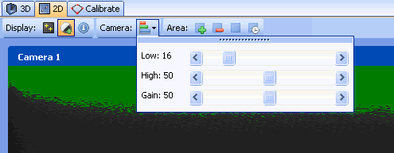

#### Setting low and high thresholds

1. ***Setting the low threshold:*** In the figure below, Camera #1 is being adjusted. In the thumbnail view, the histogram shows a distribution which represents the background noise of the tracking environment. The 2D view shows the noise as it is seen by the camera. In this case the noise is being detected near the top of the camera image. The low threshold slider currently shows the threshold at 16. You should adjust the low threshold until all the dark green pixels disappear. In general this should move the blue line in the histogram near the right edge of the noise distribution. The second image in the figure below shows the end result of adjusting Camera #1 to have a low threshold of 24.  
     
   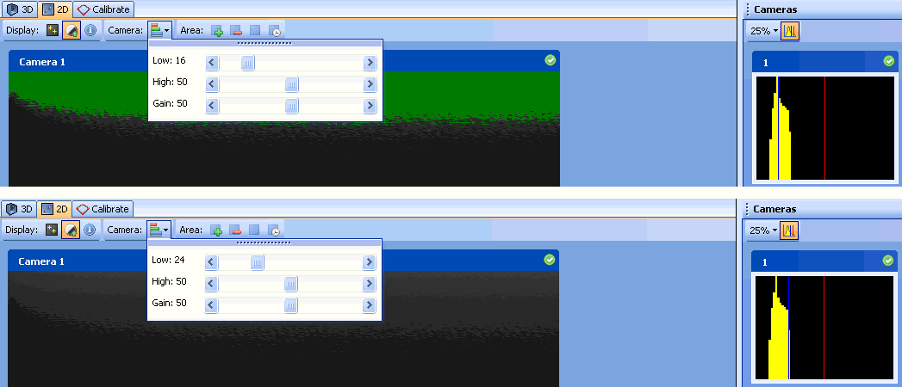
2. **Setting the high threshold:** Adjust the high threshold slider until the red line in Camera #1's histogram is to the right of the distribution by a distance equal to the distribution's width. In the example above, the high threshold is fine at 50 so adjustments were unnecessary.
3. You may choose to use the same thresholds for all cameras at this point by right-clicking on the current camera thumbnail and selecting "Copy settings to all", otherwise repeat this process with each camera. For irregular setups or setups with ambient lighting, you should adjust each camera individually.

#### Setting Gain

1. For PPT-X: Adjust the gain to 50. This is the typical setting for a 3m x 3m workspace. Workspaces significantly larger or smaller will need to increase or decrease this value, respectively.  
   For PPT-E/H: Adjust the gain to 0.

*You may choose to use the same settings for all cameras at this point by right-clicking on the current camera thumbnail and selecting "****Copy settings to all****", otherwise repeat this process with each camera. For irregular setups or setups with ambient lighting, you should adjust each camera individually.*

#### Blocking Interfering Light Sources

1. Ensure that all LED markers are turned off.
2. For each camera, double-click its thumbnail view in the Cameras panel to access its controls via the 2D View window.
3. Turn on the threshold visibility. cid:00c401d11877$0e0e9d5d$_CDOSYS2.0Dark green visualizes the area above the low threshold and light green the area above the high threshold.  
     
   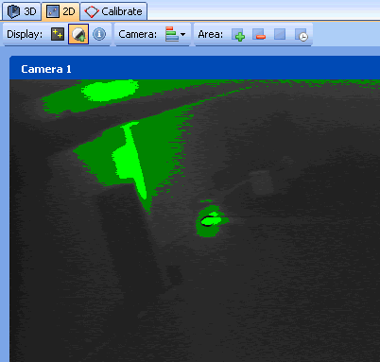
4. In the example above, a lamp has been placed in Camera #1's view. We want to remove the area's illuminated by the lamp since it will interfere with tracking.
5. You can selectively restore or remove tracked regions by selecting the add (cid:00cb01d11877$0e0e9d5d$_CDOSYS2.0) or remove (cid:00cc01d11877$0e0e9d5d$_CDOSYS2.0) button and dragging a square in the 2D View. The red area indicates regions that will be ignored by the PPT system (the figure below indicates the removed area as red stipple).  
     
   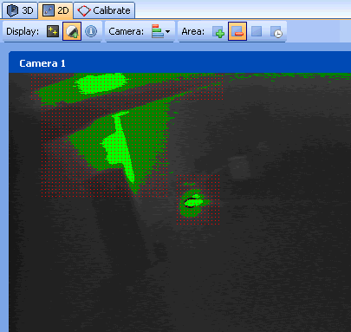
6. You can also use the "Auto-remove" mode (cid:00ce01d11877$0e0e9d5d$_CDOSYS2.0) to remove all regions that are above the camera threshold. Alternatively, you can restore all tracking areas by selecting the restore (cid:00cf01d11877$0e0e9d5d$_CDOSYS2.0) button.

#### Advanced: Setting your cameras for special cases

There are several cases when you may wish to part from the suggested standard procedures.

Regarding gain, you may observe that markers flicker or disappear even though there is no line-of-sight occlusion. This typically happens when the marker intensity is to low, as when operating at large distances from a camera, or tracking on object that is moving very fast. To improve marker acquisition, use a higher gain. Overall, increasing sensitivity causes a reduction in tracking resolution, so only increase sensitivity beyond recommended values the amount that is necessary (maintaining reliable acquisition).

Regarding threshold, you may find that increasing the high-threshold beyond recommended values is a useful technique to eliminate ambient light distractions. The cost of having a high threshold is you'll loose marker acquisition whenever the intensity drops below this value. You might observe this happening whenever your marker moves very fast. In the case of fast moving markers, you will want to test performance by decreasing the high-threshold below recommended values.

PPT Studio 2013 Documentation - Version 3.40 - Copyright © 2002-2013 WorldViz. All Rights Reserved.

[cid:009601d11877$0e0e7654$_CDOSYS2.0](http://www.worldviz.com/)

## Calibration Overview

Calibration is critical to setting up your PPT system, and without a valid calibration, you will not be able to capture 3D data.  Calibrating your system is quick and takes no more than a few minutes for standard configurations. An existing calibration can be invalidated by moving any one of your PPT cameras by even the slightest amount.  If you are not certain if your cameras have not been moved or jostled, then it is imperative that you re-calibrate.

After calibrating your system, you will suddenly see your workspace appear on the [3D View](file:///C:/Users/Daniel/AppData/Local/Temp/CHM%20Editor/ppt_42314.4058039352/Using_your_3D_view.htm).  The location and orientation of each PPT camera will be revealed, as will the location and traces for any tracked PPT markers.

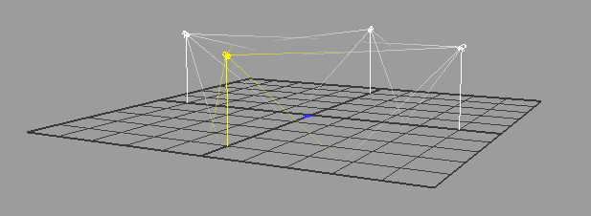

#### Bootstrapping

The goal of calibrating is to teach your system where each of the cameras is located in your workspace.  All you have to do is allow each camera to see the supplied PPT calibration rig - your system will compute the camera's exact position and orientation based on the blink pattern provided by the calibration rig. The calibration process can take as little as 2 minutes to complete.

In a typical calibration, you place the PPT calibration rig on the floor at a location where all cameras can see it simultaneously. The calibration rig is marked with a +X and a +Z direction. You should align these axes so that PPT's coordinate system is oriented in the way you desire. You then run the calibration wizard (explained below) and within a minute all the cameras are calibrated. Your system's (0,0,0) origin and the forward-up vector is established by the position and orientation of the PPT calibration rig during calibration.

In a more complicated calibration, you might have a physical workspace where not all cameras can see the calibration rig simultaneously (e.g., the room is L-shaped). In this case, you use the calibration wizard to successively capture views of the calibration rig until all cameras have seen it. Your PPT will then automatically chain all these independent calibrations together and form a single reference frame, setting its origin and orientation at the first location of the calibration rig.

PPT Studio 2013 Documentation - Version 3.40 - Copyright © 2002-2013 WorldViz. All Rights Reserved.

[cid:009601d11877$0e0e7654$_CDOSYS2.0](http://www.worldviz.com/)

## Calibrating

**NOTE for PPT-X users**:

Before running the calibration wizard, you need to be absolutely certain that your cameras are connected in the correct order. To verify this, wave your hand or a marker in front of each camera and double-check that each camera's physically labeled number matches it's number in the PPT software interface. A mismatch cannot be detected by the software and calibration will be possible but the calibration quality will be significantly deteriorated. PPT-E and PPT-H systems automatically identify themselves and ensure correct connections.



#### Standard calibration

In this method, all cameras are calibrated simultaneously.

1. Before continuing, ensure that you have configured your PPT cameras to optimal sensitivity and thresholds, and that your workspace lighting is ready for data collection (e.g., outside windows blocked, warm lights off).
2. Turn off all of your PPT markers.
3. Turn on the PPT calibration rig and place it in the center of your workspace. Orient the calibration rig so that the +X and +Z axis markers are aligned in the directions that you desire for PPT's coordinate system. PPT north is defined as the direction of the +Z axis.
4. Try to keep the rig as close to the center of each camera's field-of-view as possible.  Avoid placing the calibration rig markers at extreme edges of a camera's view. Use the Cameras panel to view all of the cameras simultaneously.
5. Click the Calibrate tab in the main viewport. This will launch the calibration wizard.  
     
   cid:00d201d11877$0e0e9d5d$_CDOSYS2.0
6. Find the Calibration Rig Size options and select the proper calibration rig size. The size is defined by the distance between the adjacent IR LEDs. In general, a system usually comes with a calibration rig which has the default size (57cm).   
     
   cid:00d301d11877$0e0e9d5d$_CDOSYS2.0
7. For a standard calibration, all cameras should be reset to Uncalibrated (as indicated by the red icon next to each camera). If this is not the case, click the Reset button before proceeding.  
     
   cid:00d401d11877$0e0e9d5d$_CDOSYS2.0
8. Click the Calibrate button at the top of the window. Each of the camera's four indicator lights will turn green for each flash of the PPT calibration rig. If any camera fails to light up all green, then there was a problem with that camera seeing all four markers of the PPT calibration rig. Use the Cameras panel to re-examine that camera.
9. If all cameras calibrated successfully, you'll receive a quality score. Good scores are in the range of 95-100; scores greater than 90 are still acceptable.  
     
   cid:00d501d11877$0e0e9d5d$_CDOSYS2.0

#### Chained calibration

In this method, cameras are calibrated in stages. Use this method for a physical workspace where not all cameras can see the calibration rig simultaneously (e.g., the room is L-shaped).

1. Follow steps 1 - 4 above.
2. If you're starting a new chained calibration, click the Reset button to clear all previous data.
3. Click the Calibrate button at the top of the window. Each of the camera's four indicator lights will turn green for each flash of the PPT calibration rig.
4. Cameras that are fully calibrated are now indicated with the green checkmark icon. Cameras that show a yellow icon indicate that the camera saw all four makers on the calibration rig but it cannot yet chain due to lack of data from a neighboring (connecting) camera. Cameras that show a red icon indicate cameras that saw less than four markers on the calibration rig.
5. Move the calibration rig enough so that some or all those cameras indicated as red can now fully see the calibration rig.
6. Once all cameras are calibrated, you'll receive a quality score. Good scores are in the range of 95-100; scores greater than 90 are still acceptable.

**NOTE about chaining**

Use as few calibration snapshots as possible, typically this is done by "sweeping" the calibration rig from one end of the space to the other. If you suspect a camera calibrated but may contain poor measurements (e.g., the rig was at the extreme edge of the camera's view), you can easily right click on the camera to mark it as uncalibrated, and then redo it.

#### Clearing calibrations

From either the Cameras panel or the 2D view, you can right-click a camera and select Clear calibration to void a particular camera's calibration, forcing the PPT system to re-calibrate it during the next calibration. You can also clear all or some cameras directly in the Calibration guide.

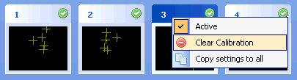

PPT Studio 2013 Documentation - Version 3.40 - Copyright © 2002-2013 WorldViz. All Rights Reserved.

[cid:009601d11877$0e0e7654$_CDOSYS2.0](http://www.worldviz.com/)

## Tuning

Unlike calibration (which is necessary step), tuning is optional and adjusts PPT's tracking algorithms to the specific needs of your application.

Tuning is very important but it is quick to perform. Do it whenever your requirements change, even if that means you tune once an hour.

For instance, if you plan to use PPT in a confined region and only with slow moving objects (e.g., a person's head), then the process of tuning will let PPT optimize it's internal parameters for that portion of your workspace and for objects moving at that speed. Alternatively, if you plan to use every bit of trackable workspace at high speeds (e.g., a dancer's body), the process of tuning will let PPT optimize accordingly for this scenario.

#### Tuning your PPT system:

Before beginning, ensure that your PPT cameras are all properly [configured](file:///C:/Users/Daniel/AppData/Local/Temp/CHM%20Editor/ppt_42314.4058039352/Adjusting_camera_settings.htm) and you have a recent, good quality [calibration](file:///C:/Users/Daniel/AppData/Local/Temp/CHM%20Editor/ppt_42314.4058039352/Purpose_of_calibration.htm). If not, then perform those steps first.

1. Turn off all of the PPT markers.
2. Ensure that no false lights can be seen in each camera. Check each camera image in the Cameras panel and ensure that no lights detected (indicated by yellow cross-hairs).
3. Turn on **1** LED marker.
4. Click on the Tune button and start sampling.  
     
   cid:00d701d11877$0e0e9d5d$_CDOSYS2.0
5. Move the marker around as if you were using it in your application.  Make sure that you cover the entire space the marker will move during your application and move the marker at the maximum speed the marker will move when used in your application.
6. Inspect and then accept the suggested settings. If the values look very large compared to the usual values or the defaults, you may need to perform the tuning process again, or perhaps try recalibrating your cameras.

*Additional information can be found in each 3D Plugin topic.*

PPT Studio 2013 Documentation - Version 3.40 - Copyright © 2002-2013 WorldViz. All Rights Reserved.

[cid:009601d11877$0e0e7654$_CDOSYS2.0](http://www.worldviz.com/)

## Sending data to a client application

There are different methods for communicating to a host application or system depending on your needs. Unless you have specific reasons for not doing so, WorldViz recommends using our VRPN Ethernet-based network protocol. The alternatives are shared memory (for when rendering with Vizard on the same machine), RS-232 serial communication, or connection to a Motion Builder server.

All methods use the "Talk" toggle to turn the connection on and off. You must have talk active to send data to a client application. The talk button is automatically active while the PPT Studio is under 3D view. You can switch it off by clicking the talk button under 2D view.

cid:00d801d11877$0e0e9d5d$_CDOSYS2.0

#### VRPN 7 (Recommended)

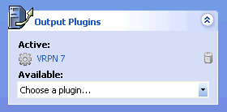

The Virtual-Reality Peripheral Network (VRPN) is the preferred method of connecting to your host application. The Ethernet-based network connection is versatile and offers lower latencies than serial communication, especially for large numbers of markers and high update rates. If your host application does not currently support a VRPN connection, adding this functionality is straightforward. Both VRPN6 and VRPN7 are supported.

By default, your PPT will output in VRPN7 format. You can easily change this configuration by selecting the desired output plugin as found in the Configuration Pane.

VRPN is a tool set that has been made available to the public domain by Russell M. Taylor II at the University of North Carolina at Chapel Hill. It is designed to implement a network-transparent interface between application programs and the set of physical devices (tracker, etc.) used in a virtual-reality (VR) system. The idea is to have a PC or other host at each VR station that controls the peripherals (tracker, button device, haptic device, analog inputs, sound, etc). VRPN provides connections between the application and all of the devices using the appropriate class-of-service for each type of device sharing this link.

For additional information on **VRPN**: http://www.cs.unc.edu/Research/vrpn/index.html

Shared memory

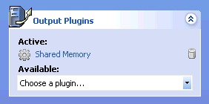

The Shared memory method can be used only for connecting to Vizard VR Toolkit render processes that are running on the same host as the PPT software. Multi-core PCs are suitable for running both a PPT system and Vizard-based 3D rendering.  (See [Using PPT with Vizard](file:///C:/Users/Daniel/AppData/Local/Temp/CHM%20Editor/ppt_42314.4058039352/Using_PPT_with_Vizard.htm).)

#### Serial

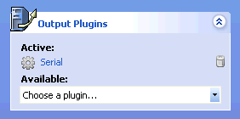

When necessary, you can connect to PPT using standard RS-232 serial communication. The method is robust but has slightly higher latency than the methods above. The serial method becomes especially unsuitable for tracking applications utilizing more than 8 markers. However, you may have older applications that require this functionality. Use the Output plug-in to select Serial, then by double-clicking the item you can continue to configure your serial options by entering the appropriate COM port.

Enter the COM port in the serial options window. The plugin supports any COM port that Windows is able to support.

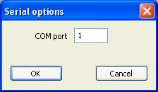

Motion Builder

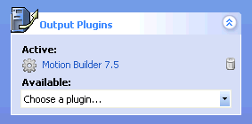

Use this for connecting to a separate computer running MotionBuilder 7.5 to drive full body inverse kinematics simulations. You will need to install the PPT MoCap plugin on your MotionBuilder system to support PPT in MotionBuilder. The installer can be [downloaded](http://www.worldviz.com/download?id=34) for free from the WorldViz website. More information about the work flow to use this plugin is available at [MoCap Plugin](file:///C:/Users/Daniel/AppData/Local/Temp/CHM%20Editor/ppt_42314.4058039352/PPT_MoCap.htm).

PPT Studio 2013 Documentation - Version 3.40 - Copyright © 2002-2013 WorldViz. All Rights Reserved.

[cid:009601d11877$0e0e7654$_CDOSYS2.0](http://www.worldviz.com/)

|  |
| --- |
| cid:00de01d11877$0e0e9d5d$_CDOSYS2.0 |

## 

## 

## Connecting to Vizard

If you are a new user to either Vizard or PPT, WorldViz recommends that you use the default PPT output setting (VRPN7) and either of the first two methods described below.

If you are connecting to a pre-existing PPT/Vizard installation, you should read the last section of this chapter about running PPT in legacy serial communication mode to maintain compatibility with your existing Vizard applications.

Connect to PPT directly

This section describes the basic building blocks for adding a PPT tracker, linking the tracker to 3D or view objects, accessing the raw data, resetting the origin, and applying scale factors and smoothing filters.

**Adding a PPT tracker**

Follow the example below, replacing hostname with the local name (or IP address) or you PPT computer. Returned is the tracker object that can subsequently be used in the samples below.

vrpn = viz.add('vrpn7.dle')   
tracker = vrpn.addTracker('PPT0@hostname')

**Linking the tracker**

Use the link command to connect a tracker object to node, viewpoint, and uniform objects. In this example, a PPT tracker is linked to myHandModel causing it to translate and rotate in correspondence to the PPT marker.

viz.link(tracker, myHandModel)

**Resetting the origin**

Using the link created above, it is easy to use the link's reset method to arbitrarily establish new translation origins. In this example, the PPT data stream is reset to the absolute origin (0,0,0).

link.reset(viz.RESET\_X|viz.RESET\_Y|viz.RESET\_Z)

For cases in which the PPT wireless marker's actual altitude should be retained and only the X and Z axes reset to zero, remove the viz.RESET\_Y flag from the example above.

**Accessing the raw data**

To access the raw data from the PPT marker (including orientation data if the marker is running in 6DOF mode), use the following technique.

data = tracker.getData()  # Access the raw data   
print data                # Print the array of data

**Applying Scale factors**

To apply a scale (gain) factor on your position data, use the link's postScale method to arbitrarily establish a non-identity scale along any of the three dimensions. In the example below, the X and Z dimensions are given a 2.0 scale factor while the Y (altitude) dimension is kept to the default of 1.0.

link.postScale([2,1,2],target=viz.LINK\_POS\_OP)

Connect to PPT using viztracker

This is the most convenient method if you do not need to perform transformations on the tracking data and just want to use the tracker within a 3D world. To help you get started with viztracker for PPT, you should install the latest Vizard release (at least 3.16). You should then write a file called vizsetupcfg.py with your tracker configuration (included below). The main advantage of using viztracker is it abstracts the tracking details so that changing your tracker configuration ideally has no impact on your Vizard applications.

In your application, the viztracker module is called to configure the display and trackers.

import viztracker

tracker = viztracker.go()

Here is an example vizsetupcfg.py that you can edit and then save to your desktop or to your local application directory:

# Setup option Input    --> Manufacturer: Keyboard    Type: Mouse LR / PageUpDn  
# Setup option Tracker  --> Manufacturer: WorldViz    Type: PPT w/Local Intersense  
# Setup option Display  --> Manufacturer: Generic     Type: Default Window  
# Setup option Avatar   --> Manufacturer: Generic     Type: No Avatar  
  
# This file must be loaded by the correct version of viztracker.py included with Vizard  
import viz  
viz.requireVersion("3.16.0010")  
  
# Source code that defines the composite. This is user editable but changes will be lost if this file is regenerated  
from vizuniverse import \*  
import \_\_main\_\_  
import hand  
  
# Create a custom composite that handles tracking, display, and input devices all together  
def createCustomComposite(id=0):  
    # ---- Trackers ----  
    # Initialize an empty composite object to store all the trackers  
    # The composite.storeTracker() method is used to combine the individual trackers for the user's body within the composite  
    composite = VUCompositeTrackers()  
    vrpn7 = viz.add('vrpn7.dle')  
    hostname = 'localhost'  
    headpos = vrpn7.addTracker('PPT0@'+hostname,0)  
    isense = viz.add('intersense.dle')  
    headori = isense.addTracker(port=0)  
    magneticzero = 0.0  
    if magneticzero == 0:  
        onkeydownspecial ('r', headori.reset) # Assign Alt-R to reset the magnetic offset  
    else:  
        output = viz.addGroup()  
        link = viz.link (headori, output, enabled=False)  
        vizact.onupdate(viz.PRIORITY\_PLUGINS+1, link.update)  
        link.postEuler ([-magneticzero, 0, 0]) # Apply fixed magnetic offset  
        headori = output  
    # Store all the tracker sensors we can find, it does not matter if some are not available  
    composite.storeTracker(composite.HEAD,  viz.mergeLinkable(headpos, headori))  
    composite.storeTracker(composite.LHAND, vrpn7.addTracker('PPT0@'+hostname,1))  
    composite.storeTracker(composite.RHAND, vrpn7.addTracker('PPT0@'+hostname,2))  
    composite.storeTracker(composite.LFOOT, vrpn7.addTracker('PPT0@'+hostname,3))  
    composite.storeTracker(composite.RFOOT, vrpn7.addTracker('PPT0@'+hostname,4))  
    composite.storeTracker(composite.HIP,   vrpn7.addTracker('PPT0@'+hostname,5))  
    # Make the orientation of the hands match that of the viewpoint (if selected)  
    copyHandOri = 1  
    if copyHandOri: composite.copyHandOriFromHead()  
      
    # ---- Display ----  
    pass  
      
    # ---- Input ----  
    composite.createLeftHand(hand.MultiInputSensor(pinchButtons=[viz.KEY\_PAGE\_UP,viz.MOUSEBUTTON\_LEFT], fistButtons=[viz.MOUSEBUTTON\_MIDDLE]))  
    composite.createRightHand(hand.MultiInputSensor(pinchButtons=[viz.KEY\_PAGE\_DOWN,viz.MOUSEBUTTON\_RIGHT], fistButtons=[viz.MOUSEBUTTON\_MIDDLE]))  
      
    # ---- Avatar ----  
    composite.createAvatarNone()  
      
    # ---- Finalize Composite ----  
    composite.finishTrackers()  
    composite.defineViewpoint(offset=[0,0,0]) # Can adjust the position of the viewpoint if needed  
      
    # ---- Extra Adjustments Editable By The User ----  
      
    # Note that the examples below will not work with LiveCharacters, only inputs with individual trackers  
    # composite.getRawTracker(composite.HEAD).getLink().postEuler([0,0,45])    # Apply 45 degree offset to the head tracker  
    # composite.getLeftHand().setScale([2,2,2])                           # Apply scale to the left hand representation  
    # composite.getLeftHand().alpha(0.0)                                  # Make the left hand invisible  
    # composite.getRawTracker(composite.LHAND).getLink().postTrans([0,-0.5,0]) # Lower the hand tracker 50 cm  
    # composite.setPosScale([2,1,2])                                      # Scale XZ position of all trackers by a factor of 2x  
    # composite.setOriScale([0,0,0])                                      # Suppress all orientation changes for all trackers  
      
    # The following examples are compatible with all kinds of composite objects, including LiveCharacters  
    # composite.getMovableNode().setPosition([1.0,0.0,0.0])               # Move the user and all trackers +1 unit along the X axis  
      
    # ---- Return Back Result ----  
    return composite  
  
  
# If this script is run directly, then we should allow it to work for testing purposes (normally viztracker.py loads this file in, and this file is not used standalone)  
if \_\_name\_\_ == "\_\_main\_\_":  
    print 'Manually overriding viztracker to test vizsetupcfg configuration'  
    import viztracker  
    viztracker.createCustomComposite = createCustomComposite  
    viztracker.go()  
    viz.add('gallery.ive')

Connect to PPT using shared memory or legacy serial communication

NOTE: These techniques are discussed for the purposes of backward compatibility with older configurations. If you are not supporting an existing Vizard code base written for earlier versions of PPT (prior to version 3), then WorldViz highly recommends that you use either of the first two VRPN methods described in detail above. If your PPT and Vizard are running on the same machine, you may consider using this section to reduce latency using the shared memory plugin.

**Adding a PPT tracker**

The COM port specified by PORT\_PPT is the serial port that PPT is connected to. If left 0 or undefined, PPT will try to use the shared memory interface and then scan ports 1-4 for a device. The following shows how to connect to a PPT device on COM1.

PORT\_PPT = 1  
tracker = viz.add('vizppt.dls')

**Linking the tracker**

Use the link command to connect a tracker object to node, viewpoint, and uniform objects. In this example, a PPT tracker is linked to myHandModel causing it to translate in correspondence to the PPT marker.

viz.link(tracker, myHandModel)

**Resetting the origin**

Using the link created above, it is easy to use the link's reset method to arbitrarily establish new translation origins. In this example, the PPT data stream is reset to the absolute origin (0,0,0).

link.reset(viz.RESET\_X|viz.RESET\_Y|viz.RESET\_Z)

For cases in which the PPT wireless marker's actual altitude should be retained and only the X and Z axes reset to zero, remove the viz.RESET\_Y flag from the example above.

**Accessing the raw data**

To access the raw data from the PPT marker (including orientation data if the marker is running in 6DOF mode), use the following technique.

data = tracker.get()  # Access the raw data   
print data            # Print the array of data

**Applying Scale factors**

To apply a scale (gain) factor on your position data, use the tracker's scale method to arbitrarily establish a non-identity scale along any of the three dimensions. In the example below, the X and Z dimensions are given a 2.0 scale factor while the Y (altitude) dimension is kept to the default of 1.0.

tracker.scale(2,1,2)

**Applying smoothing filters**

For situations in which you need to smooth your tracking data, the tracker's built-in smooth method can be used. In the sample below, a mean filter is applied that generates a running average across 4 samples.

ppt.smooth(4) #Smooth data over 4 samples

PPT Studio 2013 Documentation - Version 3.40 - Copyright © 2002-2013 WorldViz. All Rights Reserved.

[cid:009601d11877$0e0e7654$_CDOSYS2.0](http://www.worldviz.com/)

## Connecting to 3rd party software

The recommended method of communicating with PPT is using the built-in VRPN 7 server, which is included as an output plugin by default.

Of all PPT output methods, VRPN 7 is preferred since it provides the lowest latencies and highest bandwidth compared to all other available methods.

#### Interfacing with Vizard

If you are writing Vizard applications, then there is a separate page describing how to use [PPT with Vizard](file:///C:/Users/Daniel/AppData/Local/Temp/CHM%20Editor/ppt_42314.4058039352/Using_PPT_with_Vizard.htm).

#### Other Applications With VRPN Support

If your 3rd party application includes support for VRPN, then you should be able to use this, since PPT provides a VRPN 6 and VRPN 7 output server as plugins. VRPN is portable across many platforms, including Windows and Linux. Make sure the correct server is enabled for your 3rd party application, and that Talk mode is enabled in the PPT user interface.

#### Other Applications With MechDyne / VRCO TrackD Support

PPT includes a plugin for use with the MechDyne TrackD software. The plugins are ppt-trackd.dll and pptwand-trackd.dll, and are located in C:\Program Files\WorldViz\PPTStudio34.

1. Copy ppt-trackd.dll and pptwand-trackd.dll from C:\Program Files\WorldViz\PPTStudio34, and put it into your trackd\bin directory (which may reside on a different machine).
2. In the trackd configuration file, include the following lines for a standard PPT tracking system:  
   DefineDevice ppt ppt-trackd  
   DeviceOption ppt address 127.0.0.1
3. If you have a PPT wand connected, then you will need to add the following extra lines:  
   # Define PPT Wand (can optionally specify number of wands, defaults to 1)  
   DefineDevice pptwand pptwand-trackd  
   # Specify PPT Wand address (Device ID , PPT hostname/IP address, PPT Wand light number)  
   DeviceOption pptwand address 1 127.0.0.1 1
4. The above is written assuming trackd is installed on the PPT machine. If TrackD is running elsewhere, then 127.0.0.1 should be replaced with the IP address of the PPT machine.
5. Make sure Talk mode is enabled within the PPT user interface.
6. Start up TrackD using the configuration file just written and test the output.

#### Other Applications Not Supported

If your 3rd part application does not already support VRPN, WorldViz recommends that you use the freely available VRPN API to write your own client-side connection for this protocol.

#### Legacy Serial API

PPT has also implemented an RS-232 based serial API for a number of years, and this is also supported as an output plugin. However, this interface is deprecated since it cannot support the large number of markers and high update rates of PPT-E and PPT-H systems. The source code for this interface is available from the PPT Studio installer, and is located in C:\Program Files\WorldViz\PPTStudio34\Serial API.

Note however that if you are writing a new interface for your application from scratch, the serial interface is not recommended and you should implement a VRPN 7 client instead.

PPT Studio 2013 Documentation - Version 3.40 - Copyright © 2002-2013 WorldViz. All Rights Reserved.

[cid:009601d11877$0e0e7654$_CDOSYS2.0](http://www.worldviz.com/)

## Using your 3D view

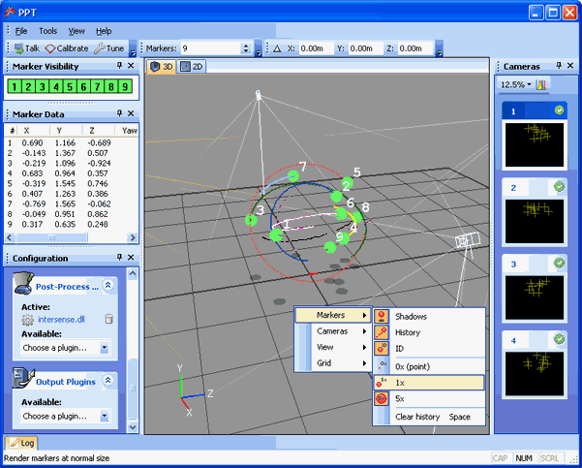

3D

Inspect your data in real-time and configure the view as you like by right-clicking to bring up a menu of options for controlling the Markers, Cameras, Views, and Grid settings.  The talk button is always active when 3D view is selected.

Dragging with the right and left mouse button within the 3D view rotates and pans. Scrolling with a mouse wheel zooms the 3D view.

#### Number of markers

cid:00e001d11877$0e0e9d5d$_CDOSYS2.0

Specify the maximum number of markers that PPT will try and track in your environment.

#### Marker visibility

cid:00e101d11877$0e0e9d5d$_CDOSYS2.0

This view shows each of the markers and their visibility in the environment. Markers failing to compute a 3D fix will display as red instead of green. If a marker value is not visible it means that a plugin has hidden this marker. See the plugin documentation for more information about why this would happen.

#### Marker data

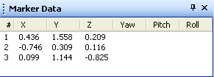

This view shows the raw position and orientation value for each marker. A standard PPT wireless marker will only show up with position information, but with the addition of a post-processing plugin, markers can also contain orientation information as well. The units shown here are in meters for position, and Euler angle degrees for rotation.

PPT Studio 2013 Documentation - Version 3.40 - Copyright © 2002-2013 WorldViz. All Rights Reserved.

[cid:009601d11877$0e0e7654$_CDOSYS2.0](http://www.worldviz.com/)

## Orientation and position plugins

PPT can deliver position and orientation data to your host application through Post-Process plugins. These plugins use combinations of magnetic/inertial orientation sensors and/or groups of PPT markers.

You can use the [Local Offset](file:///C:/Users/Daniel/AppData/Local/Temp/CHM%20Editor/ppt_42314.4058039352/Applying_position_offsets.htm) plugin to have PPT report a locally offset position when using PPT's orientation and position plugins.  HMD users can use the Local Offset plugin to have PPT report the location of the user's eyes rather than the PPT marker's position which may be a considerable distance away. The Local Offset plugin removes the false movement artifact when a HMD user pitches their head forward and thus moves the marker.

#### Filter - Smooth out position and orientation values

**Use When:**

* You have jitter in position or orientation values that you would like to smooth
* You are tracking complex objects that are being occluded and would like to fill in the gaps with interpolated data

**You Need:**

1. Any number of markers with position and/or orientation data

**Software Configuration:**

1. Add the "Filter" post process plugin in the Configure Panel.
2. Click the configure button on the Filter plugin, which will show a list of all filters currently in place. Right click here and select Add to create a new filter.
3. Specify the light (marker number) that you would like to apply smoothing to
4. The filtering in this plugin takes the previous value and combines it with the current value according to the rate percentage. A value of 10% indicates that the output will be 10% of the new value, and 90% of the previous value. A value of 100% indicates there should be no filtering. You can use 100% to disable filtering when you want to filter only one component.
5. The cutoff value is the maximum distance a change can be before the filtering is disabled. With an orientation cutoff of 45 degrees, if the sensor moves 60 degrees then the filter will be disabled and an immediate jump will take place. The cutoff helps to remove large smoothing delays during initialization and very fast motions.
6. This filter does not provide default values, you must enter something for each value.
7. Click Ok and the filter will be applied immediately within PPT.
8. If you right-click on a filter, you can edit or remove it if necessary.

**Data Output:**

* Each marker is affected by its own filter, and position and orientation filtering can be specified independently.
* The algorithm for the filter is ((rate x current) + ((1-rate) x previous)).

#### Intersense - Intersense and Optical Marker Hybrid Tracking

**Use When:**

* You want to augment a marker's position data with an Intersense InertiaCube orientation device.
* You want to avoid the jitter and dropout issues of fully optical position and orientation tracking.

**You Need:**

1. An Intersense InertiaCube 2 or 3 connected to the PPT computer.
2. The COM port number the Intersense is connected to.  To check what COM ports your computer has: right-click "My Computer", select Manage, select Device Manager, select Ports.

**Software Configuration:**

1. Add the Intersense Post-Process Plug-in found in the Configure Pane.
2. Right-click in the white area to Add a new Intersense device.
3. Enter the Intersense COM port number, and also the PPT wireless marker number you would like to assign it to.
4. If the Intersense device is successfully found, you should see orientation information being displayed from the device.

**Magnetic Calibration:**

In most situations, magnetic north for the cube will differ from the PPT north, which is the +Z axis on the calibration rig. Also, you may have the cube mounted in an orientation where it has some pitch and roll component. You can compensate for this using the PPT reset function built into the Intersense plugin.

1. Right click on the Intersense device you would like to calibrate, and select the Reset feature
2. A calibration Wizard will appear, and you will be asked to align your device so the InertiaCube is facing toward PPT north. It is important that the InertiaCube is level and stable, it does not matter what the orientation is of any other equipment connected to it.
3. At this point, you can click the Finish button in the wizard. This will just capture the heading offset of the InertiaCube, and will calibrate only the offset between magnetic and PPT north. Any pitch and roll will not be taken into consideration. Many users with a cube mounted level on a head mounted display can use this option.
4. If your InertiaCube is mounted with a pitch and roll offset as well, you will need to press the Next button on the Wizard. You should now rotate your device (such as a head mounted display, or input wand) is facing in the direction of PPT north, with no pitch or roll. It does not matter what direction the InertiaCube is pointing. Click the Finish button to complete the process.

**Data Output:**

* The marker associated with the plugin will have valid orientation and position information.

#### Optical heading - Hybrid Intersense and Optical

**Use When:**

* You have one or more orientation sensor that does not provide accurate yaw data. The Intersense InertiaCube provides distorted yaw data when there is magnetic interference. If you disable the magnetic sensor, then the InertiaCube will drift in yaw over time. This plugin compensates for distortions caused by interference or drift.

**You Need:**

1. An orientation sensor, like the Intersense InertiaCube 2 or 3.
2. Two PPT markers rigidly mounted on the left and right sides of the tracked object.
3. Optionally you may have other orientation sensors that will be calibrated using the calculations from the first sensor, but these extra sensors must be affected by similar distortions to be effectively corrected.

**Software Configuration:**

1. Use the InterSense ISDEMO software to perform a magnetic calibration of your InertiaCube, it may be that your distortions can be calibrated by the hardware itself. You can also disable the magnetic sensor using ISDEMO if you think the magnetic distortions are too high. Make sure you save the settings to the InertiaCube so that they will be kept when the power is turned off.
2. Set the number of markers to at least 2 in the PPT interface.
3. Setup the orientation sensor to provide data to marker 1.  If using an Intersense InertiaCube, do this with the Intersense plugin described above. Make sure you calibrate the sensor as best as you can to deal with any pitch and roll offsets, although yaw offsets do not matter.
4. Add the "Optical heading" post process plugin in the Configure Panel.
5. Click the configure button on the Optical Heading plugin and enter the distance between the markers mounted on the left and right sides of the tracked object.
6. Leave the separation tolerance at the default, but if there are problems with tracking you may want to make this larger. This value specifies how flexible it should be when looking for the two markers to track from the set available.
7. The change rate field is a percentage that controls how much of the new distortion correction should be added to the current correction. This helps to smooth out optical jitter and transitions during occlusion, but does not affect tracking latency.
8. There is a check box "Correct first or all orientations" which if you select it, all orientation values within PPT will be corrected using the calculated distortion correction. This is useful if you have a person wearing two lights and an InertiaCube on the head, plus more InertiaCubes on the hands and feet. If you uncheck this box then only the orientation for marker one will be affected.

**Data Output:**

* The first marker will be a combination of the orientation data and the position which is the center of the two selected markers.
* The previous two input positions will be removed from the output, so there will be one less marker.
* If position data not part of the two marker constellation was present as marker 1, it will be remapped to one of the markers from the constellation to preserve it.
* If the apply to all checkbox is selected, all orientation values will be adjusted with the distortion correction.

#### Optical heading MarkerID - Hybrid Intersense and Optical

Similar to Optical heading plugin except that instead of providing the value for the 2 light separation, the LEFT and RIGHT marker IDs are needed to be specified in the dialog box. The current plugin supports upto 2 pair of optical heading devices. To use this plugin, make sure markerID plugin is also chosen and configured in the active list of the post-process plugin.

#### PPT Eyes - Optical 2-point for CAVEs

**Use When:**

* You need to track a user's head position and yaw orientation in front of a screen, like for a Powerwall/CAVE display.
* You want to track the user's head optically without a inertial sensor.
* You do not need head pitch tracking - a Powerwall does not need pitch information.

**You Need:**

1. Two PPT markers attached on the left and right sides of the head or LCD shutter glasses.

**Software Configuration:**

1. Set the number of markers to at least 2 in the PPT interface.
2. Add the "CAVEyes" Post-Process Plug-in found in the Configure Panel.
3. Click the configure button on the plugin and enter the distance between the markers mounted on the left and right sides of the tracked object.
4. Leave the separation tolerance at the default, but if there are problems with tracking you may want to make this larger. This value specifies how flexible it should be when looking for the two markers on the head.

**Data Output:**

* The first marker will contain a combined position value which is the center of the two selected markers, with calculated yaw and roll for orientation.
* The previous two input positions will be removed from the output, so there will be one less marker.
* If position data not part of the two marker constellation was present as marker 1, it will be remapped to one of the markers from the constellation to preserve it.

#### Rigid body - Optical Tracking of a Rigid Body

**Use When:**

* You want to extract position and orientation data optically from a constellation of PPT markers.
* You can accept small rotation oscillations (jitter) if tracking is poor.
* You can accept a temporary break in valid position data if a marker in the constellation is obscured.

**You Need:**

1. Minimum of three PPT markers attached to the tracked object.
2. The markers must be attached as a rigid body, so a marker cannot move relative to the other markers.
3. Make the markers easy for the cameras to see.  Obscuring one marker will stop tracking until the marker is reacquired.
4. Maintain 4 inches (10 centimeters) or more of separation between the markers.
5. Try to avoid putting all the LEDs on a flat plane, they should be at varying heights and distances from the mounting.

**Software Configuration:**

1. Select the correct number of markers for the rigid body in the main PPT interface (must greater than 2).
2. Add the Rigid body Post-Process plug-in found in the Configure Panel.
3. Place the rigid body on the ground so that it is completely steady. Orient the rigid body so that its forward direction is facing in PPT's +Z direction.
4. Verify that all lights are being tracked and are stable.
5. Press the Acquire Geometry button.
6. The plugin will capture 100 samples and it will indicate to you when the capture was successfully completed. The geometry will be saved to the standard PPT configuration file.
7. Once the acquiring geometry is done, you can increase the number of markers to track additional markers beside the rigid body.

**Data Output:**

* PPT sends one object with valid position and orientation data, the other markers will be hidden from view.
* The position will be the center of mass of the constellation.

#### VRPN Input - Orientation Data From External Vizard System

**Use When:**

* You need orientation information from a head-tracked user within PPT, for use with the [Mocap](file:///C:/Users/Daniel/AppData/Local/Temp/CHM%20Editor/ppt_42314.4058039352/PPT_MoCap.htm) plugin.
* You need to connect an orientation device directly to the rendering PC to ensure the lowest latency tracking.
* You are using Vizard or some other rendering software which supports exporting VRPN data

**You Need:**

1. An Intersense or Xsens sensor connected to the rendering computer.
2. A rendering computer capable of exporting VRPN data, most viztracker-based demos from WorldViz support this.

**Software Configuration:**

1. Add the VRPN Input Post-Process Plug-in found in the Configure Pane.
2. Right-click in the white area to Add a new input device.
3. Enter the path for the VRPN server on the rendering PC, which will be of the format Comp0@*hostname* (Replace *hostname* with your rendering computer IP address or name).
4. For the sensor number, the value is probably 0 for the first sensor, so enter that.
5. Make sure that you calibrate for magnetic north in your rendering software, so that the VRPN orientation values emitted are in the coordinate space of the rest of the simulation.

**Data Output:**

* The current position information is combined with orientation data from the VRPN server, and combined into 6DOF data for use within PPT.

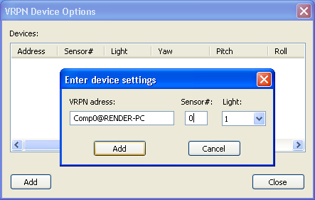

PPT Studio 2013 Documentation - Version 3.40 - Copyright © 2002-2013 WorldViz. All Rights Reserved.

[cid:009601d11877$0e0e7654$_CDOSYS2.0](http://www.worldviz.com/)

## Local offsets

Often it is impossible to locate the PPT wireless marker at the optimal location for tracker. For head tracking with head-mounted displays, the ideal marker location is at the center of the user's eyes. However, to maximize marker visibility, most user's mount the marker on the top of the head-mounted display. This causes the user's virtual view to incorrectly move forward when they pitch their head down.

Since the local offset between the marker and eye is typically fixed, the PPT system can make this correction in absolute global coordinates for you if your are running your PPT with [orientation and position tracking](file:///C:/Users/Daniel/AppData/Local/Temp/CHM%20Editor/ppt_42314.4058039352/Orientation_and_position_plugins.htm). Note that the Local offset plugin has the option of using orientation data. If the orientation data are not used, the position of the selected marker will always have the offset in the specified direction.

**To apply a local offset:**

1. Measure the offset in millimeters of the location of the PPT wireless marker IR-LED relative to the desired report location (generally the location of the user's eyes in a HMD). Make these measurements in local coordinates in which right is +X, up is +Y, and forward is +Z.
2. In the Configuration Pane, add a "Local offset" Post-process Plug-in if it is not already added.
3. Click the Configure button, right click and select Add, and enter your offset values in millimeters.
4. In the Configuration Pane, make sure a plugin supplying orientation information is active before the Local offset plugin. You can drag the plugins to change their order if necessary.
5. You can remove or edit an existing local offset by right clicking on the offset and selecting the desired option.

**Examples:**

1. If your marker is mounted on a 30 cm vertical pole above the eyes on a HMD, the offset to apply would be specified as X=0, Y=300, Z=0.
2. If your marker is mounted in front of the HMD, and there is 100 mm to the eyes, the offset to apply would be specified as X=0, Y=0, Z=100.
3. If your marker is mounted so that it is 10 cm above the eyes, 2 cm to the left of the center of the HMD, and 5 cm behind the eyes (the marker is above the user's head) then the offset to apply would be specified as X=-20, Y=100, Z=-50.

PPT Studio 2013 Documentation - Version 3.40 - Copyright © 2002-2013 WorldViz. All Rights Reserved.

[cid:009601d11877$0e0e7654$_CDOSYS2.0](http://www.worldviz.com/)

## Logging data

**Use When:**

* You want to record the marker dataLogging data from PPT into a text file.

**Software Configuration:**

1. Add the Log data Post-Process Plugin found in the Configure Pane.
2. Press the Log data plugin configuration button.
3. Configure the data options and press Start Logging.

**Data Output:**

* When logging is complete, the log file will be written to the log directory of the PPT installation which by default is in C:\Program Files\WorldViz\PPTStudio34\log.

PPT Studio 2013 Documentation - Version 3.40 - Copyright © 2002-2013 WorldViz. All Rights Reserved.

[cid:009601d11877$0e0e7654$_CDOSYS2.0](http://www.worldviz.com/)

## Marker Identification

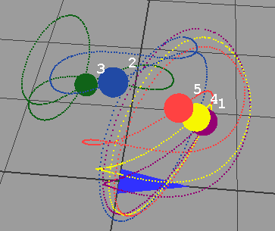A traditional PPT system does not provide absolute marker identification for 3DOF position markers. The markers are passive devices that do not contain any identification information of their own. In practice, however, PPT does an excellent job at maintaining marker identification coherence so often you can rely on the identities not to change during period of continuous capture. A scenario where marker coherence can fail is when two markers are brought together so they are touching, and then moved away again.

Keeping the identification of each marker coherent is important in some applications, particularly motion capture, where an incorrect identification can cause confusing output.

#### Mocap Plugin

PPT includes a Mocap plugin that can be used with traditional markers to robustly identify markers attached to the head, hands, and feet, which is suitable for motion capture applications. The Mocap plugin uses heuristics and knowledge of the geometry of a user's body to assist with this identification. Each body part is assigned to a fixed marker id, and so your client application will receive the markers in a constant order. If PPT gets temporarily confused about the marker ordering, it will correct this automatically once it discovers the correct marker arrangement. For more information about how to use this plugin in a motion capture scenario, please read the extensive [PPT Mocap](file:///C:/Users/Daniel/AppData/Local/Temp/CHM%20Editor/ppt_42314.4058039352/PPT_MoCap.htm) section.

#### cid:00e501d11877$0e0e9d5d$_CDOSYS2.0

#### Marker ID Plugin - Resolve marker ids using blinking markers

PPT also supports an optional new feature known as Marker ID, which uses new markers that blink out codes that support identification within the PPT software. These markers are sold as an add-on for PPT systems. The Marker ID plugin is automatic, and requires no knowledge about the layout of the markers on the user. If the markers are arranged correctly, Marker ID can also be used as part of a motion capture system. For more information about implementing motion capture, please read the [PPT Mocap](file:///C:/Users/Daniel/AppData/Local/Temp/CHM%20Editor/ppt_42314.4058039352/PPT_MoCap.htm) section.

**Use When:**

* You need to resolve the id of a marker with no user intervention, such as in motion capture

**You Need:**

1. One or more MarkerID-capable blinking markers, which are sold separately.
2. Each blinking marker must be configured for PPT-X or PPT-H/PPT-E, and have a unique identification number.
3. Do not use traditional non-blinking markers with this plugin, the ids will not be assigned correctly.

**Data Output:**

* The plugin will re-number and re-order all the markers so that they match the id programmed into the markers.

**Automatic Mode Configuration (shown in image below on the left):**

1. Set the number of markers to the number of markers that you have available in the PPT interface.
2. Make sure that Talk Mode is enabled in the PPT interface. The plugin will not work if Talk Mode is off.
3. Add the "MarkerID" Post-Process Plug-in found in the Configure Panel.
4. Click the configure button on the plugin, which will show a window similar to that shown on the left in the figure below.
5. Click the checkbox for "Automatically search inventory".
6. You must place all of the markers at a location in the room where they are all visible and trackable by PPT.
7. PPT will search for the markers, and then once all are visible, the marker ids will be assigned and used for tracking.

**Manual Mode Configuration (shown in image below on the right):**

1. There is no need to set the number of markers in the PPT interface, the plugin will adjust this automatically.
2. Make sure that Talk Mode is enabled in the PPT interface. The plugin will not work if Talk Mode is off.
3. Add the "MarkerID" Post-Process Plug-in found in the Configure Panel.
4. Click the configure button on the plugin, which will show a window similar to that shown on the right in the figure below.
5. Uncheck the box for "Automatically search inventory", the plugin will run in manual mode now.
6. Select the check boxes for the physical marker ids you would like to have present in the environment.
7. You can remap markers to other id numbers if necessary by selecting a different virtual id number if desired. This feature is useful if you have replaced a physical marker with a new one that has a different id, but your application requires the same id numbering.
8. The markers will be used by the plugin with no further intervention by the user.

Automatic mode requires all markers to be visible whenever PPT is started, so that the marker ids can be detected and recorded. It is recommended that you use manual mode in typical operation so you can skip the acquisition step that is needed in automatic mode. Manual mode is the easiest mode to use for a more permanent installation.

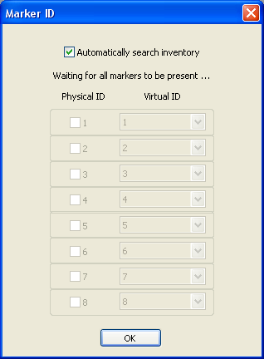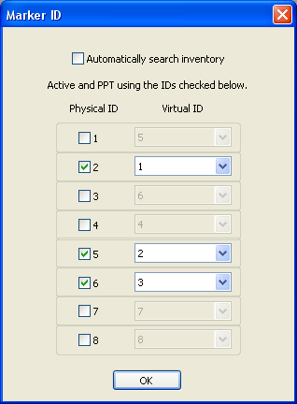

#### Marker ID 32 Plugin - Resolve marker ids using blinking markers

Similar to MarkerID plugin, Marker ID 32 plugin uses the different encoding scheme which supports up to 32 different IDs (ID1 to ID32). Therefore, it is incompatible with the marker IDs that will work with Marker ID plugin.

cid:00e801d11877$0e0e9d5d$_CDOSYS2.0

PPT Studio 2013 Documentation - Version 3.40 - Copyright © 2002-2013 WorldViz. All Rights Reserved.

[cid:009601d11877$0e0e7654$_CDOSYS2.0](http://www.worldviz.com/)

## Debugging plugins

PPT can produce a wide range of debugging output to help diagnose various problems that you might encounter while using the software. Debugging is implemented using a series of Post-Process plugins outlined here.

Camera visualization - View 3D tracking region quality

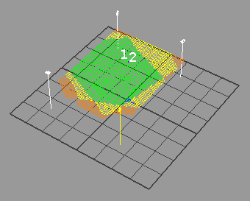**Use When:**

* You want to find out how many cameras can see a particular point in your tracking space.

**Software Configuration:**

1. Add the Camera visualization Post-Process Plug-in found in the Configure Pane.
2. The plugin will start up with suitable defaults and show you a colored visualization of the tracking space

**Options:**

1. Click on the Camera visualization plugin name to specify configuration options for the plugin.
2. By varying the slider bars, you can alter the plane used to render the tracking quality information.
3. By adjusting the delta values, you can adjust the density of the calculated space. Use larger values for very large spaces that are slow to calculate.

**Data Output:**

* The plugin uses differing colors to indicate the quality of the tracking space. Red indicates 2 cameras can see the location, orange indicates 3 cameras, while green indicates 4 or more cameras. You should aim to have green for as much of your space as possible.

Ray visualization - View 2D intersections from each camera

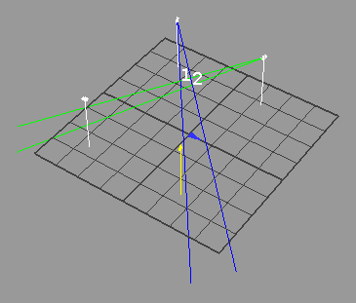**Use When:**

* You want to find out which 2D camera points correspond to 3D tracked markers.

**Software Configuration:**

1. Add the Ray visualization Post-Process Plug-in found in the Configure Pane.
2. The plugin will start up and show rays originating from the currently selected camera.
3. Click repeatedly on other cameras to turn on and off the rays intersecting each visible marker.

**Options:**

1. This plugin has no configurable options.

**Data Output:**

* The output of the plugin shows rays originating from the camera and intersecting 3D points in space.

Timing report - Measure PPT processing time

**Use When:**

* You want to find out how much time each plugin stage is taking to run

**Software Configuration:**

1. Add the Timing report Post-Process Plug-in found in the Configure Pane.
2. The plugin will start up and a window with bar graphs and timing for each plugin stage.

**Options:**

1. This plugin has no configurable options.

**Data Output:**

* A dockable window will appear containing bar graphs and timing for each plugin stage.

PPT Studio 2013 Documentation - Version 3.40 - Copyright © 2002-2013 WorldViz. All Rights Reserved.

[cid:009601d11877$0e0e7654$_CDOSYS2.0](http://www.worldviz.com/)

# Live Characters Installation

If you want to real-time animate character(s) in Vizard™ using MotionBuilder™ or export character animations for Vizard™, the "Live Characters" package needs to be installed. Make sure MotionBuilder™ is already installed. To install the "Live Characters" package do the following:

Execute the installer called "LiveCharacters\_2.00.0000.exe" or similar. Accept the "Open File - Security Warning" by clicking the "Run" button, in case it appears. The Live Characters Wizard comes up:

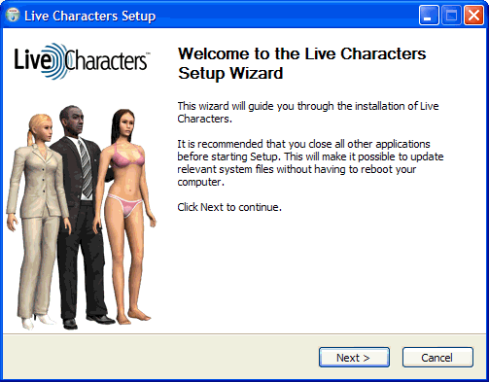

**Figure 1:** Live Characters Wizard

By clicking "Next" and accepting the License Agreement with the button "I Agree", you have the possibility to choose the components to be installed:

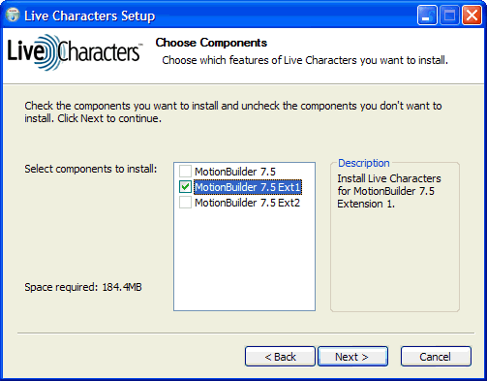

**Figure 2:** Live Characters Components

By default all versions of MotionBuilder™ are checked that have been found on your computer, to install Live Characters for each version. Keep at least one version of MotionBuilder™ checked and click "Next" to proceed.

In the last step before the installation process, you can choose the folder in which to install Live Characters. It is recommended to install to the default folder as this manual assumes the default. Click "Install" to finally install Live Characters and select "Finish" after the installation to close the wizard.

Try to locate the "Live Characters" plug-in. This plug-in can be found in the "Asset Browser". Expand the "Templates" asset by clicking on the "+" and select the "Devices" asset. The "Live Characters" plug-in is now listed in this directory (figure 1 red arrow). The plug-in can only be seen if MotionBuilder™ got restarted after the installation.

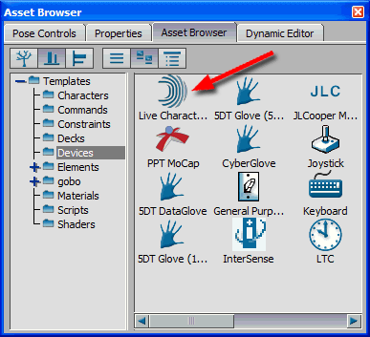

**Figure 3:** Live Characters plug-in

If the plug-in can be seen in the "Asset Browser" the installation process of Live Characters was successful.

PPT Studio 2013 Documentation - Version 3.40 - Copyright © 2002-2013 WorldViz. All Rights Reserved.

[cid:009601d11877$0e0e7654$_CDOSYS2.0](http://www.worldviz.com/)

# PPT MoCap

While PPT does not provide absolute marker identification, the included "MoCap" plugin provides a robust means to track and provide absolute identification of a subject's head, hands, and feet. Your client application receives the head/hands/feet positions in a constant order, and even if PPT gets confused about the marker ordering the plugin will attempt to correct for this automatically.

**NOTE:** Make sure your system is calibrated and tuned, with all the markers being tracked, before attempting to use this plugin.

Run PPT and adjust the marker to the amount of real markers you are tracking with PPT (Figure 1).

cid:00ee01d11877$0e0e9d5d$_CDOSYS2.0

**Figure 1:** Marker count

Add the "Intersense" post-process plugin and afterwards "MoCap" post-process plugin found in the Configuration Pane (Figure 2). It is important to add the plug-ins in this order. You can also use the "VRPN Input" plugin if you wish to keep the orientation sensor connected to your rendering PC to minimize latency. Some kind of orientation direction for the head is required for the MoCap plugin however.

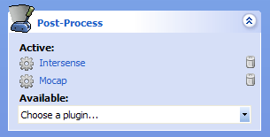

**Figure 2:** Post-Process Plugins

Click on the "Intersense" plugin to bring the Intersense options window up. Click the "Add" button, enter the COM port number your IC2 / IC3 is connected to and select the PPT wireless marker number (1 - head, 2 - left hand, 3 - right hand, 4 - left foot, 5 - right foot, 6 - hips) to be attached with the Intersense (Figure 3). Right-click the added device, select "Reset" and follow the instructions for aligning the Intersense's coordinate system with PPT's coordinate system. If you use additional IC2s / IC3s for your hips, hands, or feet, click the "Add" button again and repeat above steps.

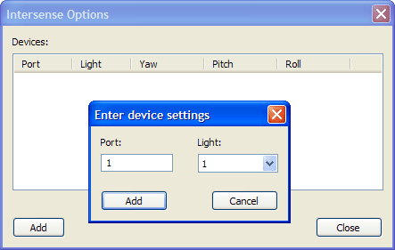

**Figure 3:** Add IC2 / IC3 and attach it with a marker

The alternative method for orientation is to use the "VRPN Input" plugin, click on the plugin name to bring the options window up. Click the "Add" button, enter the address of the VRPN server to connect to, the sensor id (which is typically 0) and the light to assign it to (see above instructions).



**Figure 4:** Add VRPN input source and attach it with a marker

Add the "Motion Builder 7.5" Output Plugin found in the Configure Pane (Figure 5) for connecting to the computer running MotionBuilder (only required for the MotionBuilder work flow).

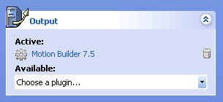

**Figure 5:** Output Plugins

Press the "Talk" button to turn the connection on (Figure 6).

cid:00f201d11877$0e0e9d5d$_CDOSYS2.0

**Figure 6:** Talk button

Click on the "MoCap" plugin (Figure 2) to show the MoCap Plugin configuration window (Figure 7). The first step is to adjust the markers in the "[Markers Tab](file:///C:/Users/Daniel/AppData/Local/Temp/CHM%20Editor/ppt_42314.4058039352/PPT_MoCap_Markers_Tab.htm)". After adjusting the markers the "[Initialize Wizard](file:///C:/Users/Daniel/AppData/Local/Temp/CHM%20Editor/ppt_42314.4058039352/PPT_MoCap_Initialize_Wizard.htm)" needs to be performed.

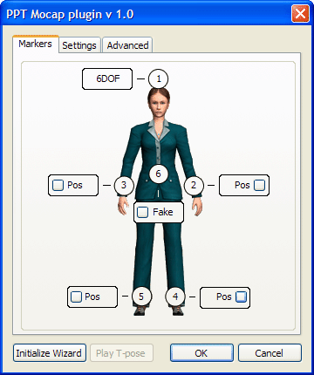

**Figure 7:** MoCap Plugin configuration window

Optional adjustments:

The "[Settings Tab](file:///C:/Users/Daniel/AppData/Local/Temp/CHM%20Editor/ppt_42314.4058039352/PPT_MoCap_Settings_Tab.htm)" lets you choose model presets and the orientation source.

The "[Advanced Tab](file:///C:/Users/Daniel/AppData/Local/Temp/CHM%20Editor/ppt_42314.4058039352/PPT_MoCap_Advanced_Tab.htm)" is only recommended for advanced users or if you use the "Fake" hips mode without arms.

PPT Studio 2013 Documentation - Version 3.40 - Copyright © 2002-2013 WorldViz. All Rights Reserved.

[cid:009601d11877$0e0e7654$_CDOSYS2.0](http://www.worldviz.com/)

# PPT MoCap - Markers Tab

The "**Markers**"tab is selected by default. The following modes exist:

* Pos: Only one marker is attached to this body part
* 6DOF: One marker and an InertiaCube are attached to this body part
* Fake: The hip marker is simulated at hip height and moves with the body, no marker and no InertiaCube are attached to this body part
* Fixed: The hip marker is simulated at hip height and is fixed above the origin, no marker and no InertiaCube are attached to this body part
* None: No data is generated for this body part, and the marker number will be grayed out, given that this marker does not exist

The MoCap plugin needs head position and orientation. Therefore the head is defined as "6DOF". Adjust the markers for hips, hands, and feet to use the mode that is consistent with the physical setup. The hips can be set to "Pos", "6DOF", "Fake", "Fixed", or "None" (Figure 1 blue arrow). The hands can individually be set to "Pos", "6DOF", or "None" (Figure 1 red arrows). The feet modes are linked together and can be set to "Pos", "6DOF", or "None" (Figure 1 green arrows). The adjustment can be done with either of the foot buttons.

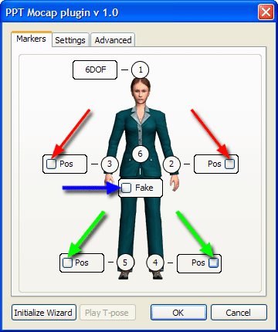

**Figure 1:** MoCap Plugin configuration window - Markers

When done, make sure all markers are positioned correctly. The head marker's LED needs to be placed in the center above the head (Figure 2 image on the left). The hand markers should be positioned right behind the wrists (Figure 2 image in the middle). The foot markers should be placed above the ankle (Figure 2 image on the right). When done turn all markers on.

**NOTE:** Make sure the LEDs of the foot markers have approximately the same distance from the floor and the hand markers approximately the same distance from the wrists; otherwise you will have trouble capturing the T-pose later on.

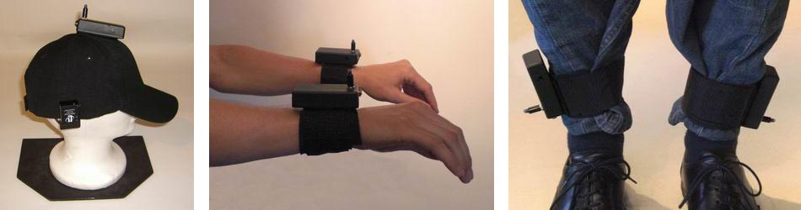

**Figure 2:** Marker placement

PPT Studio 2013 Documentation - Version 3.40 - Copyright © 2002-2013 WorldViz. All Rights Reserved.

[cid:009601d11877$0e0e7654$_CDOSYS2.0](http://www.worldviz.com/)

# PPT MoCap - Settings Tab

The "**Settings**" tab lets you choose model presets and the orientation source. Each model preset represents a set of heuristic settings. The following presets exist:

* Hard L/R separation: Separates left and right depending on the body axis. The advantage of this preset is that it does not swap markers. The disadvantage is that it will produce incorrect results if the arms or the feet are crossed, if the arms are lifted above the head, or if the arms are further back than the hip marker.
* Default: Compared to "Hard L/R separation" this preset has no movement restrictions. The downside however is that if the markers are confused, they will stay swapped until the reset T-pose is detected or until the distance between the swapped markers is close enough to swap them back.
* Good Tracking: This preset makes it even harder than the "Default" preset to swap markers by bringing them close together. This preset is recommended if you have good tracking quality that does not rely so much on the Mocap plugin to resolve mismatched markers.
* User defined: This preset just appears if you altered the heuristic settings in the advanced tab manually.

The orientation source only needs to be adjusted if the hip marker is set to "Fake" or to "Pos". Choose whether you want the hip orientation based on the head orientation, the feet orientation, or a blend of both orientations. Use the head orientation for walking motions (you keep your head most likely aligned with your torso). Use the feet orientation for standing motions (you can turn your head independently from your body as your hips is stiff as long as your feet do not move).

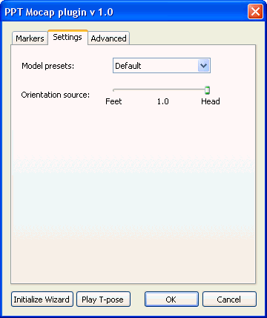

**Figure 1:** MoCap Plugin configuration window - Settings

PPT Studio 2013 Documentation - Version 3.40 - Copyright © 2002-2013 WorldViz. All Rights Reserved.

[cid:009601d11877$0e0e7654$_CDOSYS2.0](http://www.worldviz.com/)

# PPT MoCap - Advanced Tab

The "**Advanced**" tab is only recommendedAdvanced Tab for advanced users or if you use the "Fake" hips mode without arms. In this case a message will tell you which values to adjust.

*Model Settings:* The values "Head height", "Shoulder height", "Feet height", and "Estimated hip height" are measured during the initialization period. You can manually adjust those values, if needed. The recommendation is however to re-initialize instead. The "Hip offset in -Z" is preset to 140 mm and is only needed if you use the "Fake" hips mode.

*Heuristic Settings:* In general there is no need to adjust these settings manually, as presets can be found in the "Settings" tab. The following settings exist, for fine tuning:

* Maximum frame distance: Maximum frame-to-frame jump for one marker
* Minimum pairwise distance: Distance below which you experience that two markers can be swapped
* Decision distance: Pairwise distance above which the algorithm is allowed to make (fully confident) decisions
* Decision hysteresis: Once the markers' projections are apart from each other by full decision hysteresis, the left one is assigned to the first marker, the right one to the second marker
* Memory: Number of frame events that are kept in memory

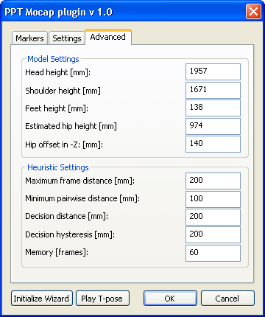

**Figure 1:** MoCap Plugin configuration window - Advanced

PPT Studio 2013 Documentation - Version 3.40 - Copyright © 2002-2013 WorldViz. All Rights Reserved.

PPT Studio 2013 Documentation - Version 3.40 - Copyright © 2002-2013 WorldViz. All Rights Reserved.

[cid:009601d11877$0e0e7654$_CDOSYS2.0](http://www.worldviz.com/)

# PPT MoCap - Initialize Wizard

Press the "Initialize Wizard" button in the lower left corner. There are two capture modes. The default mode is "Auto Capture" and allows you to do the capture without assistance. You take position in the T-pose above the origin, facing PPT north. "Pose Detection" turns green (Figure 1 image on the left), if you are in the correct pose (arms have to be balanced). Hold the pose for about 2 seconds and "Pose Captured" turns green (Figure 1 image on the right). If you uncheck "Auto Capture" the "Capture" button will appear and "Capture" has to be manually pressed while "Pose Detection" is green.

Now it depends on your marker configuration. If you have a "Fake" or "Fixed" hip marker and at least one hand marker, the wizard will move on to the hips pose after about 2 seconds. If you use a different marker configuration, the capture process is over and you will see a "Finish" button instead of the "Next" button. Press "Finish" and skip the below instructions about the hips pose.

**NOTE:** The T-pose you captured serves as reset pose. Move into the reset pose once markers got swapped and you would like to swap them back.

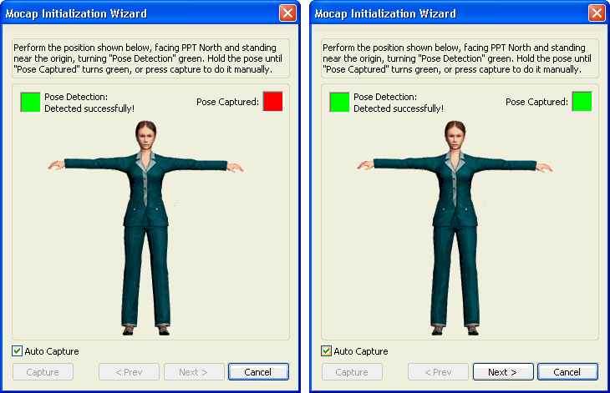

**Figure 1:** Initialize Wizard T-pose

To place the simulated hip marker, your hip height needs to be captured. Keep your body in the same pose and grab your hips with your arms. The LEDs should be at hip height. "Pose Detection" turns green (Figure 2 image on the left), if you are in the correct pose. Using "Auto Capture" the "Pose Captured" square turns green after about 2 seconds. If you uncheck "Auto Capture" the "Capture" button has to be manually pressed while "Pose Detection" is green. The initialization process is over and you will see a "Finish" button (Figure 2 image on the right) that needs to be pressed.

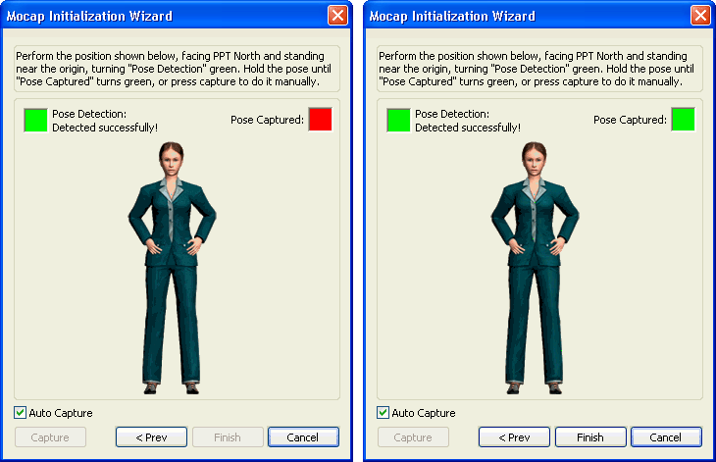

**Figure 2:** Initialize Wizard hips pose

PPT Studio 2013 Documentation - Version 3.40 - Copyright © 2002-2013 WorldViz. All Rights Reserved.

[cid:009601d11877$0e0e7654$_CDOSYS2.0](http://www.worldviz.com/)

# PPT MoCap - Play T-pose

Press the "Play T-pose" button (Figure 1 image on the left, red arrow). If you left the MoCap configuration window (clicked "OK"), you have to click the "MoCap" Post-Process plugin first. Now the T-pose that was captured in the "Initialize Wizard" is played back and is overruling the regular PPT output. While the T-pose is played back all adjustments in the "Markers" tab are grayed out (Figure 1 image on the right). You can click the "OK" button, while the T-pose is played back to navigate in the 3D view. To stop playing the T-pose, just click the "Stop" button. If you left the MoCap configuration window (clicked "OK"), you have to click the "MoCap" Post-Process plugin first.

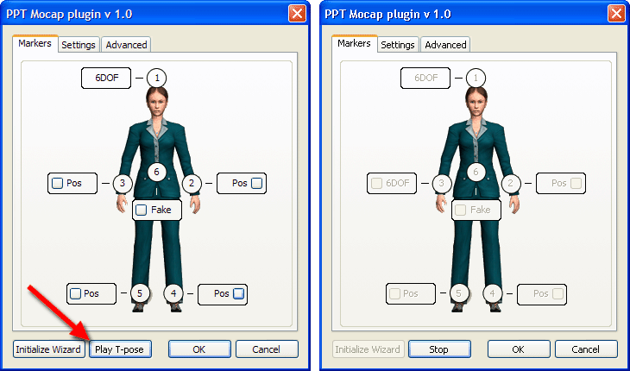

**Figure 1:** Play T-pose

**NOTE:** If the T-pose that was captured in the "Initialize Wizard" is not accurate enough, you can redo the initialization, by pressing the "Stop" and afterwards the "Initialize Wizard" button.

PPT Studio 2013 Documentation - Version 3.40 - Copyright © 2002-2013 WorldViz. All Rights Reserved.

[cid:009601d11877$0e0e7654$_CDOSYS2.0](http://www.worldviz.com/)

# Installing PPT MoCap MotionBuilder Plugin

If you want to use the WorldViz PPT system to stream 3DOF and 6DOF point data into MotionBuilder™ you need to install the PPT MotionBuilder™ plug-in called "PPT MoCap". Make sure MotionBuilder™ is already installed. To install the plug-in do the following:

Execute the installer called "PPTMoCap\_1.00.0000.exe" or similar. Accept the "Open File - Security Warning" by clicking the "Run" button, if it appears. The PPT MoCap Setup Wizard comes up:

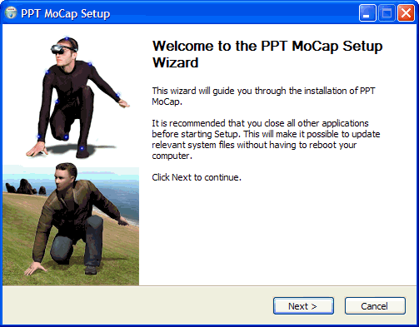

**Figure 1:** PPT MoCap Wizard

By clicking "Next" and accepting the License Agreement with the button "I Agree", you have the option to choose the components you want to install:

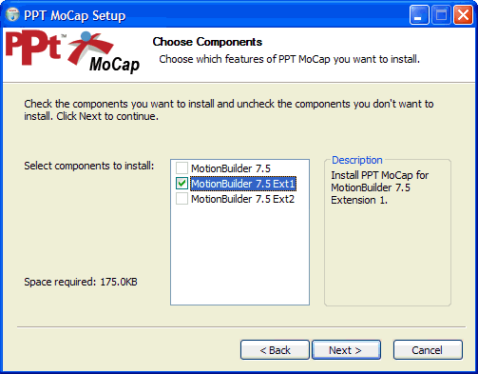

**Figure 2:** PPT MoCap Components

By default, all versions of MotionBuilder™ that are found on your computer will appear with check marks and are ready to install with PPT MoCap. Make sure at least one version of MotionBuilder™ is checked and click "Next".

In the last step before the installation process, you can choose a folder to install PPT MoCap. It is recommended to install to the default folder as this manual chooses. Click "Install" to finally install PPT MoCap and select "Finish" after the installation to close the wizard.

After restarting MotionBuilder™ try to locate the "PPT MoCap" plug-in. This plug-in can be found in the "Asset Browser". Expand the "Templates" asset by clicking on the "+" and select the "Devices" asset. The "PPT MoCap" plug-in is now listed in this directory (Figure 3 red arrow). The plug-in can only be seen if MotionBuilder™ has been restarted after the installation.

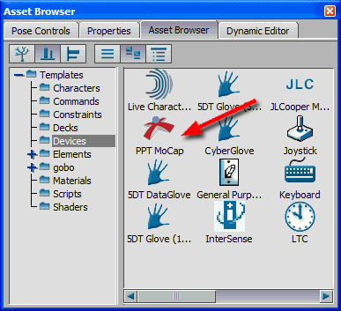

**Figure 3:** PPT MoCap plug-in

If the plug-in can be seen in the "Asset Browser" the installation process of PPT MoCap was successful.

PPT Studio 2013 Documentation - Version 3.40 - Copyright © 2002-2013 WorldViz. All Rights Reserved.

[cid:009601d11877$0e0e7654$_CDOSYS2.0](http://www.worldviz.com/)

# Configure PPT MoCap Device

Start MotionBuilder™ and load the "PPT MoCap" device. This plug-in can be found in the "Asset Browser". Expand the "Templates" asset by clicking on the "+" and select the "Devices" asset. The "PPT MoCap" device is listed (figure 1 red arrow).



**Figure 1:** PPT MoCap device

Drag and drop the "PPT" icon into the "Viewer" (figure 2, red arrow). The "PPT MoCap" device interface appears in the "Navigator".

**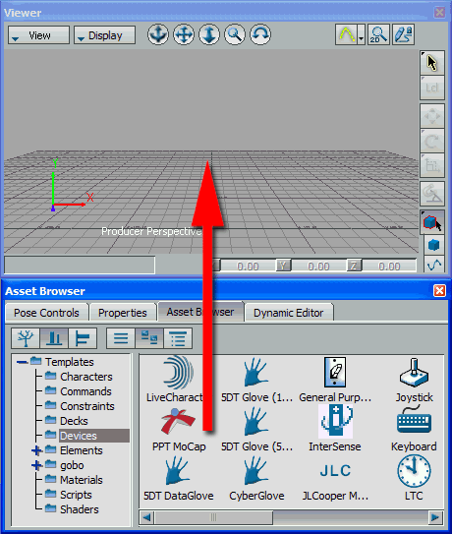  
Figure 2:** Drag and drop the "PPT MoCap" device

The "PPT MoCap" device contains two tabs. Select the "Settings" tab. The "Settings" tab gives the possibility to change the "Server Address", the "Marker Count" and the "Sample Rate" in frames per second (figure 3). Enter the name or the IP address of the PPT computer in the "Server Address" field and enter the number of markers you want to connect to in the "Marker Count" field.

**NOTE:** When using the Mocap plugin with only 5 points, make sure the marker count is set to 6 here since the hip marker is artificially generated.

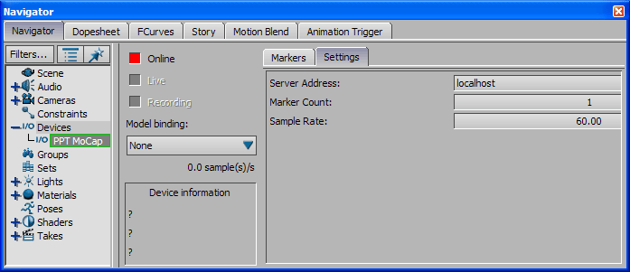

**Figure 3:** Adjusting the Settings

If your PPT computer is setup correctly and talking, then the "PPT Mocap" device is ready to go online. Click on the red square next to "Online" to activate the stream. The red square should turn green (figure 4 red arrow). Check "Live" to visualize the real-time data and "Recording" to prepare for recording the PPT data (figure 4 green arrows). In the "Model binding" drop down menu, select "Create ..." to create the actual markers (red cubes) in the scene (figure 4 yellow arrow).

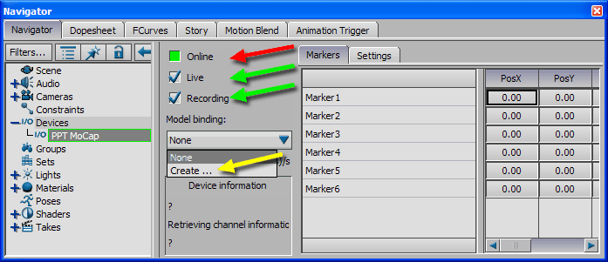

**Figure 4:** Set device Online, Live, Recording and create Model Binding

The "Scene" asset on the left side of the "Navigator" contains a new item called "PPT:Root" which lists all markers (figure 5 red arrow).

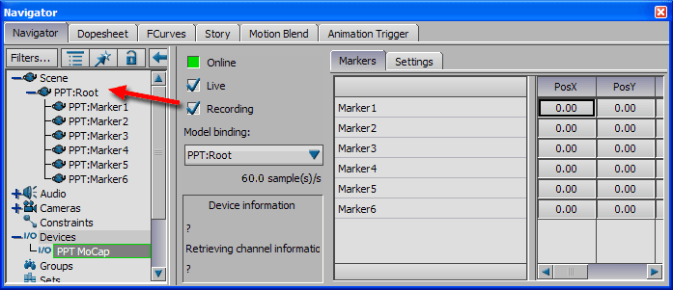

**Figure 5:** "PPT:Root" added to Scene

PPT Studio 2013 Documentation - Version 3.40 - Copyright © 2002-2013 WorldViz. All Rights Reserved.

[cid:009601d11877$0e0e7654$_CDOSYS2.0](http://www.worldviz.com/)

## Eye 2013 Overview

cid:010101d11877$0e0ec467$_CDOSYS2.0

PPT Eyes is a two IR LED based tracker device that is meant to be used with optically tracked projection systems like CAVEs, Powerwalls and others where they allow for accurate real time tracking of the users view point in connection with shutter glasses or polarization glasses, etc. The device which has an integrated push-in button located at the bottom side of the surface allows users to access all features of the device. To activate or de-activate the device, simply press the button once to toggle it. More detail settings can be configured through the WorldViz Device Configuration program or follow the instructions in this document to learn how use the single push-in button to change the settings.

PPT Studio 2013 Documentation - Version 3.40 - Copyright © 2002-2013 WorldViz. All Rights Reserved.

[cid:009601d11877$0e0e7654$_CDOSYS2.0](http://www.worldviz.com/)

## Eyes 2013 Specifications

|  |  |
| --- | --- |
| **Degrees of Freedom** | 5 (X, Y, Z, yaw, roll) NOTE: This fully determines left/right eye locations needed for stereoscopic viewing. |
| **Angular Range** | Full 360 deg – both axis |
| **Precision** | Position: < 0.25 millimeters over 3 x 3 x 3 m volume Rotation: 0.09 deg |
| **Accuracy** | Position: |
| **Update rate** | 180 Hz (PPT E series) / 60 Hz (PPT X series) |
| **Latency** | 20 ms (PPT E series) |
| **Range** | >20 m (with High intensity) |
| **Battery** | 350mAh rechargeable lithium ion battery. Maximum of 6 hours (with low intensity mode). |
| **Weight** | ~30 g (with 2 IR LED diffusion balls) |
| **Dimensions** | 203 mm x 14 mm x 32 mm |
| **LED mode** | Active |
| **Protocols** | TrackD, VRPN, PPT Studio 2008 or later |

PPT Studio 2013 Documentation - Version 3.40 - Copyright © 2002-2013 WorldViz. All Rights Reserved.

[cid:009601d11877$0e0e7654$_CDOSYS2.0](http://www.worldviz.com/)

## Eye 2013 Components list

|  |  |
| --- | --- |
| **Component Name** | **Quantity** |
| Eyes 2013 | 1 |
| Micro USB to USB charging/data cable | 1 |
| AC to USB 5V adaptor | 1 |

PPT Studio 2013 Documentation - Version 3.40 - Copyright © 2002-2013 WorldViz. All Rights Reserved.

[cid:009601d11877$0e0e7654$_CDOSYS2.0](http://www.worldviz.com/)

## Configurations

Method 1. WorldViz Device Configuration

Connect the Wand to the PPT computer with the USB data cable and open up the “WorldViz Device Setup.exe” in the installation folder or you can contact support@worldviz.com to obtain the program , i.e.:

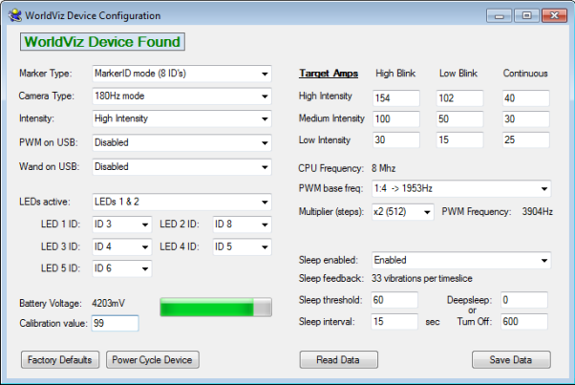

**Method 2. Push-in Button operations**

|  |  |
| --- | --- |
| **Button** | **LED Color Indicator** |
| Short Press (hold less for 1 sec.) | White |
| Long Press (hold for 2 sec.) | Green |
| Extra Long Press (hold for 10 sec.) | White |

|  |  |  |
| --- | --- | --- |
| **Actions** | **Steps** | **Details** |
| **Turn ON/OFF** | Single Short Press | PPT-X: shown in Green  PPT-E: shown in Blue |
| **Turn Sleep Mode ON /OFF** | Single Long Press | Blinking RED = OFF, Blinking GREEN = ON  Under sleep mode: The device goes into sleep mode after 15 seconds without detecting motions and then completely shuts down after 10 minutes. Any motion that detects by the device will automatically activate the device. |
| **Checking ID number for specific LED** | Multiple Short Press (LED index number + 1, ie. To check LED 1, apply 2 Short Presses) | Blinking ID in Green |
| **Enter Configuration Menu** | Single Extra Long Press | LED Shows in White. Please refer to Configuration Menu table for detail. The index of the Menu shows in Green blinks and the index of the options shows in Red. |
| **Toggle USB power activation** | Two Long Presses |  |
| **Checking Battery’s Power Level** | Three Long Presses | Display battery percentage (Green = tens, red = ones) |

#### Configuration Menu

While Wand is ON, a single Extra Long Press to the button will allow the device to enter the configuration menu. Release the button when you see white LED light.

* Green blinks on shows menu index and Red blinks shows the corresponding options. (see the table below)
* During the configuration menu mode, a single or multiple short presses on the button to enter the value (single press means option 1, twice means option 2, etc…)
* The current menu index and option will display after a new value is entered
* Hold the button until the white light shows to enter next menu
* Once all the menu items have been gone through, the device will apply the new settings and restarts itself.

|  |  |  |
| --- | --- | --- |
| **Menu Index** | **Menu Name** | **Options** |
| **1** | Marker Mode | 1: Marker 8, 2: Marker 32, 3: Marker Continues mode |
| **2** | Camera Type | 1: PPT-E, 2: PPT-X |
| **3** | Intensity | 1: High, 2: Median, 3: Low |
| **4** | Sleeping Mode | 1: Sleep mode enable, 2: Sleep mode disable |
| **5** | Active LEDs | 1: LED 1, 2: LED 2, 3: LED 1 and 2  4: LED 1,2,3,4,5, 5: LED 3, 6: LED 4  7: LED 1,2,3,4, 8: LED 5 |
| **6** | LED 1 | ID for LED 1 |
| **7** | LED 2 | ID for LED 2 |
| **8** | LED 3 | ID for LED 3 |
| **9** | LED 4 | ID for LED 4 |
| **10** | LED 5 | ID for LED 5 |

PPT Studio 2013 Documentation - Version 3.40 - Copyright © 2002-2013 WorldViz. All Rights Reserved.

[cid:009601d11877$0e0e7654$_CDOSYS2.0](http://www.worldviz.com/)

## Wand 2013 Overview

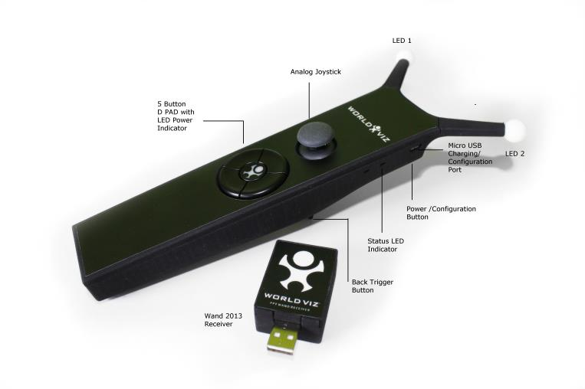

Designed to work in conjunction with a WorldViz Precision Position Tracker (PPT), this hand-held tracking device is equipped with dual tracker LEDs for optical orientation assist, an internal inertial sensor for continuous orientation response, and ergonomic trigger, joystick, and D-pad buttons. The device which has an integrated push-in button located at the top right of the bottom case allows you to be able to access all features of the device. To activate or de-activate the device, simply press the button once to toggle it. More detail settings can be configured through the WorldViz Device Configuration program or follow the instructions in this document to learn how use the push-in button to change the settings.

PPT Studio 2013 Documentation - Version 3.40 - Copyright © 2002-2013 WorldViz. All Rights Reserved.

[cid:009601d11877$0e0e7654$_CDOSYS2.0](http://www.worldviz.com/)

## Specification and Performance

#### Specification

|  |  |
| --- | --- |
| **Degrees of Freedom** | 6 (X, Y, Z, yaw, pitch, and roll) |
| **Angular Range** | Full 360 deg – all axis |
| **Precision** | Position: < 0.25 millimeters over 3 x 3 x 3 m volume Rotation: 0.03 deg |
| **Accuracy** | Position: |
| **Update rate** | 180 Hz (PPT E series) / 60 Hz (PPT X series) |
| **Latency** | 20 ms (PPT E series) |
| **Range** | Position: >20 m (with High intensity) |
| **Battery** | 2000mAh rechargeable lithium polymer battery. Operation time > 8hour in all most except for >6.5 hours in high intensity dual light mode |
| **Weight** | ~200 g |
| **Dimensions** | 239 mm x 65 mm x 110 mm |
| **LED mode** | Active |
| **Protocols** | TrackD, VRPN, PPT Studio 2013 |

#### Charging

It is suggested to use the USB AC adaptor with the micro-USB to USB cable provided in the package to charge the Wand. The Wand can also be charged through a computer USB port with the slower charging rate.

Charging time (with USB AC adapter): ~ 4 and ½ hours (it is suggested to charge over-night)

|  |  |
| --- | --- |
| **Device Status** | LED Indicator |
| **Charging** | Blinking in Red (From fast rate to slow rate, indicating the charge progress) |
| **Fully Charged** | Solid Green |
| **Low Battery** | PPT-X: Quick blinking in Green  PPT-E: Quick blinking in Blue |

PPT Studio 2013 Documentation - Version 3.40 - Copyright © 2002-2013 WorldViz. All Rights Reserved.

[cid:009601d11877$0e0e7654$_CDOSYS2.0](http://www.worldviz.com/)

## Components List

|  |  |
| --- | --- |
| **Component Name** | **Quantity** |
| Wand 2013 | 1 |
| Wand Receiver | 1 |
| Micro USB to USB Charging/Data Cable | 1 |
| AC to USB 5V adaptor | 1 |
| 1.5 ft USB Extension Cable | 1 |

PPT Studio 2013 Documentation - Version 3.40 - Copyright © 2002-2013 WorldViz. All Rights Reserved.

[cid:009601d11877$0e0e7654$_CDOSYS2.0](http://www.worldviz.com/)

## Configurations

**Method 1. WorldViz Device Configuration**

Connect the Wand to the PPT computer with the USB data cable and open up the “WorldViz Device Setup.exe” in the installation folder or you can contact support@worldviz.com to obtain the program , i.e.:



**Method 2. Push-in Button operations**

|  |  |
| --- | --- |
| **Button** | **LED Color Indicator** |
| Short Press (hold less for 1 sec.) | White |
| Long Press (hold for 2 sec.) | Green |
| Extra Long Press (hold for 10 sec.) | White |

|  |  |  |
| --- | --- | --- |
| **Actions** | **Steps** | **Details** |
| **Turn ON/OFF** | Single Short Press | PPT-X: shown in Green  PPT-E: shown in Blue |
| **Turn Sleep Mode ON /OFF** | Single Long Press | Blinking RED = OFF, Blinking GREEN = ON  Under sleep mode: The device goes into sleep mode after 15 seconds without detecting motions and then completely shuts down after 10 minutes. Any motion that detects by the device will automatically activate the device. |
| **Checking ID number for specific LED** | Multiple Short Press (LED index number + 1, ie. To check LED 1, apply 2 Short Presses) | Blinking ID in Green |
| **Enter Configuration Menu** | Single Extra Long Press | LED Shows in White. Please refer to Configuration Menu table for detail. The index of the Menu shows in Green blinks and the index of the options shows in Red. |
| **Toggle USB power activation** | Two Long Presses |  |
| **Checking Battery’s Power Level** | Three Long Presses | Display battery percentage (Green = tens, red = ones) |

#### Configuration Menu

While Wand is ON, a single Extra Long Press to the button will allow the device to enter the configuration menu. Release the button when you see white LED light.

* Green blinks on shows menu index and Red blinks shows the corresponding options. (see the table below)
* During the configuration menu mode, a single or multiple short presses on the button to enter the value (single press means option 1, twice means option 2, etc…)
* The current menu index and option will display after a new value is entered
* Hold the button until the white light shows to enter next menu
* Once all the menu items have been gone through, the device will apply the new settings and restarts itself.

|  |  |  |
| --- | --- | --- |
| **Menu Index** | **Menu Name** | **Options** |
| **1** | Marker Mode | 1: Marker 8 2: Marker 32 3: Marker Continues mode |
| **2** | Camera Type | 1: PPT-E 2: PPT-X |
| **3** | Intensity | 1: High 2: Median 3: Low |
| **4** | Sleeping Mode | 1: Sleep mode enable 2: Sleep mode disable |
| **5** | Active LEDs | 1: LED 1, 2: LED 2, 3: LED 1 and 2  4: LED 1,2,3,4,5, 5: LED 3, 6: LED 4  7: LED 1,2,3,4, 8: LED 5 |
| **6** | LED 1 | ID for LED 1 |
| **7** | LED 2 | ID for LED 2 |
| **8** | LED 3 | ID for LED 3 |
| **9** | LED 4 | ID for LED 4 |
| **10** | LED 5 | ID for LED 5 |

PPT Studio 2013 Documentation - Version 3.40 - Copyright © 2002-2013 WorldViz. All Rights Reserved.

[cid:009601d11877$0e0e7654$_CDOSYS2.0](http://www.worldviz.com/)

## Operation Diagram

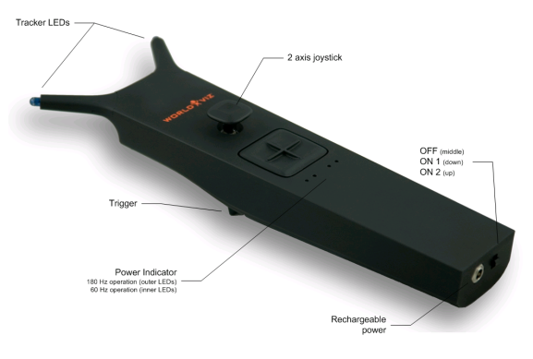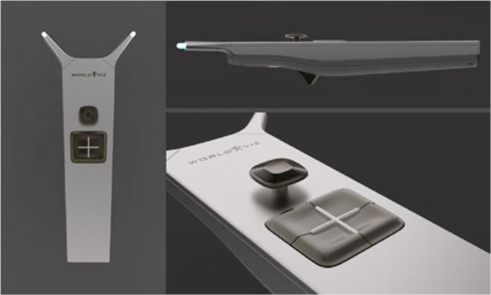

##### Wireless PPT Wand

Designed to work in conjunction with a WorldViz Precision Position Tracker (PPT), this hand-held tracking device is equipped with dual tracker LEDs for optical orientation assist, an internal high-quality inertial sensor for continuous orientation response, and ergonomic trigger, joystick, and D-pad buttons. The machine aluminum housing is both rugged and elegant in design. The internal rechargeable battery is powerful enough to provide a full working day of tracking performance.

On the bottom of the wand are the charging jack and the mode switch. The wand can be charged with the included charger which indicates the charging mode (red) and the fully charged mode (green). The operating time for a wand is ca. 8 hrs and its charging time is ca. 2 hrs.

**Switch positions**

* Center: OFF
* Down: Single left wing tracked IR LED activated (standard operation), either left or center left (depending on H or X system) green indicator LED turns on
* Up: Both wing tracked IR LEDs activated (for calibration of magnetic distortions), two green indicator LEDs left and right turn on, indicating X mode or H mode.

In addition to the indicator LEDs, the IR LEDs are illuminated by a dim blue light for better identification.

**Function of the green indicator LEDs:**

* **Left:** H system ID activated for left IR LED (tracked wing LED)
* **Center Left:** X system ID activated for left IR LED (tracked wing LED)
* **Center Right:** X system activated for right IR LED (tracked wing LED)
* **Right:** H system ID activated for right IR LED (tracked wing LED)

*The individual programming for the indicator LEDs and IR tracking LEDs is done by Worldviz. The LEDs are factory preset by Worldviz to a specific ID; contact Worldviz support for reprogramming information or more advanced use cases.*

##### Default marker ID values

By default, your wand has been assigned marker ID values that correspond to a right-hand by the Vizard VR Toolkit (preset ID 3 for left LED & ID 8 for right LED). This impacts default behavior only and you can of course still use the wand for any purpose. If you plan to use two wands in the same PPT tracking arena and ordered them together, you’ll find that one wand is labeled “R” and then other “L” (preset left hand IDs are 2 for left LED & 7 for right LED).

PPT Studio 2013 Documentation - Version 3.40 - Copyright © 2002-2013 WorldViz. All Rights Reserved.

[cid:009601d11877$0e0e7654$_CDOSYS2.0](http://www.worldviz.com/)

## Technical Performance

|  |  |
| --- | --- |
| Degrees of Freedom | 6 (X, Y, Z, yaw, pitch, roll) |
| Angular Range | Full 360 deg – all axes |
| Precision | Position: < 0.25 millimeters over 3 x 3 x 3 m volume    Rotation: 0.03 deg |
| Accuracy | Position:    Rotation: 1 deg RMS yaw, .25 deg RMS in pitch & roll |
| Update Rate | 180 Hz (PPT H series) |
| Latency | 20 ms (PPT H series) |
| Range | 33 m |
| Battery | Type: Rechargeable Lithium Ion    Endurance: 8 hours typical usage |
| Weight | 460 g |
| Dimensions | 26 cm x 6cm (including the joystick height) x 10cm |
| LED Mode | Passive & Active (PPT Marker ID); both LEDs can be individually programmed with IDs 1 thru 8 |
| Protocols | TrackD, VRPN, PPT Studio 2008 or later |

PPT Studio 2013 Documentation - Version 3.40 - Copyright © 2002-2013 WorldViz. All Rights Reserved.

[cid:009601d11877$0e0e7654$_CDOSYS2.0](http://www.worldviz.com/)

## Included Components

* Wand (wireless)

* USB base station (connects to host PC)

* 8.4 VDC universal charger

* Storage case

PPT Studio 2013 Documentation - Version 3.40 - Copyright © 2002-2013 WorldViz. All Rights Reserved.

[cid:009601d11877$0e0e7654$_CDOSYS2.0](http://www.worldviz.com/)

## Rechargeable Battery

##### Battery specifications:

|  |  |
| --- | --- |
| Capacity | 2200mAh |
| Voltage | 7.2V (peak at 8.4V) |
| Dimensions | 2.63 x 1.45 x 0.7 inch |
| Weight | 3.2 oz |
| Max. charge current | 1C (2.0A) |
| Max. discharge current | 2.5C (5A) |
| Cut off voltage | 6V |

PPT Studio 2013 Documentation - Version 3.40 - Copyright © 2002-2013 WorldViz. All Rights Reserved.

[cid:009601d11877$0e0e7654$_CDOSYS2.0](http://www.worldviz.com/)

## Configuring WorldViz PPT system for wand use

##### Enabling the wand using a single light with Marker ID

1. Turn the wand on (1 light mode is switch down position) before starting PPT Studio (because PPT Studio automatically attempts to connect to the wand if it was last used with a wand connected)
2. Place the wand on a stable, non-metallic surface with joystick pointing up
3. In the Configuration pane, add “Marker ID” under Post-Process options if it’s not already added using the dropdown menu. This plug-in must be topmost in your list of plug-ins (drag to reorder if necessary). If you have a factory configured wand, its Marker ID is 3 for single light use (right hand).
4. Click on Post- Process / Marker ID and uncheck “Automatically search inventory” if it is currently selected. Instead, put a checkmark for ID 3 under the list of physical IDs and do not change the virtual ID value. NOTE: If you’re also tracking other markers in your scene, ie. PPT Eyes, you must now use the Marker ID plug-in to establish the number and ID of the other markers. See your PPT manual for details about Marker ID. Hit “OK” when you complete the selections.

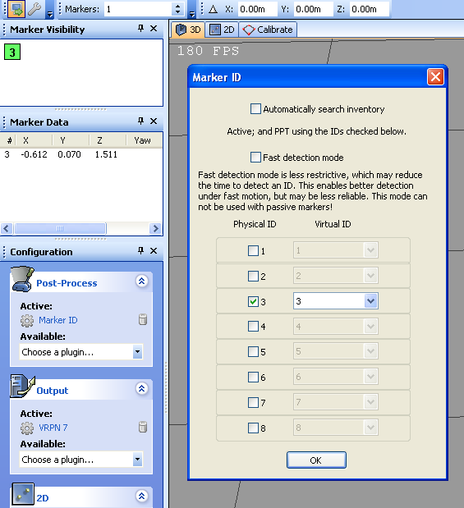

1. In the Configuration pane, add “PPT Wand” under Post-Process options if it’s not already added using the dropdown menu. It might take few seconds to load. This plug-in must be beneath Marker ID in your list of plug-ins.

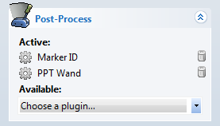

1. Click on Post-Process / PPT Wand, and add an orientation sensor if none is presently added. To add a sensor, press the “Add” button and enter 0 (zero) for port number and hit “Add”; this will auto-detect the wand.
2. Configure the light number (in Post-Process / PPT Wand) by right-clicking the row showing the wand data. Under normal circumstances, this will be 3 (the marker ID of your wand). Hit “OK”.
3. The current screen should be similar to the one shown below and finally hit “Close” to complete the PPT Wand configuration.

**NOTE:** For magnetic compensation (2 light) mode of the PPT Wand, please refer to section “[Compensation for magnetic distortion](Compensation%20for%20Magnetic%20Distortion.htm)” for further details.

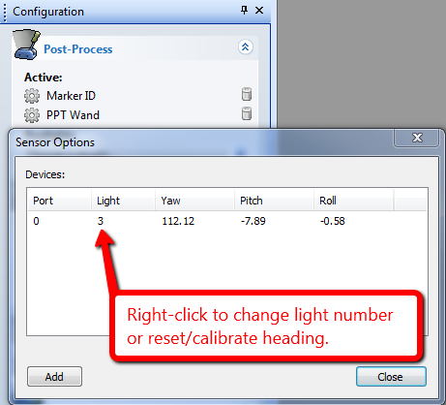

**Reset/Calibrate wand’s virtual North**

1. Since the wand uses a magnetic sensor in the standard 1 light mode, you need to reset the straight ahead or North direction.
2. Click on Post-Process / PPT Wand
3. Right-click on the row showing the Wand data and select “Reset”
4. Follow the Reset Wizard to completely calibrate your wand (Normally, you want to have your wand’s LED end pointing to the Z direction or to the screen)
5. Hit “Close.” Your calibration is now complete and is stored; the next time you run PPT you do not need to reset the wand

PPT Studio 2013 Documentation - Version 3.40 - Copyright © 2002-2013 WorldViz. All Rights Reserved.

[cid:009601d11877$0e0e7654$_CDOSYS2.0](http://www.worldviz.com/)

## PPT Wand with PPT Eyes

PPT Eyes is a device that provides position and orientation tracking of a user’s head and is typically mounted onto a pair of 3D glasses for viewing a 3D projection screen. PPT Eyes is designed to work in conjunction with PPT Wand, and together they provide a rich head and hand interactive solution for CAVE and powerwall environments.

Using PPT Eyes in conjunction with PPT Wand is as simple as combining the configuration for the two stand-alone devices. Below the configuration technique for PPT Eyes is provided. If the Marker ID and PPT Wand plug-ins have not been set up, it is recommended to follow section 2.2 “Configuring WorldViz PPT system for wand use” at this stage. While PPT Eyes do not need to be configured first, its plug-in should always be moved to below the “Marker ID” and above the “PPT Wand” in the Post-Process stack (drag to reorder).

##### Configure PPT Eyes

1. Turn on PPT Eyes (slide the micro-switch on the back to the top)
2. Place PPT Eyes in the tracking field where both LED markers can be seen.
3. Correctly set PPT Studio number of markers (the Eyes count as 2 additional markers so adjust accordingly)
4. With standard PPT Eyes and Wand configuration, you would have 3 markers in total. Remember to select additional 2 marker IDs in the Marker ID plug-in. Normally, we uncheck the “automatically search inventory” and manually select physical ID 1, 2, and 3 for the PPT eyes and wand. Add “Marker ID” under Post-Process options if it’s not already added. NOTE: It is not necessary to add Marker ID plug-in if you use PPT Eyes alone.
5. In the Configuration pane, add “PPT Eyes” under Post-Process options if it’s not already added using the dropdown menu.

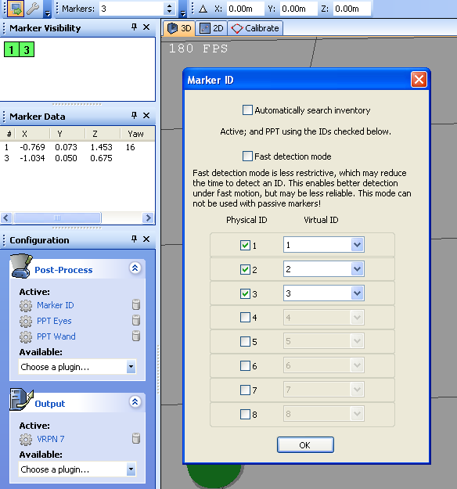

1. Drag to re-order PPT Eyes so that it is below “Mark ID” and above “PPT Wand” in the Post-Process.

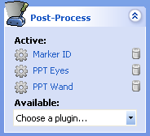

1. You should not need to configure the PPT Eyes plug-in as its default settings are correct for nearly all uses. The default value is shown below.
2. You should now see orientation data shown for marker ID # 1. This is the ID data computed from the PPT Eyes’ two LED markers.

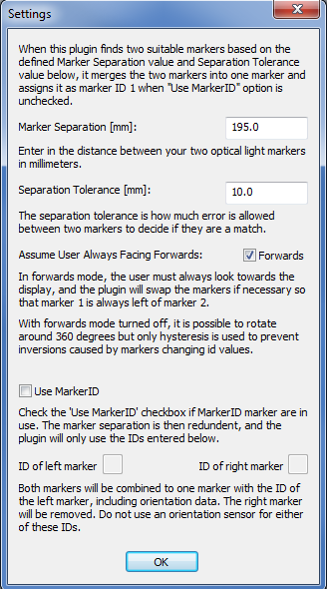

PPT Studio 2013 Documentation - Version 3.40 - Copyright © 2002-2013 WorldViz. All Rights Reserved.

[cid:009601d11877$0e0e7654$_CDOSYS2.0](http://www.worldviz.com/)

## Configuring Vizard VR Toolkit

This section describes how to use with wand with Vizard VR Toolkit. This usage described here bases the Vizard side connection on the viztracker utility. This is the recommended method because it provides considerable functionality without any required Vizard-side programming. To use the wand without viztracker, please see “Advanced usage” further in next section of the manual.

##### Configure viztracker

Viztracker is a module in Vizard that abstracts the functionality of trackers and various inputs sensors from the hardware implementations. To use viztracker, a Vizard application needs to call the appropriate functions, which in turn will use your stored viztracker configuration settings to activate the appropriate hardware devices. Configuring viztracker is accomplished by running the viztracker\_setup.py script which should be included in your local installation of Vizard (you can expect to find this here: C:\Program Files\WorldViz\Vizard4 [or Vizard30]\python\viztracker.py).

To properly configure viztracker for a PPT Wand, use the following settings:

* **Display:** any setting—does not affect Wand
* **Tracker:** set to WorldViz / PPT \*
* **Input:** set to WorldViz / VRPN Wand \* (any option for hands)
* **Avatar**: any setting—does not affect Wand

These are recommended settings; using these settings allow for all wand configurations to be stored on PPT and be removed from the rendering application. The data are transmitted from PPT thru VRPN to the Vizard application.

NOTE: If you set viztracker to connect to a right hand, then you need to have PPT configured with marker ID set to 3. For the left hand, you set it to 2 instead.

##### Vizard and viztracker together

To test out your wand in a Vizard-based application that uses the viztracker configuration that you created above, please run the script called “WandTester.py” that can be found in your “WorldViz / PPTStudio / Vizard Examples” program files folder.

When you run this program, its default view will be to center the tracked hand on the screen. You can use the onscreen control buttons to swap the view to that of the PPT tracker.

PPT Studio 2013 Documentation - Version 3.40 - Copyright © 2002-2013 WorldViz. All Rights Reserved.

[cid:009601d11877$0e0e7654$_CDOSYS2.0](http://www.worldviz.com/)

# Configuring Multiple PPT Wands or with IC2 Devices

PPT Studio supports up to maximum of 4 PPT wands per receiver operating simultaneously. The configuration is similar to the single wand set up except for that the marker ID of the wands need to be adjust accordingly. For example, if you have 3 wands working at the same time, you may have one wand with default marker ID 3 (assume operating at one-light mode) and the other 2 wands with the other 2 unused marker ID (ie. 4 and 5.) However, each wand has to go through the pairing process with its receiver. If you have a wired IC2 connected instead, there is no pairing process needed. Please read the "Pairing a Wand with its receiver" section for detail.

Configuring Multiple Wands

Please first try to follow the previous section "Configuring WorldViz PPT System for Wand Use" and repeat the procedure for the additional wands you intend to use. The final Sensor Option window will look like below.

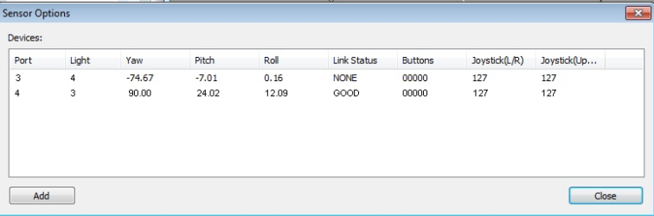

**Configuring PPT Wand with IC2**

Having a IC2 works with PPT wand is relatively simple. Once you have the wand(s) setup correctly (follow the "Configuring WorldViz PPT System for Wand Use"), all you have to do is follow the procedure below.

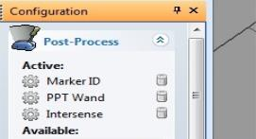

1. Select the "Intersense" plug-in in the Post-Process section under the Configuration panel.

2. Click on the Intersense plug-in and click on "Add" button in the Sensor Option Window.

3. Similar to adding a PPT wand, fill out the port number for the IC2 device and choose light number as 1 (in most of cases, we use IC2 for a HMD which has the head tracking light number 1.) You may choose the other light number for combining the orientation data of IC2 with different Marker ID.

4. Hit "Close" once you finish adding the IC2 device.

PPT Studio 2013 Documentation - Version 3.40 - Copyright © 2002-2013 WorldViz. All Rights Reserved.

[cid:009601d11877$0e0e7654$_CDOSYS2.0](http://www.worldviz.com/)

### Vizard data access

Use the sample Vizard scripts to connect to your PPT Wand. These samples demonstrate how to connect and obtain wand data.

##### Sample Code: Use this for wands connected via PPT Studio

#first add the intersense

isense = viz.add('intersense.dle')

#create a tracker object - \*note port number(0 is auto scan and can be slow )

wandTracker = isense.addTracker(port=0)

#euler angle of the wand

eul = wandTracker.getEuler()

#analog joystick data

xy = wandTracker.getJoystickPosition()

#callback function for buttons

def onSensorDown(e):

if e.object is wandTracker:

print 'Button', e.button, 'down'

viz.callback( viz.SENSOR\_DOWN\_EVENT, onSensorDown )

#or in a timer function you can see if a certain number is down

wandTracker.isButtonDown(1) #checks to see if button 1 is down

#you have to get position data from PPT

vrpn = viz.add('vrpn7dle')

#define markerID of Wand in PPT

markerID = 3

posTracker = vrpn.addTracker('PPT0@localhost',markerID-1)

#now you can merge the isense tracker and the posTracker to create a 6DOF tracker

finalTracker = viz.mergeLinkable( posTracker, wandTracker )

##### Sample Code: Use this for wands connected directly to Vizard

#add the vrpn extension

vrpn = viz.add('vrpn7dle')

#define Machine Address of PPT machine

hostname = 'localhost'

#define markerID of Wand in PPT

markerID = 3

#create a tracker object for the 6DOF data

tracker = vrpn.addTracker('PPT0@'+ hostname, markerID-1)

#create analog device for the joystick

analogDev = vrpn.addAnalog('PPT\_WAND%d@%s:%d' % (markerid, 8945))

#create button device for the buttons

buttonDev = vrpn.addButton('PPT\_WAND%d@%s:%d' % (markerid, hostname, 8945))

PPT Studio 2013 Documentation - Version 3.40 - Copyright © 2002-2013 WorldViz. All Rights Reserved.

[cid:009601d11877$0e0e7654$_CDOSYS2.0](http://www.worldviz.com/)

### VRPN (generic)

The Virtual-Reality Peripheral Network (VRPN) is the preferred method of connecting to your host application. The Ethernet-based network connection is versatile and offers lower latencies than serial communication, especially for large numbers of markers and high update rates. If your host application does not currently support a VRPN connection, adding this functionality is straightforward. Both VRPN6 and VRPN7 are supported.

**Instructions:**

1. Please make sure you have a calibrated PPT system and have the PPT Studio running.

2. In PPT Studio settings, select the correct number of markers for tracking and select the VRPN 7 plugin as the Output plugin in the Configuration panel.

3. If PPT Wand is used, please make sure you have both MarkerID and PPT Wand plugins selected. For the MarkerID plugin, make sure the PPT wand is detected by the PPT with the correct ID (default ID number 3 for single LED mode [power switch DOWN]). For the PPT Wand plugin, please make sure the light number showing in the Sensor Option window is corresponding to its marker ID number and is in connected mode (if you can see the dynamically updated yaw, pitch, and roll data).

4. Press the TALK button (top left corner of the PPT Studio window) if it is not ON.

5. You should be able to access the PPT data through VRPN from your own application by using the sample code below.

In the following sample C++ code, you can retrieve the position, orientation, button, and joystick data of a PPT Wand. Similarly, you can just keep the tracking related functions if it is only for regular marker tracking.

a. You'll need the VRPN library (header files) from this site.

<http://www.cs.unc.edu/Research/vrpn/index.html>

Or download directly from

<ftp://ftp.cs.unc.edu/pub/packages/GRIP/vrpn>

b. the Wand address for the analog and button data: The address format is "PPT\_WANDX@MachineAddress:8945" where X is the marker ID number assigned to the Wand in PPT (ID is 3 in our sample code) and MachineAddress is the IP or computer name of the PPT machine. You must specify port 8945 since the Wand data is sent through a different port than the default VRPN port. In PPT again, VRPN7 output must be selected under the output plugin of the configuration pane.

c. 6DOF info is sent as "PPT0@MachineAddress"

##### Code Sample for VRPN connecting to PPT Studio

#include

#include

#include

#include

#include

#define ANALOG\_ADDRESS "PPT\_WAND2@10.24.5.240:8945"

#define BUTTON\_ADDRESS "PPT\_WAND2@10.24.5.240:8945"

#define TRACKER\_ADDRESS "PPT0@10.24.5.240"

static void VRPN\_CALLBACK handle\_analog(void \*userdata, const vrpn\_ANALOGCB a)

{

for(int i = 0; i < a.num\_channel; ++i) {

fprintf(stdout,"channel %d: %.2lf\n",i,a.channel[i]);

}

}

static void VRPN\_CALLBACK handle\_button(void \*userdata, const vrpn\_BUTTONCB b)

{

fprintf(stdout,"button %d: %d\n",b.button,b.state);

}

static void VRPN\_CALLBACK handle\_tracker\_pos\_quat(void \*userdata, const vrpn\_TRACKERCB t)

{

fprintf(stdout,"tracker %d pos: %.2lf %.2lf %.2lf\n",t.sensor,t.pos[0],t.pos[1],t.pos[2]);

fprintf(stdout,"tracker %d quat: %.2lf %.2lf %.2lf %.2lf\n",t.sensor,t.quat[0],t.quat[1],t.quat[2],t.quat[3]);

}

int main( int argc, char \*\*argv )

{

vrpn\_Analog\_Remote \*analog = new vrpn\_Analog\_Remote(ANALOG\_ADDRESS);

analog->register\_change\_handler(0,handle\_analog);

vrpn\_Button\_Remote \*button = new vrpn\_Button\_Remote(BUTTON\_ADDRESS);

button->register\_change\_handler(0,handle\_button);

vrpn\_Tracker\_Remote \*tracker = new vrpn\_Tracker\_Remote(TRACKER\_ADDRESS);

tracker->register\_change\_handler(0,handle\_tracker\_pos\_quat);

while(!kbhit()) {

analog->mainloop();

button->mainloop();

tracker->mainloop();

}

return 0;

}

For **Techviz** users, under the vrpn tracking section of Techviz configuration file, the sample setting below allows you connect a PPT Wand and head tracker through VRPN.

#######################################################################

# 4.1.f : vrpn tracking

#######################################################################

vrpn\number of devices=2

vrpn\device 0\device name=PPT0@192.168.0.1:3883

vrpn\device 1\device name=PPT\_WAND3@192.168.0.1:8945

# Modification of tracking information to comply TechViz setup

coef tracker to univ\x=1

coef tracker to univ\y=1

coef tracker to univ\z=1

tracker axe in univ\x=x

tracker axe in univ\y=y

tracker axe in univ\z=-z

offset tracker to univ\x=0

offset tracker to univ\y=0.725

offset tracker to univ\z=1.675

# Head configuration

number of head=1

head\0\device num=0

head\0\sensor=0

# Wand configuration

number of wand=2

# wand positioning

wand\0\device num=0

wand\0\sensor=2

# wand interaction

wand\1\device num=1

wand\1\sensor=2

button mapping\flystick=Flystick2

PPT Studio 2013 Documentation - Version 3.40 - Copyright © 2002-2013 WorldViz. All Rights Reserved.

[cid:009601d11877$0e0e7654$_CDOSYS2.0](http://www.worldviz.com/)

### TrackerD

PPT Studio includes a plugin for use with the TrackD software. The plugins are ppt-trackd.dll and pptwand-trackd.dll, and are located in C:\Program Files\WorldViz\PPTStudio34.

Instructions:

1. Please make sure you have a calibrated PPT system and have the PPT Studio running.

2. In PPT Studio settings, select the correct number of markers for tracking and select the VRPN 7 plugin as the Output plugin in the Configuration panel.

3. If PPT Wand is used, please make sure you have both MarkerID and PPT Wand plugins selected. For the MarkerID plugin, make sure the PPT wand is detected by the PPT with the correct ID (default ID number 3 for single LED mode [power switch DOWN]). For the PPT Wand plugin, please make sure the light number showing in the Sensor Option window is corresponding to its marker ID number and is in connected mode (if you can see the dynamically updated yaw, pitch, and roll data).

4. Press the TALK button (top left corner of the PPT Studio window) if it is not ON.

5. Copy ppt-trackd.dll and pptwand-trackd.dll from ..\WorldViz\PPTStudio34 (installation folder), and put them into your trackd\bin directory (which may reside on a different machine).

6. In the TrackD configuration file, include the following lines for a standard PPT tracking system:

DefineDevice ppt ppt-trackd

DeviceOption ppt address 127.0.0.1

7. If you have a PPT wand connected, then you will need to add the following extra lines:

#Define PPT Wand-can optionally specify number of wands, defaults to 1

DefineDevice pptwand pptwand-trackd

#Specify PPT Wand address(Device ID, PPT hostname/IP address, PPT Wand light number)

DeviceOption pptwand address 127.0.0.1

8. The above is written assuming TrackD is installed on the PPT machine. If TrackD is running elsewhere, then 127.0.0.1 should be replaced with the IP address of the PPT machine.

9. Start up TrackD using the configuration file just written and test the output.

PPT Studio 2013 Documentation - Version 3.40 - Copyright © 2002-2013 WorldViz. All Rights Reserved.

[cid:009601d11877$0e0e7654$_CDOSYS2.0](http://www.worldviz.com/)

## Compensation for magnetic distortion

There may be scenarios where the internal wand orientation sensor is affected by magnetic interference in your environment. If this is the case, then the PPT Optical Heading plug-in will help to correct this for you using the two lights on the PPT Wand.

Before proceeding, verify that your Wand has a unique Marker ID value that does not interfere with any other markers you plan to use. If you’re using your wand in conjunction with PPT Eyes, then this is not an issue because the Eyes module uses passive LEDs which do not transmit ID signals.

For this operation, you need to have 3 Post-Process plug-ins set up and ordered exactly as you see below. If they are not in the correct order, you can drag and re-arrange them. The instructions below explain how to properly configure each.

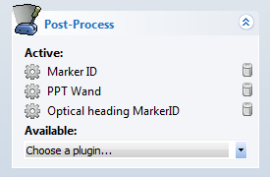

NOTE: If you have PPT Eyes post-plugin in addition to the above plugins, you should place the PPT Eyes plugin below the Marker ID and above the PPT Wand.

1. Set the wand to dual light operation (switch up position)
2. **Marker ID:** add this plug-in if not already in Post-Process and configure it for normal operation. If you assign virtual ID values to any of the wand markers, you’ll need to use those virtual ID values in the next step.
3. **PPT Wand:** add this plug-in if not already in Post-Process and configure the PPT Wand plug-in and assign the orientation to the left ID value (the result of merging the two IDs from previous step).
4. **Optical Heading MarkerID:** add this plug-in if it’s not already in Post-Process and configure it with the following settings:
   1. Type in the IDs 3 and 8 for the two wand marker ids.
   2. Uncheck the "Second Set" option if you only have one PPT wand.
   3. The change rate field is a percentage that controls how much of the new distortion correction should be added to the current correction. This helps to smooth out optical jitter and transitions during occlusion, but does not affect tracking latency. Default value 10%.

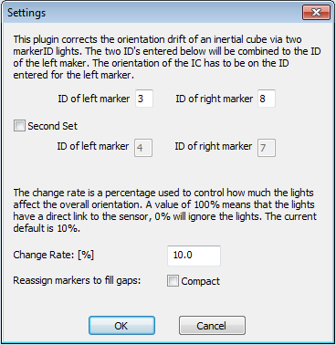

\*Without Marker ID (OPTIONAL): If the two lights on the PPT wand or an intersense cube are non-marker ID, the "Optical Heading" plug-in should be used.

1. The same setting procedures should be followed except for skipping step 2 and selecting "Optical Heading" for step 4.
2. Click on the Optical Heading post plugin and type in the distance (in mm) between the 2 lights for this plug-in.
3. Keep the rest of the values in default and make sure "Apply to all" is unchecked if you only want optical heading to correct the orientation on a single device (ie. PPT Wand). Please see the below figure for details.

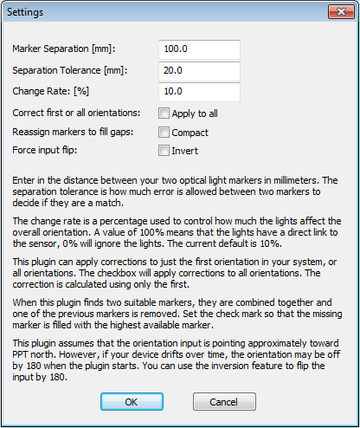

PPT Studio 2013 Documentation - Version 3.40 - Copyright © 2002-2013 WorldViz. All Rights Reserved.

[cid:009601d11877$0e0e7654$_CDOSYS2.0](http://www.worldviz.com/)

## Changing LED ID values

Each PPT Wand has two separately programmable tracker LEDs that can be configured to ID values 1 – 8. These steps explain how to change either LED.

1. Identify the hole on the back of the PPT Wand which is on the same side as the tracker LED you wish to reconfigure. You’ll need a small paperclip that can be inserted into that hole.
2. Next, while depressing the micro-switch through the back of the case using the paperclip, turn the wand’s power on and watch the green power indicator lights. You’ll see a medium flash followed by a number of short flashes. The number of short flashes corresponds to the current ID value.
3. To change ID, again depress the micro-switch and let go. Repeat this quickly until you’ve reach the ID value you desire. When you have reached the desired ID value, do nothing for 2 sec and the ID will be stored (indicated by a stead ON power light).

Remember, only ID values s 1 – 8 are available as configurations. Configurations modes 9 – 12 have other purposes as described in the table below.

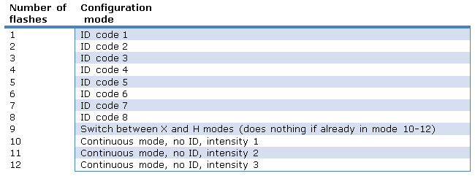

PPT Studio 2013 Documentation - Version 3.40 - Copyright © 2002-2013 WorldViz. All Rights Reserved.

[cid:009601d11877$0e0e7654$_CDOSYS2.0](http://www.worldviz.com/)

## Proper wand handling

You should avoid dropping your PPT Wand or allowing either of the two LED to impact a hard surface. If cleaning is necessary, a lightly damp cloth with mild soap can be used, but generally the anodized finish is very resistant to permanent scratches or discolorations.

The inertial sensors within the wand are delicate instruments and therefore you should always be careful that the wand is never dropped.

PPT Studio 2013 Documentation - Version 3.40 - Copyright © 2002-2013 WorldViz. All Rights Reserved.

[cid:009601d11877$0e0e7654$_CDOSYS2.0](http://www.worldviz.com/)

## Pairing a Wand with its receiver

The steps described in this section are only necessary if you are installing a PPT Wand on a machine where it has never been used on before. Under normal use, you do not need to pair the wand to its receiver as this information is stored.

##### Running ISDEMO

Pairing the wand with its receiver is done with the help of a program on your PPT computer called “ISDEMO” which can be found by typing "ISDEMO" in the windows's searching bar. This application is pre-installed in the PPT computer and can be downloaded from Intersense's official website at: www.intersense.com under support > Downloads > InertiaCube Sensors. You should see there is a download link for ProductCD\_InertiaCube.

##### Pairing Procedures

1. Close PPT Studio.

2. Plug in PPT Wand Receiver and turn on PPT Wand if you have not done so.

3. Open "ISDEMO" (ie. location C:\InterSense\InertiaCube Software\Programs\isdemo32.exe) and select "DLL Compatible"

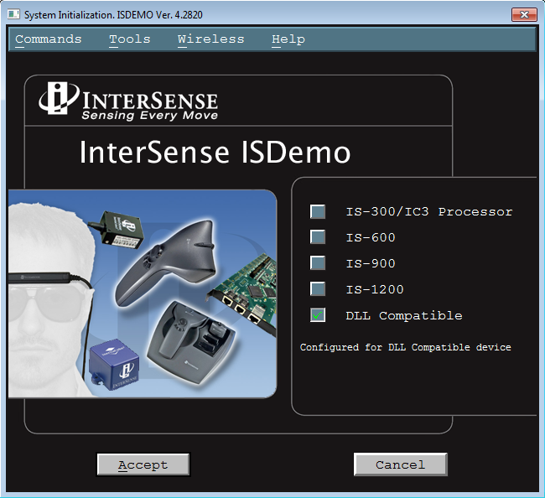

4. Click on top menu Wireless > RF Scope to browse the traffic condition for the available RF channels. Choose the less busier channel (high percentage or shorter brown bars/lower dB value.) Remeber the selected channel number for the later steps.

5. Close the RF Scope window and select the Wireless > Wireless Configuration.

The Wireless Configuration Tool can be started from the System Initialization Window. It lists the wireless status and configuration for each port on the host PC. Up to 32 ports are enumerated and up to 4 wireless devices can be configured to run on each port.

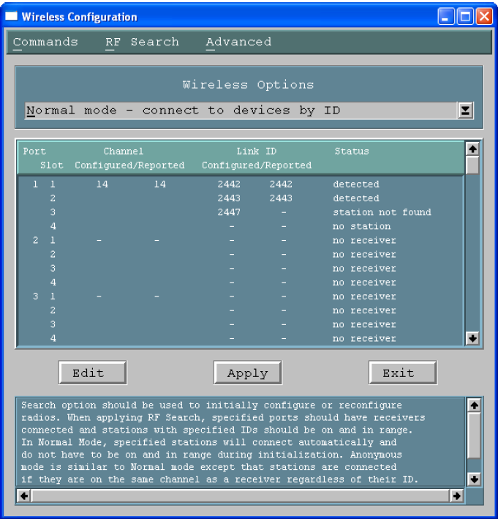

Definition:

Port > Port of the Host Computer.

Slot > One of the 4 available slots for the wireless station on one receiver.

Configured Channel > The channel that the connected receiver is configured to. No two receivers can be configured to the same channel.

Reported Channel > The channel that the connected receiver is currently on.

Configured Link ID > The link ID that is assigned to the receiver. Each wand has one ID associated with it. This ID can be found by using RF Search > Enumerate Wireless Devices.

Reported Link ID > The link ID that is currently associated to the receiver.

Status > Port status. Any ports with a status of “no receiver” do not have receivers and cannot be configured

6. Turn on the wand if you have not done so. Click on the RF Search on the top meun of the current window and select "Enumerate Wireless Devices." This tool is used to discover and display configuration data of wireless devices in range of the receiver. It can help to resolve interference and conflict problems when multiple InterSense wireless systems are used in the same space, or when Link IDs of the devices are not known.

Note: If the "Test not available" is shown, click Test > Run Test. If the message is still shown, try to close the ISDEMO completely and power cycle the receiver (wait for 15 seconds before plugging it back) and then repeat the steps above. If the procedures above does not help, restart the computer and repeat the steps above.

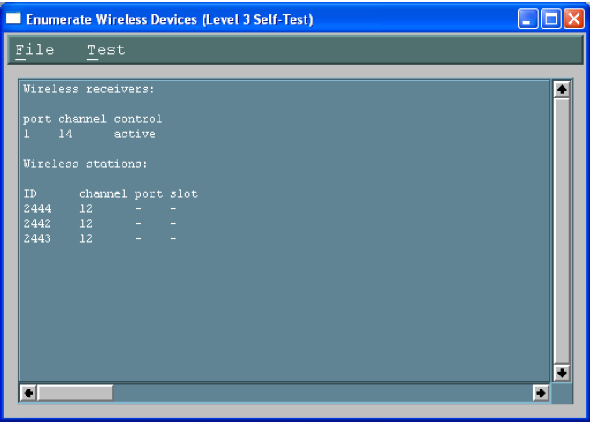

7. Record the port number and wireless station ID number before closing the window.

8. Close the "Enumerate Wireless Devices" window and select the "Normal mode" in Configuration Window. Use normal mode to set radios to desired channels and station IDs. Only stations with the specified IDs are connected.

9. Select a port with a receiver connected and click Edit. (Make sure clear the information in the ports that you are not currently using)

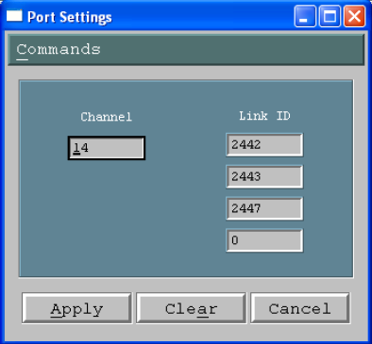

In the Port Settings dialog box, enter the channel you found in the beginning of the step (0-15) and station ID (from the previous step) to use for that port. Each port must be assigned its own channel. To maximize performance, it is recommended that active channels be separated by one unused channel. It is possible to use adjacent channels, but interference may occur under some circumstances.

Click Clear to remove settings from a port. Click Apply to dismiss the dialog box. Repeat as needed to configure additional ports.

When done, click Apply configure radios. The operation may take about a minute to complete. If successful, status for each configured port should be “detected”. If the status is “station not found,” verify that link IDs are correct and devices are on and in range. Select Search?RF Search to reapply configuration.

Once configured, stations will connect automatically and do not have to be on and in range during system initialization.

10. Close ISDEMO completely (make sure ISERVER is OFF: It will appear in the mini icon bar in windows desktop) and restart the PPT Studio with PPT Wand plugin.

**Connection establishment problem**

If you still cannot connect the PPT WAND in PPT Studio after the steps above, please contact [support@worldviz.com](file:///C:/Users/Daniel/AppData/Local/Temp/CHM%20Editor/ppt_42314.4058039352/Technical_specification_(PPT-E).htm)

PPT Studio 2013 Documentation - Version 3.40 - Copyright © 2002-2013 WorldViz. All Rights Reserved.

[cid:009601d11877$0e0e7654$_CDOSYS2.0](http://www.worldviz.com/)

## Installing Wand receiver drivers

If on Windows XP, you have to first install the FTDI drivers if it's not already installed – you may not have to do it for Windows 7. These drivers enable the USB connection of the wireless Intersense receivers. When you plug the wireless Intersense receiver into a USB port, it will ask you to install the drivers. You can find the drivers (32 and 64bit) at:

C:\Program Files\WorldViz\PPTStudio34\FTDI USB Drivers

Windows will ask you to install two different drivers, this is normal. After that is done, go to your Device Manager and make sure under Ports (COM & LPT) you see USB Serial Port(COMX) where X is the port number you have to enter in your script, viztracker, etc.

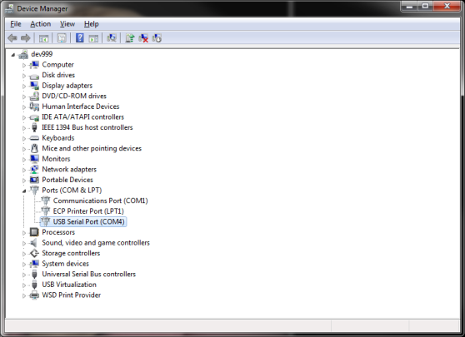

Now, on the receiver, you should see a single LED turned ON.

PPT Studio 2013 Documentation - Version 3.40 - Copyright © 2002-2013 WorldViz. All Rights Reserved.

[cid:009601d11877$0e0e7654$_CDOSYS2.0](http://www.worldviz.com/)

# PPT Eyes Specification

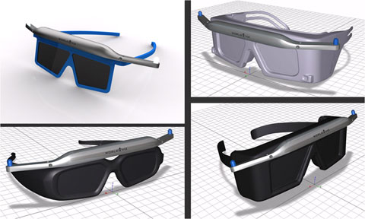

PPT Eyes are meant to be used with optically tracked projection systems like CAVEs, Powerwalls and others where they allow for accurate real time tracking of the users view point in connection with shutter glasses or polarization glasses, etc.

|  |  |
| --- | --- |
| Degrees of Freedom | 5 (X, Y, Z, yaw, roll) NOTE: This fully determines left/right eye locations needed for stereoscopic viewing. |
| Angular Range | Full 360 deg – both axes |
| Precision | Position: < 0.25 millimeters over 3 x 3 x 3 m volume Rotation: 0.09 deg |
| Accuracy | Position: |
| Update rate | 180 Hz (PPT H series) |
| Latency | 20 ms (PPT H series) |
| Range | 15 m |
| Battery | Type: Rechargeable or disposable AAA Endurance: > 24 hours typical usage |
| Weight | 60 g |
| Dimensions | 203 mm x 14 mm x 32 mm |
| LED mode | Passive only |
| Protocols | TrackD, VRPN, PPT Studio 2008 or later |

PPT Studio 2013 Documentation - Version 3.40 - Copyright © 2002-2013 WorldViz. All Rights Reserved.

[cid:009601d11877$0e0e7654$_CDOSYS2.0](http://www.worldviz.com/)

# PPT Eyes Setupcid:011801d11877$0e0ec467$_CDOSYS2.0

The PPT Eyes is part of the Worldviz PPT product family and integrates into any PPT system. This page describes the setup of PPT Eyes.

#### Starting the Plugin

1. Start PPT Studio.
2. Setup PPT and calibrate the tracking system according to the instructions given in the PPT Studio Help.
3. Set the number of tracked markers to at least 2 and turn on the PPT Eyes device. You should now see two tracked lights in the 3D view. You will need to increase this value to be larger than 2 if you are tracking other objects in your environment.  
     
   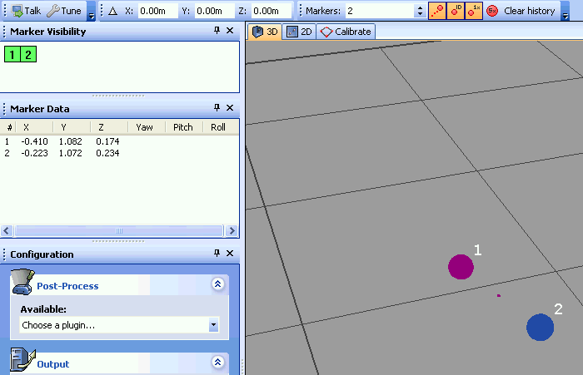
4. Next, enable the PPT Eyes plugin by choosing it from the Post-Process list. PPT Eyes will now automatically detect the two tracked lights and merge them into a single traced light with orientation data. Check the Marker Visibility panel that this is so. The 3D view should also show a single tracked light with an axis to indicate orientation data.  
     
   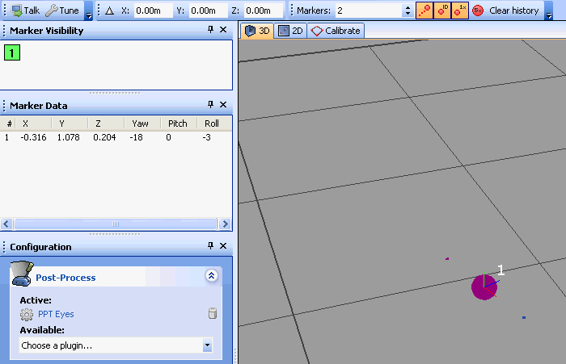
5. PPT Eyes will flip the orientation by 180 degrees if the plugin determines that the user is facing away from the display. Because of this you may see an error warning in the Messages panel. This is normal operation. If you find that the orientation is incorrect, face towards PPT north and the orientation will correct itself.  
     
   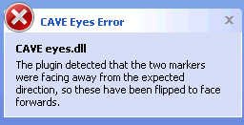

#### Configuring PPT Eyes

To configure PPT Eyes, click on the PPT Eyes plugin in the active list. This will bring up the Settings dialog.

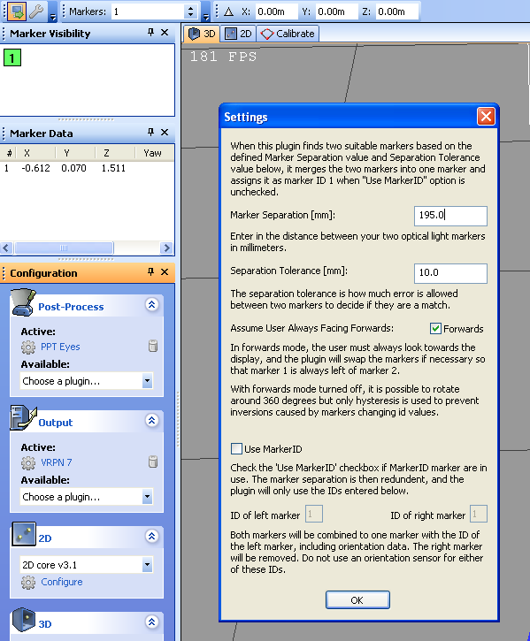

**Marker Seperation:** This is the distance between the two LED lights on the PPT Eyes device. By default this should by 195 mm. *Do not change this unless instructed to by Worldviz support, or if you have built your own custom LED device.*

**Separation Tolerance:** This is the maximum absolute difference between the observed distance of the two LED lights on the PPT Eyes device and the Marker Separation value can be. PPT Eyes will fail to detect the device if this tolerance is exceeded.

**Assume User Always Facing Forwards:** By default this mode should be turned off. The standard operating mode allows the user to rotate around and attempts to guess which direction PPT north is located. If you enable always facing forwards mode, it will be impossible to look more than 90 degrees from PPT north, and no previous information will be used to auto-detect the direction.

**Use MarkerID:** If you are using MarkerID-based markers, then you can skip the need to detect markers based on separation, and can use the IDs directly. This mode is only useful if you have built your own custom LED device, and should not be used with the standard PPT Eyes device.

PPT Studio 2013 Documentation - Version 3.40 - Copyright © 2002-2013 WorldViz. All Rights Reserved.

[cid:009601d11877$0e0e7654$_CDOSYS2.0](http://www.worldviz.com/)

## User presets

Saving / Loading custom settings

Your PPT supports saving all of its system settings for use later. By default, when you quit PPT, all of your settings including GUI arrangements are saved to a standard ppt.cfg file.

At any time, you can also select Save settings under the file menu and all your system settings will be stored in configuration file of your choosing.

This can be used, for instance, for creating presets for different device / plug-in configurations or for favorite tunings. At any time later, you simply use Load settings under the File menu to retrieve these settings.

After loading new settings, when you quit PPT these will be saved to the standard ppt.cfg so that when PPT restarts it will be configured as it was before.

Loading factory settings

If you're having difficulty finding user interface functions as discussed in this documentation, or have made a mistake with a configuration option and you cannot remember the default, you can select "Load factory settings" under the File menu. This will restore your PPT's graphical user interface back to the default factory settings from default.cfg which correspond to the screen shots used throughout the documentation.

PPT Studio 2013 Documentation - Version 3.40 - Copyright © 2002-2013 WorldViz. All Rights Reserved.

[cid:009601d11877$0e0e7654$_CDOSYS2.0](http://www.worldviz.com/)

# 3D Plugins Overview

The 3D Plugins included with PPT Studio provide different processing algorithms for calculating the position of the LED markers from the images seen by the cameras. These plugins can be found in the Configuration panel under the **3D** option:

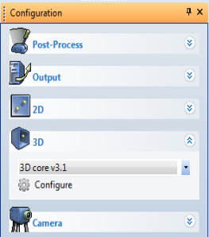

Each 3D plugin can be configured by selecting the plugin and clicking on either the **Configure** link beneath the drop-down choice box or the **Tune** button. *Refer to each 3D plugin topic for additional information.*

3D core v 3.1 (Default)

This is a 3D algorithm that adds weighting to all the computations to improve robustness and accuracy. For example, tracking results that are closer to the camera are given higher weighting than results from far away. Markers which have just recently appeared will have a lower weight than a marker which has been visible steadily for some time.

3D core v 2.0

This is the 3D processor that was used by PPT version 2.0. It is distributed for rare cases in which this processor may out-perform the version 3.0/3.1 processor and for replication of previous experimental results.

3D core v 4.0 (Beta)

(Development version) You should not use this plugin unless instructed by WorldViz. This 3D plugin which uses a completely new algorithm that does not require any configuration on threshold values nor tuning process.

PPT Studio 2013 Documentation - Version 3.40 - Copyright © 2002-2013 WorldViz. All Rights Reserved.

[cid:009601d11877$0e0e7654$_CDOSYS2.0](http://www.worldviz.com/)

# 3D core v3.1

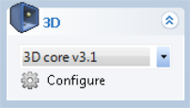

This is a 3D plugin that adds weighting to all the computations to improve robustness and accuracy. For example, tracking results that are closer to the camera are given higher weighting than results from far away. Markers which have just recently appeared will have a lower weight than a marker which has been visible steadily for some time.

This plugin needs to be configured for optimal performance. To configure the plugin for optimal performance, select the "3D core v3.1" plugin from the drop-down choice box in the Configuration panel. Click on the **Configure** link and the settings dialog box will appear:

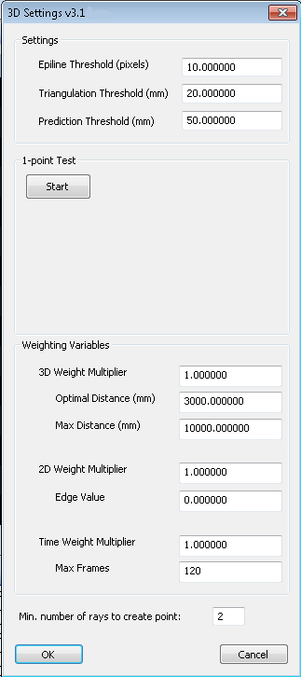

#### 3D Settings Explanation:

This plugin has three options which can be **Tuned** manually (by experienced users) or through the built in **1-point Test**. The three settings are:

1. Epiline Threshold (pixels): Helps determine which LED markers seen by each camera are included in the calculation of a final 3D point. When calculating a 3D point, this plugin needs to find a correspondence between the lights seen by each camera and the LED marker. If multiple LED markers are used with this plugin, there could multiple valid candidates in each camera image for a single LED marker.  
     
   In the following example, four LED markers are being tracked by cameras A and B. This plugin needs to match a light seen in camera A to one of the lights seen in camera B to compute a 3D point. In this example, the epiline is the line-of-sight from camera A to one of the lights it sees, projected onto camera B's image as the dotted line. Ideally this line would intersect with a light on camera B's image, but in many cases there are multiple possible candidates, such as the two lights indicated by the red dots in the example below.  
     
   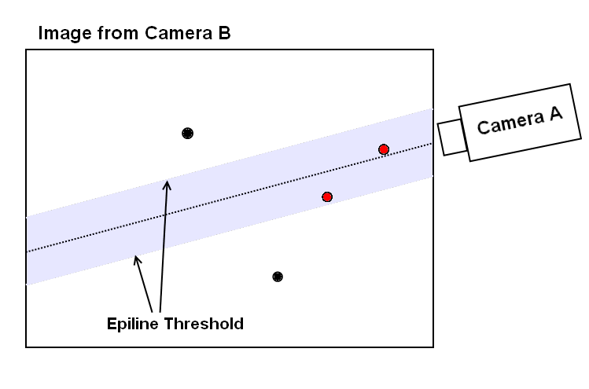  
     
   The Epiline Threshold tells this plugin how far away from the epiline to search for valid candidates. In this example, every dot within the gray area is within the Epiline Threshold and is considered a good candidate. The Epiline Threshold is the maximum distance from the epiline of camera A that visible lights in camera B's image should be found. *The units are in pixels.*
2. Triangulation Threshold (mm): Affects the accuracy and precision of PPT. This is the most important setting and must be reasonable for good performance. When more than a single LED marker is used, a single light seen from one camera could correspond to multiple lights seen from another camera. In the above example, a single light from camera A could correspond to either light indicated by the red dots in camera B. The Triangulation Threshold is used to further remove false candidates. This plugin quickly calculates the triangulation error of each choice and discards any choice which exceed this threshold. The units are in *millimeters*.
3. Prediction Threshold (mm): Determines if a 3D point is valid or not based on previous history. It is the maximum distance which a point could have moved from one frame to the next.

Users are encouraged to use the 1-point Test unless experienced with the system. The 1-point Test is a quick Tuning operation which will generate values for the three previous settings.

#### Tuning the 3D Plugin:

Before beginning, ensure that your PPT cameras are all properly [configured](file:///C:/Users/Daniel/AppData/Local/Temp/CHM%20Editor/ppt_42314.4058039352/Adjusting_camera_settings.htm) and you have a recent, good quality [calibration](file:///C:/Users/Daniel/AppData/Local/Temp/CHM%20Editor/ppt_42314.4058039352/Purpose_of_calibration.htm). If not, then perform those steps first.

1. Turn off all of the PPT markers.
2. Ensure that no false lights can be seen in each camera. Check each camera image in the **Cameras panel** and ensure that no lights are detected (indicated by yellow cross-hairs).
3. Turn on **1** LED marker.
4. Click on the Start button to begin sampling.
5. Move the marker around as if you were using it in your application.  Make sure that you cover the entire space the marker will move during your application and move the marker at the maximum speed the marker will move when used in your application.
6. Inspect and then accept the suggested settings. If the values look very large compared to the usual values or the defaults, you may need to perform the tuning process again, or perhaps try recalibrating your cameras.

#### Tuning the Weighting Variables:

The additions in v3.1 are the inclusion of the Weighting Variables. When calculating the position of any 3D point, corresponding lights seen from different cameras are used to triangulate a position. The physical location of the LED marker to the camera, the location of the perceived light in the camera image, and the length of visibility to the camera are used to calculate a single aggregate weight for each camera. Cameras with higher weights contribute more to the final 3D point.

1. ***3D Weight:*** This weight is related to the distance of the LED marker to the observing camera. For every light seen by a camera, the distance to the LED marker from the camera is calculated. If the LED marker is close to the Optimal Distance, the camera is given a higher weight. Beyond the Maximum Distance, the camera is given a zero weight for this component. Once an initial weight is calculated, it is multiplied to the 3D Weight Multiplier for the final 3D Weight.  
   1. 3D Weight Multiplier: This value represents the importance of the 3D weight component. Increasing this value will give more significance to cameras which view the LED markers from the optimal distance.
   2. Optimal Distance (mm): This value represents the distance where the LED marker should be from a camera for best tracking. In the above example, this is set to 3000 mm (3 meters).
   3. Max Distance (mm): This value represents the maximum distance an LED marker should be from a camera at any point in time.
2. ***2D Weight:*** This weight is related to the location of the observed LED marker in the camera image. Lights which appear closer to the center of the camera image result in a higher weight for the camera.  
   1. 2D Weight Multiplier:  This value represents the importance of the 2D weight component.
   2. Edge Value: The minimum weight this component can have. By setting this to a non-zero value, the weight of any observed LED marker will range from the Edge Value to the 2D Weight Multiplier. In the example above, lights at the edge of the camera are given a weight of 0.0.
3. ***Time Weight:*** This weight is related to the length of time the LED marker has been visible to the camera.  
   1. Time Weight Multiplier: This value is the maximum this component can have.
   2. Max Frames: The length of history kept and used in the calculation of the final weight. In the example above, only 120 frames are kept for history.

***Min. number of rays to create point:*** This parameter represents the number that a marker needs to be seen by the cameras in order to create a valid tracking point.

PPT Studio 2013 Documentation - Version 3.40 - Copyright © 2002-2013 WorldViz. All Rights Reserved.

[cid:009601d11877$0e0e7654$_CDOSYS2.0](http://www.worldviz.com/)

# 3D core v2.0

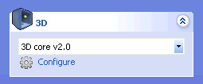

This is the 3D processor that was used by PPT version 2.0. It is distributed for rare cases in which this processor may out-perform the version 3.0 processor and for replication of previous experimental results.

To configure the plugin for optimal performance, select the "3D core v2.0" plugin from the drop-down choice box in the Configuration panel. Click on the **Configure** link and the settings dialog box will appear:

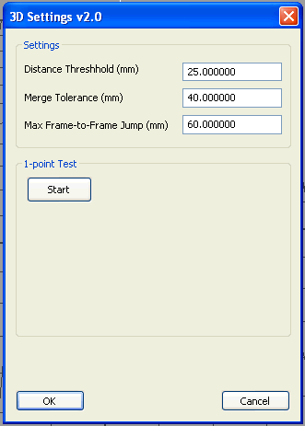

#### 3D Settings Explanation:

Similar to v3.0 and v3.1, this plugin has three options which can be changed manually (by experienced users) or through the built in **1-point Test**. The three settings are:

1. Distance Threshold (mm): Affects the accuracy and precision of PPT. *The units are in pixels.*
2. Merge Tolerance (mm): Affects the accuracy and precision of PPT. The units are in *millimeters*.
3. Max Frame-to-Frame Jump (mm): It is the maximum distance which a point could have moved from one frame to the next. *The units are in millimeters*.

Users are encouraged to use the 1-point Test unless experienced with the system. The 1-point Test is a quick Tuning operation which will generate values for the three previous settings.

#### Tuning 3D Plugin v2.0:

Before beginning, ensure that your PPT cameras are all properly [configured](file:///C:/Users/Daniel/AppData/Local/Temp/CHM%20Editor/ppt_42314.4058039352/Adjusting_camera_settings.htm) and you have a recent, good quality [calibration](file:///C:/Users/Daniel/AppData/Local/Temp/CHM%20Editor/ppt_42314.4058039352/Purpose_of_calibration.htm). If not, then perform those steps first.

1. Turn off all of the PPT markers.
2. Ensure that no false lights can be seen in each camera. Check each camera image in the **Cameras panel** and ensure that no lights are detected (indicated by yellow cross-hairs).
3. Turn on **1** LED marker.
4. Click on the Start button to begin sampling.
5. Move the marker around as if you were using it in your application.  Make sure that you cover the entire space the marker will move during your application and move the marker at the maximum speed the marker will move when used in your application.
6. Inspect and then accept the suggested settings. If the values look very large compared to the usual values or the defaults, you may need to perform the tuning process again, or perhaps try recalibrating your cameras.

PPT Studio 2013 Documentation - Version 3.40 - Copyright © 2002-2013 WorldViz. All Rights Reserved.

[cid:009601d11877$0e0e7654$_CDOSYS2.0](http://www.worldviz.com/)

# 3D core v 4.0

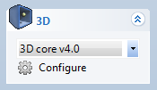

This is the latest 3D plugin which uses a completely new algorithm that does not require any configuration on threshold values nor tuning process.

The only setting that this plugin has is to set the minimum number of rays (cameras) for creating a valid tracking point. By default, it is set to 2. If the number of cameras that sees the marker is fewer than the number specified in this parameter, the marker will not show up in the 3D view as a valid tracking point.

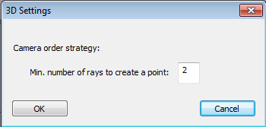

PPT Studio 2013 Documentation - Version 3.40 - Copyright © 2002-2013 WorldViz. All Rights Reserved.

[cid:009601d11877$0e0e7654$_CDOSYS2.0](http://www.worldviz.com/)

## Camera

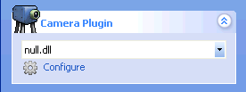

PPT-X

Use this plugin for interfacing with PPT-X cameras. The options available for configuration are:

**Progressive vs Interlace:**

Interlace Recommended

The progressive setting can sometimes offer higher quality at the cost of higher latency.

**Edit Serial Numbers:**   
Use this to reconfigure the serial numbers of your system's cameras. The serial numbers are 5 characters long (A-Z, 0-9) and must match exactly the order of the digitizers on the back of the computer, and the cabling to the cameras.

PPT-E

Use this plugin to configure the PPT-E cameras. The options available for configuration are:

**Vertical blanking:**

The amount of time the camera will wait before capturing the next frame.

Minimum value of 4 corresponds to 10.2 microseconds and the cameras will run at 196 frames per second.

If you are using PPT-H marker id units with PPT-E, then you should set this option to 47, and the cameras will run at 180 frames per second.

**Shutter time:**

The amount of time to capture light with the sensor before processing it.

4960 microseconds is the maximum value, and also the recommended value for most tracking scenarios.

Smaller values should be used to minimize motion blur with very fast objects.

If you check the box "disable synchronization" then this allows much larger shutter times, but synchronization is disabled. Typically this checkbox should always be cleared and the shutter time set to 4960 microseconds.

**Brightness shift:**

Apply an additive brightness shift to your PPT camera capture images.

Range from -255 to 255, 0 is the recommended default which applies no offset.

**Sensor gain:**

Adjust the gain applied within the camera sensor.

The recommended value for PPT-E is 4, which is the default sensor gain.

Adjusting this value may lead to unexpected side-effects, and should typically not be adjusted.

**Broadcast address:**

The address to use when scanning for cameras on your local network. This will typically be 255.255.255.255 for an automatic scan of all available network interfaces. If you have multiple PPT-E configurations on separate networks, you will need to specify this exactly.

**History length and velocity threshold:**

The two parameters are preset to WorldViz recommended values that prevent static tracking from jittering.

PPT-H

Use this plugin to configure the PPT-H cameras. The options available for configuration are:

**Frame rate:**

The approximate number of frames per second that the camera will produce (+/- 1 frame)

Between 15 Hz and 180 Hz (use 60 Hz for long range tracking of dim markers, otherwise 180 Hz is recommended)

**Exposure duration:**

The amount of time to capture light with the sensor before processing it.

5500 microseconds is recommended for the longest range 180 Hz tracking, but smaller values are best for very fast motions.

Larger values will cause the frame rate slider to adjust to a lower maximum since faster rates are not possible at that exposure time.

**Brightness:**

Apply an additive brightness shift to your PPT camera capture images.

Range from 0 to 255, 128 is the recommended default

**Broadcast address:**

The address to use when scanning for cameras on your local network. This will typically be 255.255.255.255 for an automatic scan of all available network interfaces. If you have multiple PPT-H configurations on separate networks, you will need to specify this exactly.

PPT Studio 2013 Documentation - Version 3.40 - Copyright © 2002-2013 WorldViz. All Rights Reserved.

[cid:009601d11877$0e0e7654$_CDOSYS2.0](http://www.worldviz.com/)

## 2D Plugin

2D plugins are used to process the images that are received by the cameras, and are responsible for placing the 2D crosshair over each marker. Note that only PPT-X systems use 2D plugins - the PPT-E and PPT-H system includes the 2D plugin on-board the camera, and so changing the 2D plugin has no effect in this case.

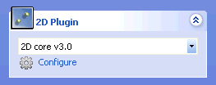

2D core v 3.1 (default)

This plugin is enabled by default within PPT, and uses an improved algorithm for finding smaller markers compared to the previous v3.0 plugin. By default, you should not alter the default settings and should not select any other 2D plugin, unless instructed to by WorldViz support. The default settings are:

* Scan Increment H: 2
* Scan Increment V: 2

* Velocity threshold: 0.03

* History length: 12

2D core v 3.0

This plugin is included for compatibility with older PPT releases, and by default is not used any more. The 2D core v3.1 plugin is recommended instead.

You should not need to alter the default settings unless directed to by WorldViz support. The defaults should be as follows:

* Scan Increment H: 2
* San Increment V: 2
* Kernel type: 5

PPT Studio 2013 Documentation - Version 3.40 - Copyright © 2002-2013 WorldViz. All Rights Reserved.

[cid:009601d11877$0e0e7654$_CDOSYS2.0](http://www.worldviz.com/)

## Output

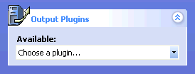

See the [Sending data](file:///C:/Users/Daniel/AppData/Local/Temp/CHM%20Editor/ppt_42314.4058039352/Talking_to_a_host_application_or_system.htm) topic for more information.

Choose from the following:

* VRPN 7 - Recommended  
  Output marker data over Ethernet using the VRPN 7 protocol. Vizard and many other applications readily connect to this protocol.
* Serial  
  Output marker data over RS-232 serial connection. This protocol provides backward compatibility for applications built using WorldViz PPT version 2. This protocol also provides a connection for configurations in which Ethernet is not an option. Note that this protocol will not handle large numbers of markers at high update rates due to RS-232 bandwidth limitations.
* Shared Memory - Advanced  
  Allow Vizard to directly connect to PPT if it is running on the same host computer. The Vizard "vizppt.dls" automatically searches for a shared memory connection before searching via other means such as RS-232.
* Motion Builder 7.5  
  Use this for connecting to [MotionBuilder](file:///C:/Users/Daniel/AppData/Local/Temp/CHM%20Editor/ppt_42314.4058039352/PPT_MoCap.htm) to drive full-body inverse kinematic simulations. The PPT MoCap plugin for MotionBuilder can be [downloaded](http://www.worldviz.com/download?id=34) for free from the WorldViz website.

PPT Studio 2013 Documentation - Version 3.40 - Copyright © 2002-2013 WorldViz. All Rights Reserved.

[cid:009601d11877$0e0e7654$_CDOSYS2.0](http://www.worldviz.com/)

## Post process

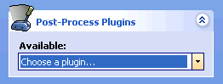

Use post process plug-ins to perform a wide variety of tasks related to transforming and filtering raw PPT 3DOF position and 3DOF orientation information. More information about these is available at the [Orientation and position plugins](file:///C:/Users/Daniel/AppData/Local/Temp/CHM%20Editor/ppt_42314.4058039352/Orientation_and_position_plugins.htm), [Local offsets](file:///C:/Users/Daniel/AppData/Local/Temp/CHM%20Editor/ppt_42314.4058039352/Applying_position_offsets.htm), [Marker Identification](file:///C:/Users/Daniel/AppData/Local/Temp/CHM%20Editor/ppt_42314.4058039352/Marker_Identification.htm), and [Debugging plugins](file:///C:/Users/Daniel/AppData/Local/Temp/CHM%20Editor/ppt_42314.4058039352/debugging_plugins.htm) sections.

Available post process plug-ins

* [Camera visualization](file:///C:/Users/Daniel/AppData/Local/Temp/CHM%20Editor/ppt_42314.4058039352/debugging_plugins.htm) - Debugging plugin that shows for each voxel in the tracking space the number of cameras that can track that location. Useful for determining tracking coverage given the current camera layout.
* [Filter](file:///C:/Users/Daniel/AppData/Local/Temp/CHM%20Editor/ppt_42314.4058039352/Orientation_and_position_plugins.htm) - Used to smooth out position and orientation values to remove jitter when used in noisy tracking environments.
* [Intersense](file:///C:/Users/Daniel/AppData/Local/Temp/CHM%20Editor/ppt_42314.4058039352/Orientation_and_position_plugins.htm) - PPT can connect to an InertiaCube and tie the data to a particular PPT wireless marker. In this way, data returned by PPT can be true 6DOF position and orientation data and is ready for use by any compatible application.
* [Local offset](file:///C:/Users/Daniel/AppData/Local/Temp/CHM%20Editor/ppt_42314.4058039352/Applying_position_offsets.htm) - Apply an offset to the position value so that the location of the user's eyes is returned rather than the actual location of the marker light which might be a considerable distance away.
* [Marker ID](file:///C:/Users/Daniel/AppData/Local/Temp/CHM%20Editor/ppt_42314.4058039352/Marker_Identification.htm) - When using markers supporting identification, this plugin is used to automatically assign consistent id numbers to each marker visible.

* [Marker ID 32](file:///C:/Users/Daniel/AppData/Local/Temp/CHM%20Editor/ppt_42314.4058039352/Marker_Identification.htm) - It works the same as Marker ID plugin but with different decoding scheme that supports 32 different marker IDs. Markers need to be programmed as the Marker ID 32 compatible in order to use this plugin.
* [Mocap](file:///C:/Users/Daniel/AppData/Local/Temp/CHM%20Editor/ppt_42314.4058039352/Marker_Identification.htm) - Heuristic model of the human body to identify PPT wireless markers attached to the head, hands, feet, and hips.
* [Optical heading](file:///C:/Users/Daniel/AppData/Local/Temp/CHM%20Editor/ppt_42314.4058039352/Orientation_and_position_plugins.htm) - Calculate a heading value using two marker lights, and using this to compensate for magnetic distortions or gyro drift.

* [Optical heading markerID](file:///C:/Users/Daniel/AppData/Local/Temp/CHM%20Editor/ppt_42314.4058039352/Orientation_and_position_plugins.htm) - Similar to Optical heading but with markerID information.
* [PPT Eyes](file:///C:/Users/Daniel/AppData/Local/Temp/CHM%20Editor/ppt_42314.4058039352/PPT_Eyes_Setup.htm) - Given two PPT wireless markers (3DOF data only), this plug-in will compute the 5DOF position and orientation solution necessary for driving a CAVE-like stereo projection system.
* [world](file:///C:/Users/Daniel/AppData/Local/Temp/CHM%20Editor/ppt_42314.4058039352/PPT_Wand_Setup.htm) - PPT can connect to a PPT Wand and tie the orientation, joystick, and button data to a particular PPT marker.

* Wand 2013 - It is similar to the PPT Wand plugin with the better connectivity and lighter weight overall.

* [Ray visualization](file:///C:/Users/Daniel/AppData/Local/Temp/CHM%20Editor/ppt_42314.4058039352/debugging_plugins.htm) - Debugging plugin used to show for each marker a set of rays indicating which cameras can see a particular 3D point.
* [Rigid body](file:///C:/Users/Daniel/AppData/Local/Temp/CHM%20Editor/ppt_42314.4058039352/Orientation_and_position_plugins.htm) - Use a constellation of PPT marker lights to return a single 6DOF position and orientation value without any extra tracking hardware.
* [Timing report](file:///C:/Users/Daniel/AppData/Local/Temp/CHM%20Editor/ppt_42314.4058039352/debugging_plugins.htm) - Debugging plugin used to show the amount of time used in each plugin processing stage.
* [VRPN Input](file:///C:/Users/Daniel/AppData/Local/Temp/CHM%20Editor/ppt_42314.4058039352/Orientation_and_position_plugins.htm) - Used for reading in orientation data from a Vizard system, to provide it to the Mocap plugin. Used to ensure that the Vizard system has orientation data with the lowest latency possible.

PPT Studio 2013 Documentation - Version 3.40 - Copyright © 2002-2013 WorldViz. All Rights Reserved.

[cid:009601d11877$0e0e7654$_CDOSYS2.0](http://www.worldviz.com/)

## Frequently asked questions

**Will it take a long time to set up PPT and calibrate the system if the cameras are to be mounted in permanent positions (say in a lab space)?**

It takes some time (probably a few hours) to carefully adjust the camera position and orientation for a given space, if you want to do a good job. Usually (in most labs) mounting the cameras and fixing the cables to the walls takes most of the time. The system calibration itself takes about 1 minute.

**What is a support contract?**

All purchases of WorldViz software products include 3 months of free priority e-support. This means you have help setting up your system, integrating your hardware components, and even getting your first immersive creation started.

**I dropped the camera and it seems to be damaged, what should I do now?**

If you are in a situation where you are urgently needing to run PPT (i.e. a conference or user study) then you should right-click on the damaged camera to deactivate and run system without the camera. You should then contact WorldViz for support to arrange for a repair or replacement.

**Are there system  limitations with ambient lighting?**

The system only operates in cool lighting conditions. This means fluorescent lights and the like (therefore all kinds of vapor lights and neon lights which are usually used in commercial settings for energy reasons will work fine). It will not work under tungsten, halogen, or sunlit conditions (even windows to the outside must be covered during system operation).

**How can I determine the field of view (FOV) for each of the PPT cameras?**

PPT-X has a field-of-view of 68 degrees horizontal and 51 degrees vertical.

The PPT-E and PPT-H with standard 45mm lenses is 78 degrees horizontal and 59 degrees vertical.

The PPT-E and PPT-H with wide-angle 35mm lenses is 101 degrees horizontal and 74 degrees vertical.

**What is the H:V aspect ratio of the cameras?**

All PPT models are 4:3

**How do I specify Virtual North?**

When you calibrate your PPT system, the "virtual north" is the direction that the Z-axis on the calibration rig points towards. When you calibrate your extra orientation sensors, you should ensure that this "virtual north" is used for the alignment.

**The specifications for PPT-X state that the system has a 10m x 10m x 10m range, but what distance must the cameras be apart in order for this range to be achieved?**

A four camera system will cover all of a 10m x 10m space if the cameras are mounted in the corners of the room. As soon as at least two cameras see a marker, the system reports its position.

**What about problems with dead spots in a tracked 10x10x10 space given the horizontal FOV of the cameras?**

It is possible to use 100 degree horizontal lenses but it will deteriorate the data quality because the wider angle lenses inherently introduce greater optical distortion. If it is critical to go wider, this should be considered as a last resort. You will need to send your cameras back to WorldViz if you wish to change the lenses. Do not under any circumstances adjust the lenses on the camera yourself, otherwise it will change the calibration and will reduce tracking accuracy within PPT.

**Is it be possible to have a pilot subject walk around a volume with 3 markers on his or her torso and 1 on the head and have them do different kinds of motions like ducking and weaving and turning around?**

Yes, by using 4 cameras mounted at the corners of a 10x10x10 space

**If our volume is significantly smaller than 10 m x 10 m x 10 m, is the resolution and associated precision and accuracy numbers better for our situation?  The cameras would be considerably closer to the markers.**

3D resolution and accuracy are both entirely dependent on the camera geometry; 3D resolution increases as your close the camera geometry. The reason is simply that you are dividing a smaller volume with the same 1:20,000 chopper, so you get smaller pieces. The thing that complicates this, though, is the arrangement of the cameras.  Placing two cameras close to each other so there's a tiny base distance between them essentially makes them act as a single camera. The ideal configuration is always to have the cameras' lines-of-sight perpendicular to each other. This is very rarely the case, however, in real setups.

Contact technical support

For immediate assistance with PPT questions not addressed here, go to [www.worldviz.com/support](http://www.worldviz.com/support) and send an email to [ppthelp@worldviz.com](mailto:ppthelp@worldviz.com)

PPT Studio 2013 Documentation - Version 3.40 - Copyright © 2002-2013 WorldViz. All Rights Reserved.

[cid:009601d11877$0e0e7654$_CDOSYS2.0](http://www.worldviz.com/)

## Technical specifications for PPT-E

Sensor type

B&W CMOS

Degrees of freedom

3DOF position - standard optical only

6DOF incl orientation - with optional sensor

Maximum camera range

20 meters \*\*

Suggested tracking space

20 x 20 x 10 meters \*\*

Maximum number of targets

Up to 32 independent 3DOF bodies \*

Maximum number of cameras

System can be expanded to 32 cameras \*

Precision

< 0.25 millimeters over 3 x 3 x 3 m volume; optical sensor is 1:80,000 arc at 75% rms

Accuracy

< 0.25 centimeter over 3 x 3 x 3 m volume

Field of view

79 degrees horizontal (Standard angle lens)

98 degrees vertical (Wide angle lens)

Calibration

Less than one minute using digital calibration rig

Update rate

180 Hz \*

Minimum latency

20 milliseconds

Maximum cable length to cameras

200 metres

Interface

Ethernet, using VRPN

Ambient conditions

Indoor fluorescent only

Size & weight

Processor: 420 x 370 x 180 mm (10 kg)

Sensors: 45 x 32 x 92 mm (145 g)

Targets: 3 x 3 x 5 mm (2 g)

Software support

Directly connect to WorldViz Vizard VR toolkit; DLL for Windows; C source library for Linux

Notes

(\*) Actual update rate depends on the number of targets and number of cameras. Please contact WorldViz for details on this tradeoff

(\*\*) For a marker to be tracked, it must be visible by two or more cameras. Overall tracking space dimensions are determined by the camera range, camera layout, and background lighting

PPT Studio 2013 Documentation - Version 3.40 - Copyright © 2002-2013 WorldViz. All Rights Reserved.

[cid:009601d11877$0e0e7654$_CDOSYS2.0](http://www.worldviz.com/)

## Technical specifications for PPT X

Sensor type

CCD

Degrees of freedom

3DOF position - standard optical only

6DOF incl orientation - with optional sensor

Maximum camera range

15 meters \*

Suggested tracking space

10 x 10 x 10 meters \*

Number of targets

Up to eight independent 3DOF bodies

Precision

< 1 millimeter over 3 x 3 x 3 m volume; optical sensor is 1:20,000 arc at 75% rms

Accuracy

< 0.5 centimeter over 3 x 3 x 3 m volume

Field of view

68 degrees horizontal, 51 degrees vertical

Calibration

3 minute process using digital calibration board

Update rate

60 Hz

Minimum latency

18 milliseconds

Interface

RS-232, 115.2 kbs, streamed or polled

Ambient conditions

Indoor fluorescent only

Size & weight

Processor: 420 x 370 x 180 mm (10 kg)

Sensors: 160 x 70 x 60 mm (500 g)

Targets: 3 x 3 x 5 mm (2 g)

Software support

Directly connect to WorldViz Vizard VR toolkit; dll for Windows; C source library for Linux

Notes

(\*) For a marker to be tracked, it must be visible by two or more cameras. Overall tracking space dimensions are determined by the camera range, camera layout, and background lighting

PPT Studio 2013 Documentation - Version 3.40 - Copyright © 2002-2013 WorldViz. All Rights Reserved.

[cid:009601d11877$0e0e7654$_CDOSYS2.0](http://www.worldviz.com/)

## Technical specifications for PPT-E

Sensor type

B&W CMOS

Degrees of freedom

3DOF position - standard optical only

6DOF incl orientation - with optional sensor

Maximum camera range

20 meters (at 175 Hz) \*\*

45 meters (at 60 Hz) \*\*

Suggested tracking space

50 x 50 x 50 meters \*\*

Maximum number of targets

Up to 32 independent 3DOF bodies \*

Maximum number of cameras

System can be expanded to 32 cameras \*

Precision

< 0.25 millimeters over 3 x 3 x 3 m volume; optical sensor is 1:80,000 arc at 75% rms

Accuracy

< 0.25 centimeter over 3 x 3 x 3 m volume

Field of view

79 degrees horizontal, 59 degrees vertical

Calibration

3 minute process using digital calibration board

Update rate

Up to 175 Hz \*

Minimum latency

20 milliseconds

Maximum cable length to cameras

100 metres

Interface

Ethernet, using VRPN

RS-232, 115.2 kbs, streamed or polled

Ambient conditions

Indoor fluorescent only

Size & weight

Processor: 420 x 370 x 180 mm (10 kg)

Sensors: 240 x 57 x 80 mm (900 g)

Targets: 3 x 3 x 5 mm (2 g)

Software support

Directly connect to WorldViz Vizard VR toolkit; DLL for Windows; C source library for Linux

Notes

(\*) Actual update rate depends on the number of targets and number of cameras. Please contact WorldViz for details on this tradeoff

(\*\*) For a marker to be tracked, it must be visible by two or more cameras. Overall tracking space dimensions are determined by the camera range, camera layout, and background lighting

PPT Studio 2013 Documentation - Version 3.40 - Copyright © 2002-2013 WorldViz. All Rights Reserved.

[cid:009601d11877$0e0e7654$_CDOSYS2.0](http://www.worldviz.com/)

## Contact WorldViz

E-Mail support

[support@worldviz.com](mailto:contact@worldviz.com)

Help forum

[www.worldviz.com/forum](http://www.worldviz.com/forum)

Online support

[www.worldviz.com/support](http://www.worldviz.com/support)

Phone Fax

Phone +1-805-966-0786

Fax +1-866-226-7529

Address

27 West Anapamu Street

Suite 101-121

Santa Barbara, CA 93101

USA

PPT Studio 2013 Documentation - Version 3.40 - Copyright © 2002-2013 WorldViz. All Rights Reserved.